COVID-19 VACCINATION: EDUCATION FAQS FOR SOCIAL MEDIA
Updated: December 2, 2020
You can use this series of COVID-19 Vaccination FAQs to create a social media campaign to educate people about the vaccine.

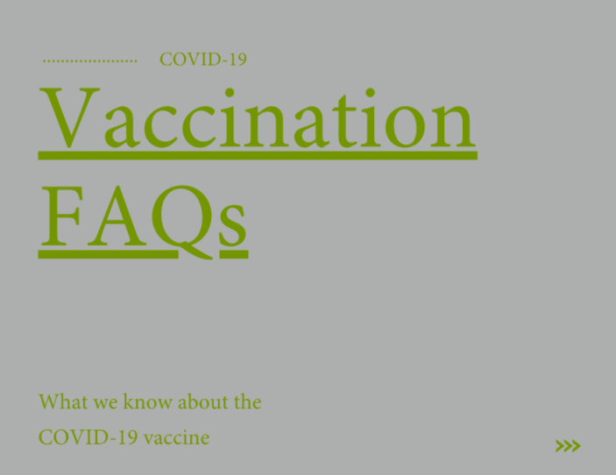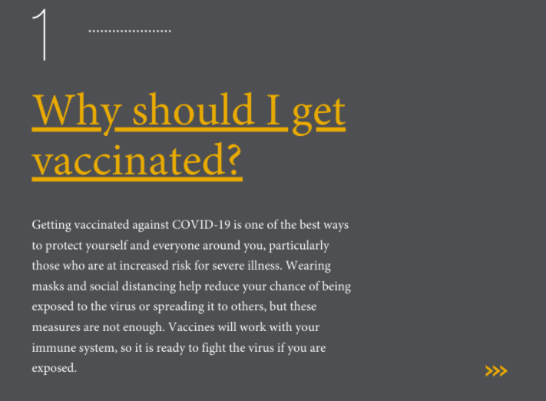

FAQ Intro
FAQ 1
FAQ 2
FAQ 3
FAQ 4
FAQ 5
FAQ 6

