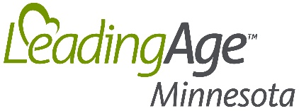

FOR IMMEDIATE RELEASE: CONTACT: Jodi Boyne
February 21, 2018 651.659.1430

USING MUSIC TO SOLVE PROBLEMS, IMPROVE CARE AND ENHANCE RESIDENT WELL-BEING
Walker Methodist Receives LeadingAge Minnesota Quality Award

SAINT PAUL – (Feb 21, 2017) – Walker Methodist recently received a Stars Among Us Quality Award from LeadingAge Minnesota for its Embedded Music program.

“The Quality Award recognizes progressive and exceptional initiatives that result in meaningful impacts to the customer experience,” said Gayle Kvenvold, President and CEO, LeadingAge Minnesota. “Walker Methodist has taken the application of music therapy to a higher level and greatly enhanced the lives of the older adults they serve.”

Walker Methodist has embedded music into nearly every aspect of resident care and daily life. It is the first certified Music & Memory organization in the Twin Cities, and now uses more than 200 iPods with personalized play lists to help more than 400 residents connect with the memories and become more engaged and interactive.

Music is also used to manage pain and anxiety without medication and as an intervention for behavior and anxiety to make daily life and personal cares more comfortable and enjoyable for residents.

By embedding music into care delivery, Walker Methodist has reduced the time needed to provide care, helped ease transitions to a new environment, addressed sundowning in residents who suffer from dementia, eased anxiety for family members whose loved ones are on hospice, and improved overall resident well-being and satisfaction.

About LeadingAge Minnesota
Driven to transform and enhance the experience of aging, LeadingAge Minnesota works alongside its members, caregivers, advocates and consumers to collectively shape the future of aging services and ensure older adults in every community live with dignity, meaning and purpose. Together with more than 50,000 caregivers, LeadingAge Minnesota members provide quality services and supports to 63,000 older adults every day in independent senior housing, assisted living communities, adult day, in-home care and skilled nursing facilities.

###

