Basic Infection Prevention (BIP) Course
Make your job “Mission possible”
Attend the APIC Minnesota Basic Infection Prevention Course
**Only course of its kind locally**

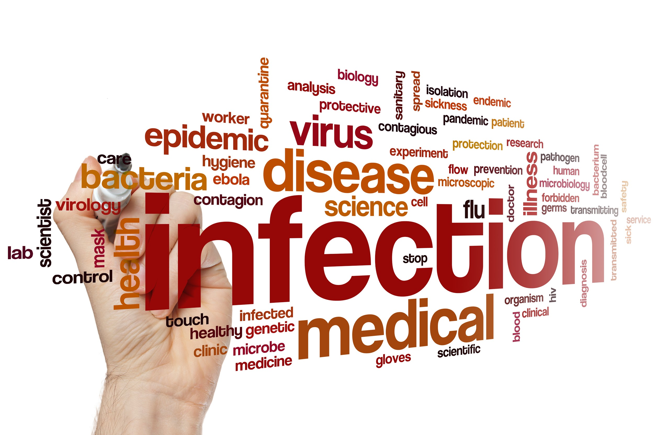
Who should attend? | What are the key benefits? | Course Instructors:
Infection Prevention Professionals in  Acute Care  Ambulatory Care  Home Care  Long-Term Care  Public Health  Quality Improvement  Occupational Health | Real-world problem solving with peers  Cutting edge, evidence based content  Current regulations and standards  Small class size  Affordable  Networking Support during and after the courses  18 CEUs  Access to electronic links to guidelines, best practice and regulatory documents | Certified practitioners from a variety of settings.  Course Facilitator:  Stephanie Tismer, RN, BSN, CIC

Now offered four times a year!
Upcoming Course Opportunities
Winter | Spring | Summer | Fall
February 13-14, 2018 | April 25-26, 2018 | July 26-27, 2018 | October 25-26, 2018

Target Audience  This interactive course will offer a comprehensive foundation for professionals specializing in infection prevention in all settings of health care including: Acute Care,  Critical Access Hospitals, Ambulatory Care, Home Care, Long Term Care and Public Health.  Participants will:  Examine the elements of effective infection prevention programs and the resources that support development and implementation.  Gain understanding of how evidence-based recommendations are used to implement best practices to prevent infections.  Sharpen networking skills with colleagues to share experience and to gain access to additional resources  Increase awareness of Centers for Medicare and Medicaid's conditions of participation to qualify for 3rd party reimbursement.  Improve understanding of the impact of infection prevention strategies to support the mission and goals of your health care system.  Continuing Education Credits  This program has been designed to meet continuing nursing education credits. A certificate of attendance for 18 contact hours will be given to each participant at the course conclusion.  Course Instructors  Certified (CIC) Instructors from a variety of clinical settings will provide the instruction. Course facilitator Stephanie Tismer, RN, BS, CIC sgtismer71@gmail.com  APIC Text  Attendees must have access to the APIC Text of Infection Control and Epidemiology. You will use this resources during the course and in your day-to-day practice. Text is available for purchase from the APIC bookstore at www.apic.org If you are unable to obtain the APIC Text for this course, please contact the course facilitator at BIP@apicmn.org | Location  All Courses will be at the:  Carpenters Union Hall,  710 Olive Street,  St. Paul MN 55130  Lodging  Hampton Inn Roseville  2050 Iona Lane W.  Roseville, MN 55113  Pre-Course Assignment  Review APIC Text Chapters before class:  10 - General Principles of Epidemiology  11- Surveillance  24 - Microbiology Basics  Registration Information  Assume your registration is accepted unless you are otherwise notified.  Cancellations made one week before the class will not be refunded.  APIC MN reserves the right to cancel this course due to insufficient enrollment.  Online registration is preferred but fax or mail registration is also acceptable. Paying by check helps to save APIC MN credit card processing fees.  Register online here: http://community.apic.org/minnesota/meetings/mnbip  Fax to: 952-858-8950  Or mail completed registration form (see next page) to:  APIC MN  2626 E. 82nd St.  Suite 270  Bloomington, MN 55425

APIC Minnesota’s Basic Infection Prevention Course
Registration Form:

Name: | APIC ID Number:
Title: | Facility:
Address:
City: | State: | Zip:
Work Phone: | Alternate Phone:
Email Address:
Facility Type ▢ Acute Care ▢ Ambulatory Care ▢ Home Care ▢ LTC
▢ Public Health ▢ Critical Access ▢ Other____________________________

Registration Fee: APIC MN Members $375; Non-APIC Member $700

Non-Members: To save $100 on the registration fee, please join APIC National and MN Chapter

Go to www.apic.org and fill out the membership form. Dues are $200 for the national chapter and $25 for the Minnesota Chapter. You must join the National organization to join the Minnesota Chapter. Once membership has been accepted, you will receive an APIC Registration number. Please contact us with that number to update your registration for the BIP course and receive the class discount.

If Paying by check make payable to APIC MN.

APIC Text: Attendees must have access to the AIPC Text of Infection Control and Epidemiology. You will use this resources for pre-reading and during class.

