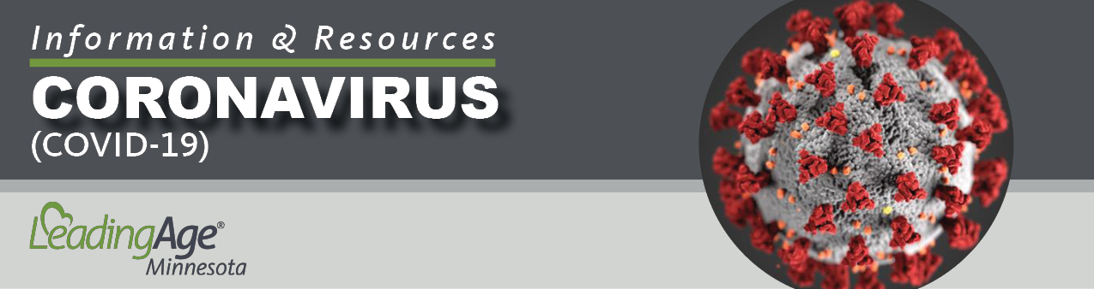

Policy Template:
Interim COVID-19 Personal Protective Equipment Sourcing and Optimization

Revision Date: May 7, 2020
This resource was developed utilizing information from one or more of the following sources: Centers for Disease Control & Prevention (CDC), Centers for Medicare & Medicaid Services (CMS), and the Minnesota Department of Health (MDH). COVID-19 guidance from these agencies changes frequently, and we remind you to update your policies and procedures, as needed, to incorporate those changes.

NOTICE:This policy template is intended for aging services providers and is for general information purposes only. Each organization and care setting is different, and it is important that you customize the policy to align with your specific operational approach to the issues it covers. This template does not constitute legal advice and does not guarantee compliance with state or federal regulatory requirements. Please direct any questions regarding this document to your organization’s legal counsel.
COVID-19: INFECTION PREVENTION & CONTROL

SUBJECT: Interim COVID-19 Personal Protective Equipment Sourcing, Optimization and Alternatives

Accountability: All Staff Document No.: COVID-003

Reference: Centers for Disease Control & Prevention (CDC) PPE Burn Rate Calculator; CDC Strategies to Optimize the Supply of PPE and Equipment; Minnesota Department of Health (MDH) Strategies for Optimizing the Supply of Personal Protective Equipment; MDH Interim Guidance on Alternative Facemasks as a Source Control Measure

POLICY: To provide health care workers (HCW), visitors, and vendors with appropriate personal protective equipment (PPE) according to state and federal guidelines.

To have alternative strategies for source control when PPE supplies become low or are exhausted.

DEFINITIONS:
PPE consists of:
- Gloves
- Facemasks / Respiratory Protection
- Gowns
- Eye Protection
Source Control: Alternative methods for or conservation techniques for PPE.

PROCEDURE:

- The facility will monitor PPE supplies on hand and update this information daily. .

- The facility will obtain additional supplies of PPE when needed through commercial vendors and suppliers, to the extent possible.

- If the facility is running low or has no PPE and is unable to procure PPE through its vendors, online providers, or other means, it will seek assistance from the State of Minnesota Emergency Operations Center, through the facility’s Regional Health Care Preparedness Coordinator (RHPC). The RHPC for this facility is:

[Insert the name of your facility’s RHCP and the key contacts for your RHCP. You can located your regional office through the MN Department of Health website https://www.health.state.mn.us/communities/ep/coalitions/rhpc.html]

- The facility will make available to employees PPE required for them to complete job duties per guidance from CDC, MDH and the Centers for Medicare & Medicaid Services (CMS) when the community is able to procure PPE.

- If the facility is unable to locate enough PPE for staff, visitors, and vendors, the facility will follow the optimization strategies for PPE supplies per CDC and MDH.

- The facility will document attempts to order / procure additional supplies and efforts to optimize the use of existing PPE.

- For facemasks and facemask alternatives, the facility will follow the MDH guidance on Interim Guidance on Facemasks as a Source Control Measure. https://www.health.state.mn.us/diseases/coronavirus/hcp/maskssource.pdf

Effective Date:
Reviewed By: Date:
Revised By: Date:

