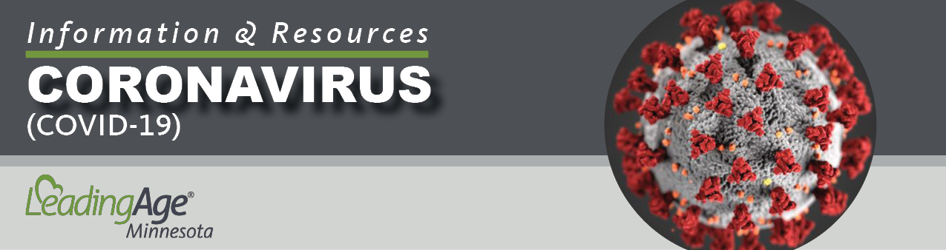

Policy Template:
Interim COVID-19 Visitor and Vendor Restrictions & Screening

Revision Date: May 7, 2020
This resource was developed utilizing information from one or more of the following sources: Centers for Disease Control & Prevention (CDC), Centers for Medicare & Medicaid Services (CMS), and the Minnesota Department of Health (MDH). COVID-19 guidance from these agencies changes frequently, and we remind you to update your policies and procedures, as needed, to incorporate those changes.

NOTICE: This policy template is intended for aging services providers and is for general information purposes only. Each organization and care setting is different, and it is important that you customize the policy to align with your specific operational approach to the issues it covers. This template does not constitute legal advice and does not guarantee compliance with state or federal regulatory requirements. Please direct any questions regarding this document to your organization’s legal counsel.
COVID-19: INFECTION PREVENTION & CONTROL

SUBJECT: Interim COVID-19 Visitor and Vendor Restrictions & Screening

Accountability: All Staff Document No.: COVID-002

Reference: Centers for Medicare & Medicaid Services (CMS) Guidance for Infection Control and Prevention of Coronavirus Disease 2019 (COVID-19) in nursing homes:QSO-20-14-NH-REVISED; CMS Frequently Asked Questions: QSO-20-28-NH; Minnesota Department of Health (MDH) Updated Guidance for MDH-Licensed Providers of Residential Settings with At-Risk Residents COVID-19.

POLICY: To minimize resident and health care worker (HCW) exposure to respiratory pathogens such as COVID-19.

PROCEDURE:

- The facility will restrict visitation of all visitors and non-essential health care personnel, except for certain compassionate care situations, such as an end-of-life situation.

- The facility will notify potential visitors of the visitation restriction through multiple means to inform individuals and nonessential health care personnel of the visitation restrictions, such as through signage at entrances/exits, letters, emails, phone calls, and recorded messages for receiving calls. [Complete this section to align with the steps you are taking in your setting.]

- All visitors and other individuals (see essential personnel) allowed to enter will be restricted to entering the building through one door.

- Vendors delivering supplies will be instructed to drop the supplies at a dedicated location outside the facility and will not be allowed to enter.

- Decisions about visitation during an end-of-life situation will be evaluated on a case-by-case basis, in consultation with the affected resident, the resident’s family, and other health care providers where appropriate. Precautions will be taken to conduct such visits safely, including following practices for hand hygiene and use of PPE. Individuals with symptoms of a respiratory infection (fever, cough, shortness of breath, or sore throat) will not be permitted to enter the facility at any time, even in end-of-life situations.

- Exceptions for Essential Personnel:
  - Health care workers who are essential to providing care for residents, such as EMS personnel, hospice staff, and home health staff, will be allowed to enter the building as long as they complete the visitor screening, wear a facemask or facemask alternative, complete hand hygiene and follow CDC guidelines for healthcare workers.
  - Surveyors are allowed to enter but will be screened like any other visitor. If a surveyor has been in a building with COVID-19 positive case in the previous 14 days but wore appropriate PPE according to CDC guidelines, the surveyor will be considered low–risk according to the CDC and can enter the building. If a surveyor has a fever or respiratory symptoms, the surveyor will not be allowed to enter the building.

- Individuals who are allowed to enter the building will complete the facility’s screening process prior to entering the building.
  - Screening includes:
    - Individuals will complete hand hygiene upon entrance to the community.
    - Individuals will have a temperature taken.
    - Individuals will be screened for current signs and symptoms of cough, shortness of breath, fever or any other signs of illness.
    - Individuals will be asked if they have traveled in the last 14-days.

  - If an individual has a temperature of greater than 100.0 degrees F or signs and symptoms of a respiratory infection the individual will be asked to refrain from visiting.
  - The facility will make an exception to screening for emergency medical services personnel, so they may attend to an emergency without delay.

- Individuals who are allowed to enter the building will:
  - Wear a facemask or facemask alternative while in the building. The facility may require individuals to use additional PPE in appropriate situations.
  - Will be escorted to/from the resident’s room/apartment or facility designated location.
  - Limit their access to the resident’s room/apartment or facility designated location.
  - Be reminded to maintain social distancing / refrain from physical contact with residents and others, and to complete hand hygiene frequently while in the building.

- The facility will advise individuals who enter the facility to monitor for signs and symptoms of respiratory infection for at least 14 days after exiting the facility, and to do the following if symptoms occur - self-isolate at home, contact their healthcare provider, and immediately notify the facility of the date they were in the facility, the individuals they were in contact with, and the locations within the facility they visited. The facility will take appropriate actions if it receives such a notification.

- [User note: consider inserting procedures regarding alternatives to visitation you will offer to the friends and family of those you serve.]

Effective Date:
Reviewed By: Date:
Revised By: Date:

