COVID-19 Facility Risk Assessment

SAMPLE

Acknowledgement

A special Thank-you! to the group of nurses who volunteered their experience, expertise, and knowledge to collaborate on a facility assessment tool that LeadingAge Minnesota can provide to our members.

Introduction

The Centers for Disease Control and Prevention (CDC) released updated Interim Infection Prevention and Control Recommendations for Healthcare Personnel During the Coronavirus Disease 2019 Pandemic. Included in the updates is information recommending a COVID-19 Facility Assessment to determine broader use of source control in nursing home and assisted living settings. The Minnesota Department of Health also recommends the CDC guidelines and provided that information on a LTC COVID-19 Call on May 11, 2023. While there are guidelines, the actual assessment and analysis is up to the discretion of each organization.

This assessment worksheet is a COVID-19 facility assessment sample organizations can choose to use when determining whether broader use of source control is an appropriate infection prevention and control measure.

References:

- CDC’s Core IPC Practices

- Interim Infection Prevention and Control Recommendations for Healthcare Personnel During the Coronavirus Disease 2019 Pandemic.

- The Council for Outbreak Response: Healthcare-Associated Infections and Antimicrobial-Resistant Pathogens

- Cases and Variants Metric MDH

- Hospitalizations & Capacity Metric MDH

When Masks are Still Required

Source control masks and N95 masks are still required in certain circumstances.

Type of Mask | Individual | Circumstances
Source Control | Residents and Staff | Residing or working on a unit or area within the building experiencing a SARS-CoV-2 outbreak or other respiratory infection.  **Source control could be discontinued as a mitigation measure when there are no new cases identified for 14 days
Source Control | Residents | Suspected or confirmed SARS-CoV-2 infection or other respiratory infection
Source Control | Residents, visitors, and Staff | Had close contact (residents/visitors) or high-risk exposure (staff) with someone with SARS-CoV-2 infection for 10 days after their exposure.
Source Control | Staff and Visitors | Facility-wide – or – based on the outcomes of a facility risk assessment
N95 or Higher Level Respirator | Staff | When working with residents who have suspected or confirmed COVID-19 or respiratory illness.

Definition of Outbreak

Residents or Visitors | 1 or more facility-acquired COVID-19 case
Staff | 3 or more suspected, probable, or confirmed COVID-19 cases in staff with epi-linkage AND no other more likely sources of exposure for at least 1 of those staff cases.
** The Council for Outbreak Response: Healthcare-Associated Infections and Antimicrobial-Resistant Pathogens

Facility-acquired COVID-19 infection in a long-term care resident refers to SARS-CoV-2 infections that originated in the nursing home. It does not refer to the following:
• Residents who were known to have SARS-CoV-2 infection on admission to the facility and were placed into appropriate Transmission-Based Precautions to prevent transmission to others in the facility.
• Residents who were placed into Transmission-Based Precautions (quarantine) on admission and developed SARS-CoV-2 infection while in quarantine.

Epi-Linkage Among Residents: is defined as overlap on the same unit or ward, or other patient care location (e.g., radiology suite), or having the potential to have been cared for by common HCP within a 7-day[s] of each other. Determining epi-linkages requires judgment and may include weighing evidence [whether] patients had a common source of exposure.

Epi-linkage among HCP: is defined as having the potential to have been within 6 ft for 15 minutes or longer while working in the facility during the 7 days prior to the onset of symptoms; for example, worked on the same unit during the same shift, and no more likely sources of exposure identified outside the facility.

Determining epi-linkages requires judgment and may include weighing evidence [whether] transmission took place in the facility, accounting for likely sources of exposure outside the facility.

COVID-19 Facility Risk Assessment Review

The COVID-19 facility risk assessment is a sample. Organizations may choose to use it in whole or in part; or, organizations may choose to use a different assessment altogether. While all areas of this assessment are customizable, the areas in red are recommended for special attention. Choose a schedule for completing facility risk assessments. Recommendation: weekly at first and modify based upon new information; or, determine a schedule that fits the community needs.

- Outbreak Determination. Included for easy reference is the current outbreak definition.

REASON FOR INCLUSION: Masks are required either building-wide or on specific areas/units when there is an outbreak in an organization or when caring for residents who are symptomatic.

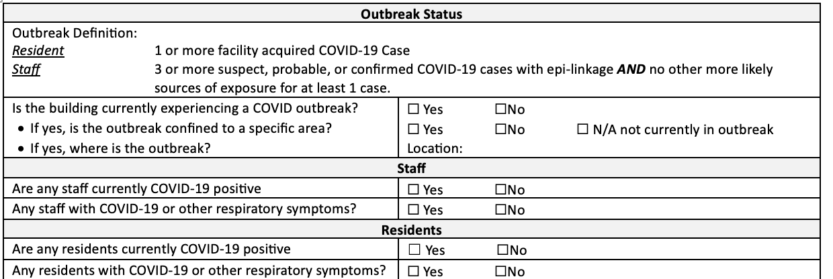

- Resident Characteristics. A baseline statement is included describing the residents who typically live in our settings. This is a baseline. From here review additional at risk residents or resident populations.

REASON FOR INCLUSION: Some residents are at increased risk due to certain specific characteristics. Identification of these characteristics in the organization informs whether a targeted source control mask strategy is needed.

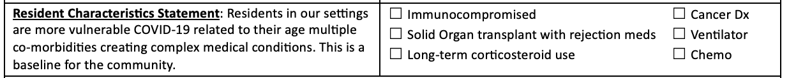

- Coordinated Approach. Each organization is unique in their ability to coordinate with other facilities in their areas. Some are located near or attached to hospitals or other facilities while others are not. A coordinated approach can be used or the team could determine this isn’t feasible for them and remove this section.

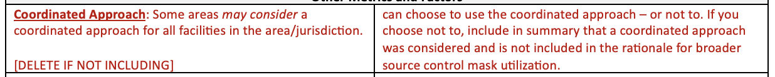

- Stakeholder Input. Seeking input from residents, families, and staff is an important part of the facility assessment. It is also difficult to do frequently. This section is the area where stakeholder input is documented along with the last review date. Recommendation: solicit stakeholder input annually or as often as is appropriate for the individual nursing home or assisted living.

REASON FOR INCLUSION: Reviewing plans with stakeholders can help determine practices that will be more broadly supported.

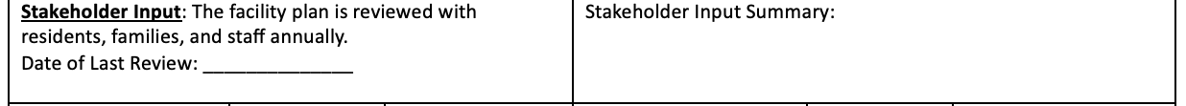

- Metrics / Measurements. The CDC and MDH provide several metrics for consideration and recommend each organization review the options and choose what staff will use within the COVID-19 facility assessment. Selected metrics include Cases and Variants and Hospitalization and Capacity. Either or both could be used; or, the organization could choose to use something different. It is important to document why the metric is included in the facility assessment.

REASON FOR INCLUSION – CASES & VARIANTS: One of the strongest indicators of increasing cases in our settings was community incidence. Therefore, Cases and Variants tracked and reported by MDH is included in the facility assessment.

REASON FOR INCLUSION – HOSPITALIZATION: There is evidence that hospitalization rates could be a pre-indicator for increased cases of COVID-19 in our settings and was therefore included in the facility assessment.

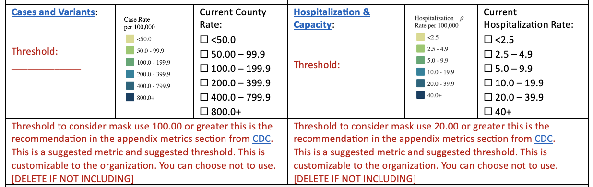

- Determination. This area is the space to determine if broader use of source control is needed or not along with any other infection control practices that may be. Make sure that not only is the box checked for broader use or IPC practices, but there is also an explanation of the plan.
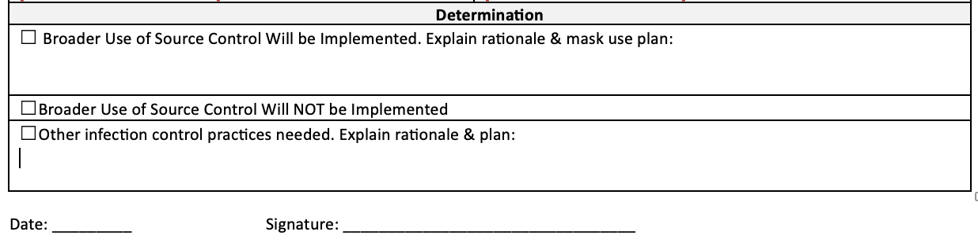

FACILITY COVID-19 ASSESSMENT WORKSHEET
Evaluation for Expanded Use of Source Control

Outbreak Status
Outbreak Definition:
Resident | 1 or more facility acquired COVID-19 Case
Staff | 3 or more suspect, probable, or confirmed COVID-19 cases with epi-linkage AND no other more likely sources of exposure for at least 1 case.
Is the building currently experiencing a COVID outbreak? |  |  |  | ☐ Yes ☐No
- If yes, is the outbreak confined to a specific area? |  |  |  | ☐ Yes ☐No ☐ N/A not currently in outbreak
- If yes, where is the outbreak? |  |  |  | Location:
Staff
Are any staff currently COVID-19 positive |  |  |  | ☐ Yes ☐No
Any staff with COVID-19 or other respiratory symptoms? |  |  |  | ☐ Yes ☐No
Residents
Are any residents currently COVID-19 positive |  |  |  | ☐ Yes ☐No
Any residents with COVID-19 or other respiratory symptoms? |  |  |  | ☐ Yes ☐No
Resident Characteristics Statement: Residents in our settings are more vulnerable COVID-19 related to their age multiple co-morbidities creating complex medical conditions. This is a baseline for the community. |  |  |  | ☐ Immunocompromised  ☐ Solid Organ transplant with rejection meds  ☐ Long-term corticosteroid use |  |  | ☐ Cancer Dx  ☐ Ventilator  ☐ Chemo
Other Metrics and Factors
Coordinated Approach: Some areas may consider a coordinated approach for all facilities in the area/jurisdiction.  [DELETE IF NOT INCLUDING] |  |  |  | can choose to use the coordinated approach – or not to. If you choose not to, include in summary that a coordinated approach was considered and is not included in the rationale for broader source control mask utilization.
Stakeholder Input: The facility plan is reviewed with residents, families, and staff annually.  Date of Last Review: ______________ |  |  |  | Stakeholder Input Summary:
Cases and Variants:  Threshold: _____________ |  | 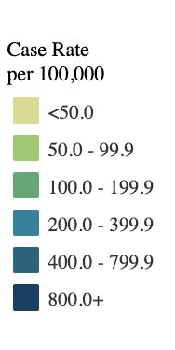 | Current County Rate:  ☐ <50.0  ☐ 50.00 – 99.9  ☐ 100.0 – 199.9  ☐ 200.0 – 399.9  ☐ 400.0 – 799.9  ☐ 800.0+ | Hospitalization & Capacity:  Threshold:  _____________ | 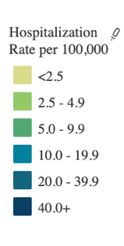 | Current Hospitalization Rate:  ☐ <2.5  ☐ 2.5 – 4.9  ☐ 5.0 – 9.9  ☐ 10.0 – 19.9  ☐ 20.0 – 39.9  ☐ 40+
Threshold to consider mask use 100.00 or greater this is the recommendation in the appendix metrics section from CDC.  This is a suggested metric and suggested threshold. This is customizable to the organization. You can choose not to use.  [DELETE IF NOT INCLUDING] |  |  |  | Threshold to consider mask use 20.00 or greater this is the recommendation in the appendix metrics section from CDC.  This is a suggested metric and suggested threshold. This is customizable to the organization. You can choose not to use.  [DELETE IF NOT INCLUDING]
Determination
☐ Broader Use of Source Control Will be Implemented. Explain rationale & mask use plan:

☐Broader Use of Source Control Will NOT be Implemented
☐Other infection control practices needed. Explain rationale & plan:

Date: _________ Signature: _________________________________

