I. Purpose of This Report

This document summarizes the status of long-term care for older persons in Minnesota through calendar year 2009, and was developed in response to a legislative mandate (M.S. 144A.351) to biennially update the legislature on the effects of legislative initiatives to “rebalance” the state’s long-term care system.

This report describes the changes in the state’s system that have resulted from a comprehensive set of historic long-term care reform provisions prepared by the state’s long-term care task force and enacted by the Minnesota Legislature in 2001. Since that time additional provisions to reduce reliance on the institutional model and to expand the availability of home and community-based options for older persons have been enacted. Demographic and market changes, as well as significant shifts in the state and national economic climate, have further affected Minnesota’s long-term care system. This report provides an update on the current status of the state’s long-term care system for older Minnesotans.

As required by statute, this report includes demographic trends; estimates of the need for long-term care among older persons in the state; and the status of home and community-based services, senior housing and nursing homes serving older persons. Also discussed are the activities and roles of the Minnesota Department of Health in regulation and quality assurance, significant changes made during the 2009 Legislative session, some of the initial impacts of state and national health care reform, and other issues that will affect long-term care in the future. The report concludes with four long-term care benchmarks that measure the progress made on key elements of long-term care reform in Minnesota and a brief summary of recent policy shifts and resource challenges.

The Minnesota Department of Health contributed data and other information necessary for the completion of this report. Counties and Area Agencies on Aging/Eldercare Development Partnerships also contributed data and comments on the changes that have occurred in the availability of services over the past two years. The cost to prepare this report was approximately $15,000.

II. Demographic Trends and Need for Long-Term Care

Earlier reports to the Legislature on Minnesota’s system for providing long-term care for older Minnesotans (2001, 2004, 2006 and 2008) have charted the demographic trends that are expected to have a profound impact on the need and demand for long-term care in Minnesota. This section summarizes those trends and reflects Minnesota’s experience over the past two years in interpreting the impact of these forecasts.

- Demographic Changes

The demographic trends section of this report has altered very little since the original 2001 report: Minnesota still ranks just about in the middle of states in its proportion of elderly. The U.S. average is 12.6 % persons age 65 and older, Minnesota is at 12.2. Across the U.S., in-migration of retirees to warmer climates, and out-migration from the northernmost tier of states has resulted in relatively slow growth of Minnesota’s older population over the past 3 decades. The current slow growth in numbers of elderly is also partly attributable to the lower birth rates during the Great Depression, when today’s oldest persons were born.

However, beginning in 2011 the first wave of boomers, born between 1946 and 1964, begins to turn 65. For the next 30 years the boomer cohort will dominate Minnesota’s population growth. Between 2010 and 2020, the population 65+ will increase by 40 %, while the under-65 population is forecast to increase by about 4 %. Between 2020 and 2030, the comparable figures are 36 % in the older group and less than one percent for the younger group.

Minnesota now ranks second among the states in terms of life expectancy at birth: 78.82 years (behind Hawaii at 80.0). Longer life expectancy in Minnesota, coupled with a small net in-migration of persons age 85+ returning to Minnesota after living their younger retirement years in another state, contribute to gradually increasing numbers and proportion of the “oldest old.” Between 2030 and 2050, the number of persons aged 85 and older is projected to double—to 250,000 persons.
Source: Office of MN State Demographer
By 2060 the overall numbers of older persons are projected to decline slightly because nearly all the baby boom generation will have died and the next generation will not be as large. Nonetheless, an older society will be a permanent fixture of the state’s demographic profile into the foreseeable future.

- Need for Long-Term Care

The need for long-term care in Minnesota is tied to both the demographic projections and disability rates. Today’s elderly are, in general, healthier than their age peers just a generation ago. Age-specific disability rates in the United States have been decreasing at about 3 % per decade for the past several decades, partly due to improved public health and nutrition during this cohort’s childhood (1920s and 30s), and partly due to advances in medical care, e.g., hip or knee replacements, and prescription drugs that reduce pain and allow more people to function independently. However, as noted above, the number of very old (and most likely at risk) is projected to continue to increase slowly through 2020, and then quite rapidly for the next two decades. Since the 1950s disability rates by age have generally declined.

Nonetheless, persons aged 85 and older have significantly higher prevalence of chronic illness and rates of disability, and although Minnesota’s disability rates are below the national average the overall need for long-term care will increase because functional disability increases with advancing age—despite the previously mentioned slowdown in the rate at which this occurs. Over two-thirds of persons age 85 and older have at least one disability, and older persons are more likely to have multiple disabilities, that is to say several chronic conditions, each of which poses a challenge to the individual’s ability to function independently.

Whether the gradual reduction in disability rates among elderly will continue into the future is unknown. For example, reduced rates of cigarette smoking may positively affect future health status, but the rising rates of obesity and adult-onset
Source: CDC, 2007
diabetes could easily offset this positive trend.

C. Implications for LTC Labor Force

In the most recent surveys in Minnesota, over 90% of long-term care is provided by children, spouses and other non-paid relatives and friends. The next generations of older Minnesotans have significantly fewer children than previous cohorts—1.9 children per couple today compared to 3.2 children per couple in the 1950s. In addition, the proportion of older persons who are expected to be living alone (whether due to death of a spouse, divorce, or never having been married) is also projected to increase significantly for the boomer generation. These trends toward smaller families and smaller households will inevitably result in less family and unpaid support, and unknown increase in demand for paid help.

Simultaneously, the state demographer forecasts a significant reduction in the state’s labor force growth: an older workforce (with expectations for employee-sponsored health care), and increasing competition for scarce younger employees. The long-term care industry depends on low-wage workers, and because of high turnover in many long-term care positions, the industry is also dependent on new workers coming on line.

Net Labor Force Growth in MN by Decade

Notwithstanding the likelihood of some in-migration from other states and other countries, the number of “new workers” in Minnesota in the decade from 2010 to 2020 is forecast to be about a third of that seen in the current decade. In a word, the projected labor force supply for long-term care is likely to be inadequate without significant changes in labor deployment, recruiting and maintenance.
Source: Office of MN State Demographer

As the chart above shows, the labor force growth in Minnesota will decrease by two-thirds in the upcoming decade. Competition for new workers will put new demands on Minnesota’s long-term care industry already coping with low wages.

In light of the continued trends, including the growth in demand for long-term care services and the aging of the general and workforce populations, the expansion and development of the direct care workforce is at risk of not keeping pace with the need for additional staff in the field of long-term care, including home and community-based services.

According to the federal Bureau of Labor Statistics (BLS), more than 1 million new and replacement nurses will be needed nationally by 2018. In addition, according to a 2007 study conducted by the PriceWaterhouseCooper Health Research Institute, the turnover rate of new nurses entering the profession is 27.1 %. The long-term care industry, which is heavily financed through public monies provided by the Medicaid and Medicare programs, also employs very large numbers of direct care paraprofessional or allied health staff. These positions typically require less formal education and are characterized by lower wage and benefit structures and low retention rates.
Bureau of Labor Statistics (BLS)
U.S. Labor Data Projections 2008-2018*
Occupation | Actual Employment 2008 | Projected Employment 2018 | % Change | Rank (by Number of New Jobs Projected)
Home Health Aides | 922 | 1,383 | +50.0% | 3
Nurse Aides & Orderly/Attendant | 2,454 | 3,194 | +30.2 | 2
RN | 2,619 | 3,200 | +22.2 | 1
LPN/LVN | 754 | 909 | +20.6 | 4
*thousands of jobs

Workforce growth and demand, as well as turnover, for paraprofessional staff positions such as Certified Nursing Assistants or Aides (CNAs), Home Health Aides (HHAs), Personal Care Attendants (PCAs), and associated fields remains very high despite the recent economic downturn. According to BLS projections, growth in nursing as well as the paraprofessional fields will remain high for the foreseeable future. In addition, passage of recent federal health care reform is anticipated to improve access to health coverage, likely increasing the demand for health care workers - especially direct care workers, who provide the majority of care for those with chronic care needs.

Part of the problem of meeting the increased demand for a larger long-term care workforce is that needs change more rapidly than training can be provided. Some of this increase in demand may be alleviated by initiatives such as telemedicine and healthcare information technology (HIT), both of which have the potential to reduce some of the demand for direct care staff. However, the availability of an educated direct care workforce remains a key component of quality care at all levels of the long-term care spectrum.

The Department of Human Services administers several programs which are designed to help address the recruitment, retention, development and training needs of the direct care workforce.
The first, the Nursing Facility Employee Scholarship Program, was implemented in 2001. This program provides funding to participating nursing facilities in the form of a cost-based rate, for use as scholarship funding for eligible employees - those who work an average of 20 hours or more per week (excluding Registered Nurses (RNs) and most management staff). These scholarship funds are specifically dedicated for education in the field of long-term care or training leading to career advancement within their employing facility.

For the 2009 reporting year, approximately 245 nursing facilities out of 381 statewide, participated in this program. This reflects a decrease in the number of particpating facilities, from a high of 263 participating facilities in 2007. In the past three report years for which information is available (2006-2008), this program has provided $ 9,998,946 in scholarship funds to approximately 5,955 individuals employed by nursing facilities in the State.

Age of NF Employee Scholarship Program Recipients
(2005-2008)
Age Range (years) | Percent of Total Recipients
< or equal to 18 years | 2.21
19-25 | 31.82
26-30 | 17.22
31-40 | 23.70
41-50 | 17.23
51-60 | 5.78
61 and over | 2.04

The majority of the scholarships awarded under the Nursing Facility Employee Scholarship Program were granted to female employees (85 %) with the largest age group (32 %) in the 19-25 age range. This data is consistent with the demographics of our current population of direct care workers as a whole, where females comprise a much larger share of the working population.

The majority of the scholarship funding was dispersed to employees seeking an education as a Licensed Practical Nurse (LPN) or RN, or for education and advancement within their employing facility. Smaller numbers of scholarship recipients were receiving funds for training in English as a Second Language (ESL), Social Work, CPR, or to become a Trained Medication Aide (TMA), dietary or activity aide or health unit coordinator.

The second program, patterned in a similar fashion to the Nursing Facility Employee Scholarship Program, is the Home and Community-Based Services (HCBS) Employee

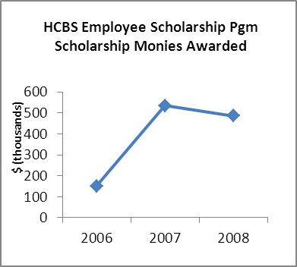

Scholarship Program which was implemented in 2006. This program provides similar, but more limited funding, to qualifying HCBS providers. These monies also are dedicated for scholarships to qualifying employees for education in the field of long-term care or for training that provides career advancement within their employing organization. In the past three report years for which information is available (2006-2008), the HCBS Employee Scholarship Program has provided $1,171,898 in scholarship funds to approximately 1,426 individuals employed by home and community-based providers.

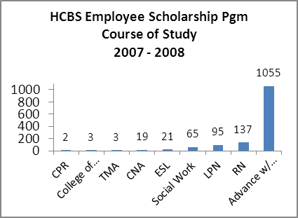

The majority of the scholarships awarded under the Home and Community-Based Employee Scholarship Program were granted to female employees. From 2007-2008, the largest age group awarded scholarships was between ages 19-25 years old, representing 61.9 % of scholarships awarded.
Age of HCBS Employee Scholarship Program Recipients
(2007-2008)
Age Range (years) | Percent of Total Recipients
< or equal to 18 years | <1
19-25 | 31.00
26-30 | 20.14
31-40 | 20.93
41-50 | 14.00
51-60 | 10.57
61 and over | 2.93
In addition to the scholarship programs, the Department and the State as a whole is committed to providing other supports for persons employed or seeking employment in the direct care worker field. Transform 2010 has studied the feasibility of providing health insurance coverage for long-term care workers. Some experts believe that lack of access to health insurance coverage is a barrier to long-term care direct care worker retention. Other direct care worker support programs exist within DHS and MDH: a clearinghouse for direct care worker information, free training, and most notably the MDH loan forgiveness program for students studying to become LPNs or RNs. Support and loan forgiveness programs also exist at the federal level. In 2007 DHS held the first statewide nursing facility diversity conference to examine issues related to diverse staffing. DHS has since published a nursing facility diversity guide. Despite these state and federal efforts the recruitment, retention and education of the long-term direct care workforce remains a critical issue–and will remain so for the foreseeable future.

III. Home and Community-Based Services

Older people in Minnesota want to preserve their dignity and their autonomy. Surveys consistently report that the vast majority want to live out their old age in their own homes and in their own communities. In the 2005 Survey of Older Minnesotans, one of the greatest expressed concerns of respondents was that they might one day have to “depend on others.”

- Family and “Informal” Care

Family members—mostly spouses and daughters and daughters-in-law—continue to provide the vast majority of help to older persons in Minnesota who need assistance with Activities of Daily Living (ADLs), although there have been some significant changes in the patterns of family help over the three decades.

As the table at the right shows, the primary sources of personal assistance–for those who need daily assistance with basic activities—has traditionally been a family member (spouse and /or child) or a friend or other relative. Over the past 10 years there has been a significant increase in the purchase of “hired help” -- whether hired by the older person or their family member -- to supplement the family’s ability to meet care needs. At the same time, there has been a decrease in the role of children (primarily daughters and daughters-in-law). For example, in 1995 over 50 % of persons depended primarily on their children, but that proportion had decreased to 35 % by 2005.
Source: Survey of Older Minnesotans, 2005

The role of “friends and neighbors” in providing long-term care supports continues to be an area of interest to the state in anticipating future long-term care policies and programs. Church-sponsored and volunteer-based programs provide a basic level of support for many older persons across the state. Home delivered meals programs, transportation, chore services and caregiver respite/support are particular service areas where non-paid personnel are a major component of the prevalent service models. While there is no comprehensive inventory of such community- and faith-based programs, it is estimated that there are now between 500 and 700 such groups, operating in virtually all of Minnesota’s 87 counties.

It is anticipated that the next cohort to become aged, the boomers, will demand more choice, expect more paid help, and more control over their long-term care, especially because they are the first real “service consumer” generation—subject, of course, to their own individual buying power and their relative clout in the political arena. The beginnings of this trend are already evident in the changing market for long-term care services and supports.
The growth of the “senior market” is reflected in private sector home care. The proportion of older persons (and their caregivers) who pay someone to help them with chores and other household help increased from about 4 % in 1988 to 27 % in 2005—partly to meet long-term care needs and partly attributable to lifestyle changes in this “new” elderly cohort. This “hired help” is distinguished from more formal “agency-based” home health care and is most likely persons in the community who are recruited and paid on an ad-hoc basis. There is new national awareness of this phenomenon as an emerging “gray market” in long-term care that is occurring across the United States. This
Source: Survey of Older Minnesotans, 2005
emerging model blurs the distinction between “family and friend” sources, often called informal help and the “paid professional” sources, often called formal help.

- Local/Community Long-Term Care Capacity

As noted above, the majority of long-term care is provided by family, and a smaller but growing portion is purchased from non-agency sources. However, when an older person’s family can no longer handle their relative’s needs (or there is no family to depend on), professional or paraprofessional and “agency” assistance is frequently sought. These more formal service providers are sanctioned by the state and are the providers of choice to fulfill most of the obligations of public long-term care interventions.

The table below shows the numbers of different types of providers licensed and registered in Minnesota in 2010. As the market changes, so do the number of providers in any one of these categories. Between 2007 and 2010, most categories of providers experienced only slight increases or decreases in number except for Housing with Services Registrations which decreased significantly from 1,164 registrations in 2007 to 660 registrations in 2010.

Source: Minnesota Department of Health, 2010

Service Capacity
How many service providers are needed? How well are different parts of the state served? Are there “gaps” in available services in some parts of the state? Since 2001 all counties in Minnesota have been asked every two years to prepare an analysis of the local capacity to meet long-term care needs of current residents, including any significant “gaps” in services or supports. All 87 counties participated in the 2009 Gaps Analysis survey.

The following table summarizes the top ranking service gaps across the years since 2003. In this report “service gaps” are defined as services that are rated as (a) inadequate to meet local need, (b) unavailable in the local area, or (c) available with limitations as to adequacy or quality.
Note that Transportation (both Non- Medical and Medical), Chore Service, Companion Service, Respite Services (both In- Home and Out of Home), Adult Day Care and Caregiver Training & Support continue to be top aging service gap areas across the years.

Most Frequently Cited Gaps in LTC Service Capacity
2003 |  |  | 2005 |  |  | 2007 |  |  | 2009
72 counties responding |  |  | 76 counties responding |  |  | 79 counties responding |  |  | 87 counties responding
Type of service | Rank | % of counties | Type of Service | Rank | % of counties | Type of Service | Rank | % of counties | Type of Service | Rank | % of counties
Transportation | 1 | 42% | Transportation | 1 | 55% | Transportation | 1 (tie) | 63% | Non-Medical Transportation*** | 1 | 66%
Chore Service | 2 | 28% | Evening and Weekend Care** | 2 | 50% | Companion Service | 1 (tie) | 63% | Chore Service | 2 (tie) | 60%
In-Home Respite/ Caregiver Supports* | 3 | 22% | Chore Service | 3 (tie) | 47% | Chore Service | 3 | 62% | Companion Service | 2 (tie) | 60%
Adult Day Service | 4 (tie) | 21% | Adult Day Service | 3 (tie) | 47% | Respite Care- In Home | 4 | 51% | Respite Care- Out of Home | 4 | 58%
Home Delivered Meals | 4 (tie) | 21% | In-Home Respite/ Caregiver Supports* | 5 | 42% | Respite Care- Out of Home | 5 | 47% | Medical Transportation *** | 5 | 56%
 |  |  |  |  |  | Caregiver/ Family Support Training | 6 | 46% | Respite Care, In Home | 6 | 55%
 |  |  |  |  |  | Adult Day Care | 7 | 44% | Adult Day Care | 7 | 51%
 |  |  |  |  |  |  |  |  | Caregiver Training & Support | 8 | 44%
* Surveys conducted 2001-2005 included “In-Home Respite/Caregiver Supports” as a service category. This service area was expanded into 3 categories for 2007 and 2009: Caregiver/Family Support Training and In-Home Respite Services. Out-of-Home Respite Services was also added as a new service category.
** Evening and Week-end Care was not included as a service item in the 2007 and 2009 surveys.
*** In 2009 Transportation was separated into Medical and Non- Medical Transportation

The proportion of counties reporting gaps has remained constant since 2007 for Chore Service, Companion Service, In-Home Respite Care and Caregiver Training & Support. The percent of counties report gaps have increased since 2007 for Out of Home Respite Care (58% vs. 47%) and Adult Day Care (51% vs. 44%). Beginning with the 2009 survey, Transportation was separated into two categories: Medical Transportation and Non-Medical Transportation. Although it is difficult to compare changes in transportation given the two new categories it is important to note that the Non-Medical Transportation gap rate (66%) is slightly higher and the Medical Transportation gap rate is lower (56%) than the rate for 2007 (68%). As discussed below, the proportion of counties that have reported decreases in the supply of both Medical and Non-Medical Transportation indicate that this is an increasing gap.

Cultural Competency
As Minnesota’s population continues to become more and more culturally diverse, it is important to assess the capacity of the State’s long-term care system to provide services to older Minnesotans from diverse cultural communities. The 2009 Gaps Analysis survey asked some new questions about how prepared counties believe their provider network is to work with a few different types of cultural communities. As summarized in the chart below, only a small percent of counties believe that their providers are “very prepared” to deliver care that is culturally competent to racial and ethnic minority communities (14%), new American, immigrant and refugee communities (6%) and gay, lesbian, bisexual and transgender (GLBT) communities (12%). Most notably, 21% of counties report their provider network is “not at all prepared” to deliver care that is culturally competent to new American, immigrant and refugee communities. These results indicate that additional supports are needed in order to help prepare the long-term care provider network to provide culturally competent services to these various communities.

Capacity to Serve Culturally Diverse Communities
Community | Very Prepared | Somewhat Prepared | Not at All Prepared
Racial/ethnic minority communities | 14% | 80% | 6%
New American/ immigrant/ refugee communities | 6% | 73% | 21%
Gay, lesbian, bisexual and transgender communities | 12% | 80% | 8%

Changes in Service Availability

The 2009 Gaps Survey includes information on any increases or decreases in service availability over the prior two years. (See table on following page.) Most counties (92%) report that at least one home and community-based service became more available between 2007 and 2009. Interestingly the most common services that have increased in availability are not necessarily ones that were reported as top gaps in prior years. This may indicate that a lot of service development has happened in these areas in response to an increase in awareness of and/or demand for the service. In other cases, service development was driven by policy change, as with Minnesota’s new Medicaid waiver to promote consumer directed service models. Fiscal Support Entities function as the financial intermediary to allow persons in public programs to hire and manage their own staff.
Most Common
Services Reported as More Available 2007-2009
Type of Service | % of Counties  Expanding | Rank  as Gap in 2007
Health Promotion Activities | 60% | N/A¹⁴
Home Delivered Meals | 54% | 15
Fiscal Support Entities | 36% | 16
Personal Care Assistance | 35% | N/A
Homemaker Service | 30% | 13
Caregiver Training & Support | 27% | 7
Home Health Aide | 23% | 19
End-of-life, Hospice, Palliative Care | 21% | 17

Nearly four out of five (78%) counties reported a decrease in one or more services between 2007 and 2009. This is a marked increase from 2007 when only 46% of counties reported a decrease in one or more services between 2005 and 2007. No type of service had more than 19% of counties reporting a decrease. This is a marked difference from 2007 when the highest proportion of counties reporting a decrease in any service area was only 9%. These results indicate that while counties are experiencing expansions across many services, they are also experiencing decreases in services that they have not experienced in the past. The most common decreases were for the services that are also many of the top gaps for 2009: Medical Transportation (19%), Chore Service (19%), Companion Service (18%), Non-Medical Transportation (17%) and Adult Day Care (16%). Transportation has been particularly affected; only one county (1%) reported that Transportation was less available in the 2007 Gaps Analysis survey.

Nursing Home Specialty Beds/Services
Section V of this report focuses on the nursing home capacity in Minnesota, and most of this Report’s information about facility-based care is included in that Section. However, counties were asked to report their perceptions of localized need for “specialty” services to meet unique long-term care needs in their service area. The largest gap reported was in the availability of dementia care specialty beds, where 56% of counties reported a gap. About half of counties (48%) reported a gap in heavy care, complex medical management beds. Nearly all counties reported sufficient capacity in post-acute/rehabilitation beds with only 7% reporting a gap in this area.

- Targeted Strategies to Increase Home and Community-Based Service Capacity

Community Service/Community Services Development (CS/SD) grants promote targeted development to meet the challenges identified by the “Transform 2010 Blueprint” and the forecasted pressures on Minnesota’s long-term care system as Minnesota experiences the permanent shift in the age of our state’s population. Since its inception in 2001, CS/SD grants have helped to rebalance Minnesota’s long-term care service delivery system and increase its capacity to assist older Minnesotans age 65+ to stay in their own homes and communities. Characteristics of this capacity include, but are not limited to, improved chronic disease management in Minnesota’s communities, support for caregivers and promotion of independence through market-based solutions.

To date, about $47 million in grant funds have been awarded to 301 CS/SD projects across Minnesota. These projects have served more than 237,000 people, using more than 58,000 volunteers to provide services. The following table provides a summary of the types of projects funded in the two most recent years of the grants, and the numbers of people who have been supported in community settings through these projects. Minnesota has a highly regarded record in volunteerism and civic life. By tapping into this resource, CS/SD grantees are able to significantly expand their capacity to provide services.

Community Service/Community Services Development (CS/SD) Projects Funded
State Fiscal Years 2009 through 2010*
Service Category | Number of Projects | Total People Served | People Served Age 65 and Over | Number of Volunteers Used to Provide Service
Transportation: Transportation to medical appointments, shopping, or other activities necessary to maintain independent living. Grantee may be using volunteers to provide transportation or implementing another means for more efficient operation. | 8 | 778 | 589 | 702
Home Delivery: Delivery of groceries, prescriptions, and other needed goods to individuals in their own homes. | 6 | 1,853 | 1,616 | 523
Caregiver Support: Training, education, counseling, and respite services for informal caregivers who provide direct and ongoing care to a family member or friend. | 17 | 12,402 | 8,478 | 1,119
Care Coordination/ Service Management: Identifying individuals who are at high risk of hospitalization or placement in a long-term care facility due to effects of one or more chronic diseases, dementia or other disability. Providing individual assistance to clarify service needs, determine available resources, make referrals, coordinate services (especially across health care and community supports), assist with forms completion, and/or provide ongoing support in a community setting. | 17 | 8,092 | 6,791 | 431
Chore: Providing assistance to persons having difficulty with heavy housework. Examples include yard work, shoveling snow, washing floors or windows. | 13 | 1,737 | 1,693 | 4,900
Homemaker: Providing assistance to persons who are unable to manage their home. Examples include meal preparation, routine housekeeping, assistance arranging transportation, answering or making telephone calls, managing money, shopping for food or other personal items, monitoring the safety and well being of the older person. | 8 | 799 | 735 | 110
Companion: Providing regular visits to isolated, homebound elders to reduce their isolation and loneliness. | 6 | 655 | 554 | 482
Home Modification/ Repair: Improving or maintaining the independent living environment of an older person. It includes modifications to accommodate mobility impairments. | 5 | 109 | 98 | 106
Health Promotion and Chronic Disease Self-Management: Supporting the efforts of older adults to reduce their risk factors for chronic disease and/or falls. Providing opportunities for older adults to maintain and/or improve their health (and thereby reduce future disability risk) and learn self-management skills to maintain maximum functioning and quality of life by engaging in evidence-based interventions. | 5 | 1,386 | 1,314 | 82
Direct Services: Licensed and/or trained professionals and paraprofessionals providing a direct service to individuals, such as nursing care, direct mental health service, Physical Therapy, Occupational Therapy, professional health screenings or assessments, etc. | 13 | 1,624 | 1,159 | 127
Capital/Renovation Projects: Affordable housing units suitable for provision of home care services to persons age 65 and older, or alteration of physical space to accommodate provision of services provided in a center licensed by the State as an Adult Day Care Center. | 12**  (Totaling 157 Housing Units) | 51 | 48 | 84
Unduplicated Count Across Service Categories | 63 | 29,619 | 23,183 | -

*Data provided through 6/30/10.
**No Capital/Renovation projects were funded in FY10. FY09 Capital/Renovation Grantees complete construction during the grant period and begin serving individuals after the construction is complete.

Mandated by the 2008 Minnesota Legislature, the Community Consortium grant program supports two community projects that demonstrate models for increasing access to home and community-based services for people age 65 and older. Each community project must:
- Ensure community access to a continuum of older adult services
- Create an adequate supply of affordable home-based alternatives to care for persons currently using a nursing facility or likely to need nursing facility services
- Establish and achieve measurable performance targets for care delivered through the continuum
- Support the management of chronic and complex conditions through greater coordination.
The two projects received three years of funding beginning April 2010. The projects involve local health care systems, clinics, hospitals and social service providers in order to deliver better care, better care transitions and more effectively delivered home and community-based services to support older adults in their homes.

Currently, a federal Community Living Program grant from the Administration on Aging to the Department of Human Services is being used to develop and disseminate the Live Well at Home model to (1) detect persons at highest risk for nursing home placement, and (2) refer them (and their caregivers) to flexible customized support options. The goal of this demonstration grant is to divert at-risk, private pay older adults and family caregivers from higher-cost, residence-based care and to provide them with lower-cost and evidence-based service/support options. Families, using their own resources to pay for these supports, can prolong the amount of time that older persons can stay in their own homes and delay spend-down to public program eligibility.
ElderCare Development Partnerships
The state’s Eldercare Development Partnerships (EDPs) program provides targeted technical assistance to counties, local communities and service providers to maximize the efficiency and effectiveness of local long-term support services and resources across the state and to increase the supply of affordable home and community-based services. EDPs are instrumental in supporting Minnesota’s efforts to rebalance its long-term support system by expanding locally sustainable home and community-based service options for all older Minnesotans and their families. Through collaboration and technical assistance, new services are created and existing services are redesigned to improve quality and sustainability. EDPs focus on the following areas:
- Develop and implement service delivery models in line with long-term care (LTC) systems rebalancing priorities;
- Expand sustainable home and community-based services capacity, maximizing efficiency, quality and consumer choice;
- Promote evidence-based service models and appropriate application of new technologies that improve service and administrative quality and efficiency, or reduce the need for LTC personnel.

Area Agencies on Aging
The state is divided into 7 planning and service areas for the purpose of administering Older Americans Act programs in Minnesota, with some state support for several key programs. Area Agencies on Aging (AAAs) are key partners in the success of the CS/SD grants as are the EDP initiatives described above. In addition, the AAAs administer the state’s Senior LinkAge Line® (as well as the Disability Linkage Line® and the Veterans’ Linkage Line®) and the web-based consumer information tool. This system and its impact is described in greater detail in Section VIII.

The AAAs also administer the statewide senior nutrition program that provides 3 million nutritionally balanced meals each year for 71,000 older adults through 550 sites located in community centers, senior housing, civic buildings and other locations across Minnesota. The senior nutrition program (senior dining and home-delivered meals) is targeted to frail, older adults at the greatest risk of losing their independence. Approximately 183 sites statewide (one in every three) are located in senior housing buildings. Most senior dining sites provide home-delivered meals.

- Publicly Funded Entitlement (and Low-Income) Programs

As the preference of older people for home and community-based services (HCBS) has grown, so too has the utilization of home and community-based services within publicly funded programs. In Minnesota, publicly funded HCBS is available through three separate programs:

- Elderly Waiver (EW) for very low income persons who are assessed as at risk for nursing homes. (.i.e., they meet the income and asset eligibility criteria for Medicaid and the functional criteria for institutional care). The intent of the EW program is to provide the necessary supports to keep these persons in their own homes or apartments, and to prevent or delay institutionalization. The EW “service package” includes an array of home- and community services and may be provided in one of three ways: (1) via a Managed Care arrangement through a health plan, (2) via a Fee For Services (FFS) arrangement through their county, or (3) through Tribal management of the Elderly Waiver.

- Alternative Care (AC), the state-funded program for very low income persons who are just above Medicaid eligibility and who are assessed to be at risk for nursing homes. The intent of the AC program is to provide the necessary supports to assist these persons by supplementing their own resources to keep them in their own homes or apartments, and to prevent or delay institutionalization. The AC “service package” includes an array of in-home services and is delivered via a Fee For Services (FFS) arrangement through their county or a tribal arrangement.

- Medical Assistance (MA) Home Care, which covers the services provided to Medicaid enrolled persons who are not assessed to be at risk for nursing home care.

In the past seven years (2001 – 2009), the overall number of persons 65+ served through the EW, AC and MA home care programs has grown from 23,000 to more than 34,000, a 46 % increase. During that same time period, the expenditures for HCBS have grown from $130 million to $346 million, a 166 % increase. In the past 2 years alone (2007 – 2009) HCBS expenditures have grown from $287 million to $346 million, a 21 % increase in just two years. It is important to note that while these figures have increased for the EW, AC and MA Home Care programs, the number of older persons served and dollars expended for nursing home care for the same target population have declined, as described in more detail in Section V.

The following table shows the changes from 2001 through 2009 in the number of clients and the total expenditures for each of these three programs.
Total Annual Utilization and Expenditures for Publicly Funded HCBS
for Persons 65+ in Minnesota, 2001 – 2009
SF Year | Alternative Care |  | Elderly Waiver |  | MA Home Care |  | Total HCBS
 | Clients | Cost | Clients | Cost | Clients | Cost | Clients* | Cost
2001 | 11,787 | $56,346,000 | 10,978 | $69,112,000 | 695 | $4,057,000 | 23,460 | $129,515,000
2002 | 12,233 | $66,969,000 | 12,050 | $84,024,000 | 1,847 | $5,471,000 | 26,130 | $156,464,000
2003 | 11,709 | $76,445,000 | 13,561 | $104,267,000 | 4,129 | $14,483,000 | 29,399 | $195,195,000
2004 | 9,106 | $59,294,000 | 16,249 | $133,378,000 | 3,633 | $13,982,000 | 28,988 | $206,653,000
2005 | 7,557 | $55,807,000 | 17,124 | $152,476,000 | 3,380 | $15,783,000 | 28,061 | $224,066,000
2006 | 6,867 | $40,864,349 | 20,347 | $190,201,847 | 3,580 | $18,416,993 | 30,794 | $249,483,189
2007 | 4,963 | $28,834,725 | 22,625 | $234,709,636 | 3,950 | $23,273,003 | 31,538 | $286,817,365
2008 | 4,985 | $29,590,023 | 24,086 | $245,593,905 | 4,084 | $26,441,432 | 33,155 | $301,625,360
2009 | 4,825 | $30,560,962 | 25,508 | $286,814,497 | 3,979 | $28,622,142 | 34,312 | $345,997,601
*Numbers may include duplicated count, since some clients use more than one program over a year’s time.
Source: Minnesota Department of Human Services Data Warehouse , and Hennepin County Social Services for Hennepin County AC figures. For MA and EW, figures do not include some services paid for under managed care; MSHO program not included 2001-2003. EW State Plan Home Care costs included in Elderly Waiver costs.

Note that the trends for the three publicly-supported LTC programs have very different trend-lines. The state-funded AC program has shown a dramatic decrease in both numbers of persons served and the expenditures over the past nine years (described below). At the same time the EW program has expanded with more than double the number of persons served from nearly 11,000 per year in 2001 to nearly 26,000 in 2009; and the costs have increased more than 300%. For the MA Home Care, the numbers of persons served has remained fairly stable over the past 7 years, while the costs remained relatively stable until 2005. Since that time the annual costs in this program have also nearly doubled to $28.6 million.

Impact of Changes in the Alternative Care Program.
In 2003 and again in 2005 the Legislature enacted major changes in the Alternative Care (AC) program to reduce overall program expenditures, and to refocus this state-funded program on services and supports in people’s own homes. These changes included eliminating the previously imposed state recovery provisions (liens), but tightening eligibility criteria and eliminating coverage for “assisted living” and adult foster care services in the AC package, thereby focusing the AC program on assisting older persons to stay in their own home or apartment.

As noted in earlier Reports, when these changes went into effect, DHS tracked the impact on AC recipients who had been in “assisted living” facilities. The majority of them used their own funds to pay privately or made other arrangements in order to continue to stay in these settings. But because of their very low incomes the majority have subsequently “spent down” to eligibility for the Elderly Waiver (EW) program. Another small group (about 12% of those affected) was admitted to nursing facilities. DHS will continue to monitor these changes, especially the use of institutional care by those who would otherwise have been served by the AC program.

Impact of Changes in the Elderly Waiver and MA Home Care and Programs.

In the last 5 years changes in Minnesota’s Medicaid programs have created, in effect, several service delivery systems for Medicaid eligible long-term care clients:

- Fee For Service (FFS) – through which a service provider bills the MN Department of Human Services for reimbursement for authorized services (as defined in an individual care plan) for eligible individuals.
- Minnesota Senior Care (MSC) – Effective June 2006 all Medicaid PMAP-enrolled seniors were transferred to a new managed care waiver authority for their basic care. This was a change in name only, and did not change the service delivery to individuals or the plans responsible for service delivery.
- Minnesota Senior Care Plus (MSC+) – In 2003 state legislation added LTC waiver services and an additional 90 days of nursing home coverage to the basic Medicaid Managed Care package. This new product now includes the basic Medicaid health care services plus LTC services (viz. all services included in the Elderly Waiver package plus mandatory for Medicaid enrolled seniors).
- Minnesota Senior Health Options (MSHO) – This program began as a CMS purchasing demonstration project in 1997, and includes full risk for Medicare and Medicaid primary, acute and long-term care, including the entire EW package and 180 days of a Nursing Facility benefit. The program is voluntary for persons age 65 and older who are “dual eligible” – namely eligible for both Medicare and Medicaid. MSHO has expanded statewide. Currently 9 health plans participate in MSHO because it allows them to serve dual eligibles as Special Needs Plans (SNPs) – thereby including Medicare Part D drug benefits for their enrollees. This latter benefit has accelerated the enrollment of dual eligible seniors into the MSHO option rather than the MSC+ option.

Currently 7% of all Elderly Waiver clients are receiving EW services through fee-for-service models managed by the counties, 22% are receiving their EW services through MCS+, and 71% through MSHO.

Consumer-Directed Service Options

It is anticipated that tomorrow’s older Minnesotans will expect more flexible service options that are in line with their lifelong experiences with the private service market. In 2005 Minnesota received a CMS waiver to replicate the Consumer-Directed Community Supports (CDCS) model (originally piloted in three states) which allows eligible persons to use a “needs-based allowance” to purchase necessary goods and services, including the hiring of familiar workers such as family members, friends or neighbors to provide authorized services. Because the consumer-directed approach offers the opportunity to “customize” services and improve care outcomes and personal satisfaction, it also has the potential to make long-term care spending more cost-effective.

Minnesota also applied this model to the AC program, and as of April 2009, 44 counties and 7 managed care organizations, had implemented CDCS for one or more older clients, and had enrolled a cumulative total of 237 older persons. One tribe implements a CDCS model.

Quality Assurance
The basic monitoring system in Minnesota for quality assurance in long-term care is heavily weighted toward the institutional model where formal regulations and rules dominate. As the state successfully “rebalances” long-term care and encourages older consumers to “age in place” in their current home and community, we need to develop a quality assurance system that is responsive to the reality of services provided in non-regulated environments.

In addition to the work and role of the Minnesota Department of Health in assuring HCBS provider quality, the Department of Human services, in the role of system/program administrator, has adopted the Quality Framework developed and promoted by the Centers for Medicare and Medicaid Services (CMS) to provides an overall approach for quality assurance and continuous quality improvement. This framework includes seven key elements, and each of these requires a method for discovery, remediation and improvement:
- Participant access
- Participant-centered service planning and delivery
- Provider capacity and capabilities
- Participant safeguards
- Participant rights and responsibilities
- Participant outcomes and satisfaction
- System performance

In 2007 and 2008, DHS systematically reviewed the state’s ability to address each element of this framework, across programs and target populations, to ensure that Minnesota is on target with CMS expectations for quality assurance. In addition, the Continuing Care Administration (within the Department of Human Services) completed a business process analysis related to all home and community-based services. This review (called the Quality Framework) identified how well the current programs are designed to meet quality goals.

Two main components of DHS’ quality assurance approach for the Elderly Waiver and Alternative Care programs are: (1) Lead agency reviews and (2) EW Statewide Consumer Experience Survey. The Lead Agency Review involves a review of the EW and AC program of each lead agency in Minnesota. Lead agencies include health plans, counties and tribes. The primary purpose of the review is to document assurances that the state makes to CMS about EW and AC. Reviews are constructive in nature and focus on program improvement to help:
- Assure lead agencies comply with program requirements;
- Discuss program opportunities, trends and barriers;
- Evaluate how the needs of program participants are being met;
- Identify best practices and quality improvement opportunities; and
- Target areas for technical assistance.

The EW Consumer Experience Survey is used to gather feedback directly from consumers about their experiences with their services and their general quality of life. The survey was first developed and conducted in 2003-2004 with assistance from a federal CMS Real Choice Grant. The survey is conducted every year to ensure programs are meeting state and federal requirements and to identify promising practices and opportunities for improvement.

IV. Senior Housing

One of the most significant trends in Minnesota has been the market demand for senior housing and particularly assisted living. The range of housing choices for older Minnesotans includes their own homes and apartments as well as an ever-growing array of housing options marketed to older persons, from active adult communities to senior cottages to memory care facilities.

The great majority of older Minnesotans currently own their homes. Until the housing market downturn of the last couple of years, older Minnesotans in most of the state’s housing markets were able to sell their homes at relatively high prices compared to their initial investments, thus creating a strong market for new housing, catering specifically to their needs and preferences.

A. Locally Identified Need for Senior Housing

In 2009 counties were asked to report on any gaps in housing, including the availability of resources for accessible housing and the wide range of housing options. The table below provides a summary of the housing needs for older persons across the state, as perceived by county personnel. The two most commonly reported challenges in finding appropriate housing were in the availability of subsidies for low-income persons who need home modifications (65% of counties indicated that this was a local problem), and the availability of resources to track housing units that are available, accessible and affordable (53% reported this as a problem).

Major Barriers to Appropriate Housing
For Elderly Persons
 | Gap Indicated
 | # Counties | %  Counties
Subsidies for low-income persons who need home modifications | 55 | 65%
Available resources used to track available accessible and affordable units | 44 | 53%
Landlords willing to allow accessibility modifications on their property | 40 | 47%
Adequate reimbursement under the waiver plans for needed modifications | 30 | 36%
Builders/contractors willing to take on accessibility modifications | 26 | 31%
Local county staff with experience in promoting accessibility modifications | 25 | 29%
Local builders/contractors with accessibility remodeling/new construction expertise | 16 | 19%
Source: Statewide Long Term Care Gaps Analysis Survey, 2009

When asked about the specific types of housing that were most in need, over half of counties reported there was not sufficient capacity across a variety of types of subsidized housing. The table on the next page shows the percentage of counties reporting housing gaps in specific areas. It is interesting to note that between 2007 and 2009 there was a significant decrease in the perceived need for housing options of all kinds, and both market-rate and subsidized.

Gaps in Housing Capacity
 | Counties Reporting Gaps
 | Subsidized |  | Market Rate
 | # | % | # | %
Rental Apartments with Supervision/ Health Care Services | 50 | 60% | 32 | 38%
Rental Apartments with Support Services Only | 48 | 57% | 29 | 34%
Rental Apartments with No Services | 33 | 39% | 16 | 19%
Other housing options (such as Board & Care, Residential Care) | 45 | 54% | 43 | 51%
Adult family foster care | 47 | 56% | 41 | 48%
Corporate adult foster care | 40 | 48% | 43 | 51%
Source: Statewide Long Term Care Gaps Analysis Survey, 2009

B. Assisted Living / Housing with Services

Any senior housing in Minnesota that offers some type of service package to residents is considered to be a type of “housing with service establishment” and must be registered as such with the Minnesota Department of Health (MDH). The building itself must comply with applicable housing and safety codes, and the services must be provided by appropriately licensed providers. Residents usually pay a fixed monthly base fee that includes the rent and often includes a “package” of services.

Some residents of housing with services establishments receive Customized Living Services through the EW program. Customized Living is purchased as a bundled service under EW and is delivered in registered Housing with Services settings by licensed home care providers. EW, like other waiver programs, pays for needed individualized services only, not rent or board. In general, the percentage of EW recipients who use Customized Living services has increased since FY2000 but has not changed significantly since 2005.

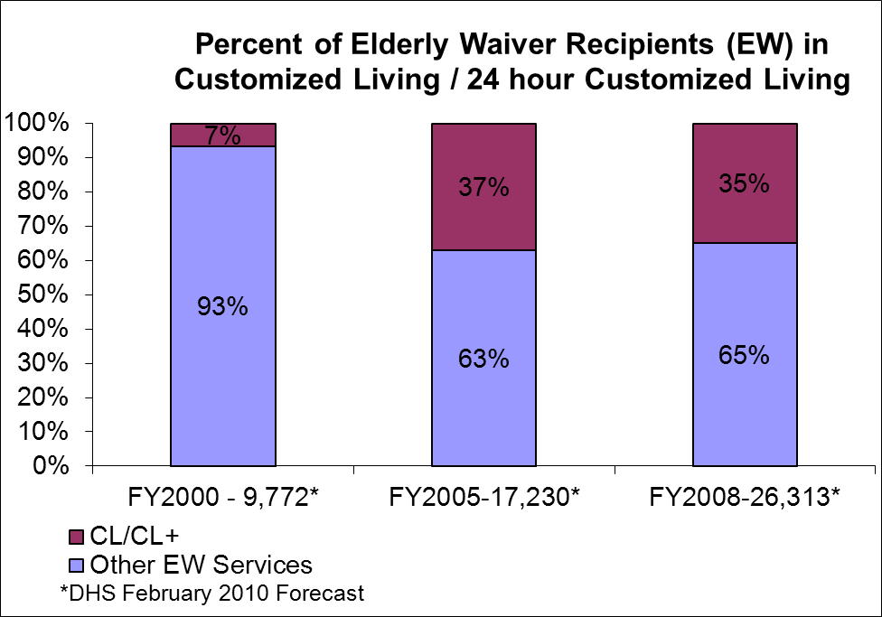

Over the past twelve years there has been a steady increase in the availability of housing choices for older persons in Minnesota, particularly market rate options. The MN Department of Health’s registry of housing with services establishments keeps a running total of such establishments. This registration includes (a) senior housing with services, and (b) a new category that is identified as Assisted Living. This latter definition requires that in order to advertise itself as Assisted Living, a housing with services establishment must meet requirements outlined in state statute regarding the types of services that must be offered and the types of providers who may provide those services, as well as consumer protection and consumer information requirements (see Laws of Minnesota 2006, chapter 282, article 19, sec.1 – 20). In 2001 there were 780 housing providers in Minnesota that also offered services to residents. Nine years later, in 2010, there were 1,807 such facilities operating in Minnesota.

The 2006 law also established a Uniform Consumer Information Guide (UCIG) that standardizes the information provided to consumers in all housing with services establishments (as of July 1, 2010), allowing them to compare across providers. This information will be available on the MinnesotaHelp.info website as well through the Senior LinkAge Line®. This effort, like the development of the Nursing Home Report Card (described in Section VI of this Report) is a collaborative effort between the Minnesota Departments of Health and Human Services—to provide meaningful information about long-term care options to consumers, and to make the market more transparent.

V. NURSING HOMES

Minnesota’s strategy for long-term care has been to “rebalance” the locus of care from institution-based to home- and community based models. However successful this strategy, there continues to be a need for nursing homes, and several policy issues related to the future of nursing homes are of interest, namely quality, cost and industry size.

A. Quality

Goal: Quality of long-term care services is an ongoing concern, both in institutional settings and in home- and community-based settings. This concern is especially important in nursing homes where quality affects all aspects of a resident’s life and where the burden of changing providers may be quite high. DHS is interested in quality of nursing home care for several reasons. As the State Medicaid Agency, DHS is responsible for certifying nursing facilities for participation in the program, a function that is delegated via contract to the Minnesota Department of Health (MDH), the state agency that licenses nursing homes and boarding care homes. The licensure and certification processes involve strenuous inspections that take place annually and are discussed in further detail in Section VI of this report. As a purchaser, spending hundreds of millions of dollars of state funds each year for nursing home care, DHS believes that it has an obligation to nursing home residents and to the public to go beyond inspection and use the purchasing activity to leverage quality.

Design of Quality Measures: DHS has worked with MDH and stakeholders for several years to develop quality measures. Several criteria must be met for a quality measure to be useful:
- The measure should be relevant, meaning that it is important to consumers, providers and purchasers, it makes sense to them, it relates to guidelines, it can lead to improvement and it measures performance attributable to the provider. Measures of outcomes are most desirable.
- The measure should be scientifically sound, meaning it has validity, it can be measured reliably, it can be aggregated.
- It is feasible to implement the measure, meaning the data is available, preferably electronically or can be acquired economically.

Seven quality measures have been developed and are currently in use:
- Quality of life and satisfaction
- Clinical outcomes
- Amount of direct care staffing
- Direct care staff retention
- Use of temporary staff from outside pool agencies
- Proportion of beds in single bed rooms
- Inspection findings from certification surveys

Public Disclosure of Quality Measures, the Nursing Home Report Card: Beginning in January 2006 MDH and DHS published a web-based nursing home report card. Hosted on the MDH website (www.health.state.mn.us/nhreportcard) the Minnesota Nursing Home Report Card is believed to be the most comprehensive nursing home report card in the nation. It is interactive in that it allows users to view results for a specific facility, or, alternatively, to specify a location they are interested in and to select the quality measures they consider most important. The report card then provides a list of all facilities that meet the geographic criteria and it sorts the list according to the scores of those facilities on the seven quality measures with emphasis placed on the measures prioritized by the user. The user can then select a facility from the list and see its scores on the seven quality measures, using a five star rating.

The Minnesota Nursing Home Report Card averages approximately 2,000 unique visits per month. This suggests that while the Web site is accessed by repeat users who are likely facilities monitoring their scores as well as those of their peers, it is also used by consumers and other stakeholders outside the provider industry.

When selecting the measures most important to them, Report Card users increasingly and overwhelmingly prioritize resident outcomes (quality of life and satisfaction, inspection findings, and clinical outcomes) over process or structural measures, as shown by the following bar graph.

A concern with any form of measuring and publicly disclosing of quality information is that the measures are never perfect. It is always a judgment call as to whether or not the quality measures are ready. It is then important to seek ways to improve the measures over time, guided in part by research and user feedback. Two changes that have been made to the report card since it went live in 2006 were dropping direct care staff turnover as a quality measure and revamping the scoring methodology used on the inspection findings from certification surveys.

The departments are working on several enhancements to the report card at this time:
- Adding family satisfaction as a new quality measure,
- Including non-MA facilities in the report card
- Incorporating features allowing users to focus in on dementia and short stay care, and
- Making actual data available in addition to the five star rating.

Trends in Quality Outcomes: DHS and MDH have calculated Report Card measures for multiple years; measure trends are presented in the following graphs.

Resident quality of life and satisfaction is measured by annual face-to-face interviews with a representative sample of residents in all MA certified nursing facilities, and are risk-adjusted to allow a fair comparison of facilities. The following bar graph shows improved scores on all quality of life domains and the residents’ overall quality of life score since the survey’s first full fielding in 2006 (though the survey was first used in 2005, subsequent improvements to the tool and the interview process for the following year require the use of 2006 as a baseline). The areas of greatest improvement include satisfaction, privacy, mood, and especially meaningful activity.

The next bar graph shows 24 clinical care processes and outcomes that are calculated using Minimum Data Set resident assessment information and risk-adjusted to allow fair comparison of facilities. Scores on 17 of 24 measures have improved since 2004, with particular positive change in the areas of reversal of pressure ulcers, appropriate use of antipsychotic drugs, and pain control. However, seven have worsened during this time, especially continence care.

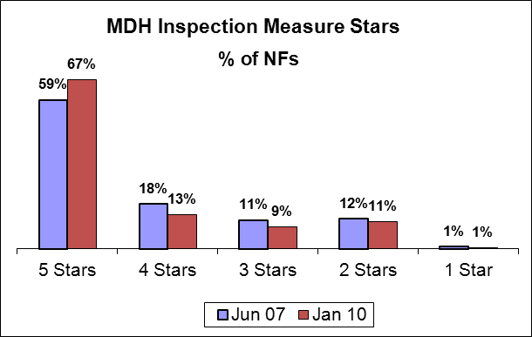

The method used to calculate the MDH inspection measure was improved in June 2007, limiting the amount of historic data available for trending. However, the trends to date in the graph on the right show that more facilities are earning five stars, meaning that they have good results on their current and prior inspection surveys and on their one-year complaint record.

Trends have also been positive for the Report Card measures relating to staffing. First, direct care hours per resident day, adjusted for wage differences (to counter any facility incentive to shift staffing emphasis to lower-compensated positions) and resident acuity differences (to more-fairly compare staffing for facilities serving different types of residents), are shown on the next chart. Direct care staffing in standard and in hospital attached facilities has increased by 13% since 2004 to over five hours per resident day, although it has declined by 5% in board and care facilities that typically serve a less physically-impaired population.

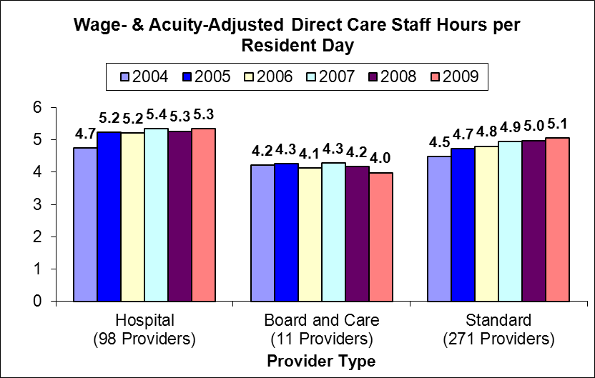

The next staffing measure, direct care staff retention, considers how many direct care staff employed in a facility at the beginning of the year are still employed at the end of the year. As shown in the graph on the right, it has been remarkably consistent since 2003, averaging about 72% and increasing to 75% in 2009.

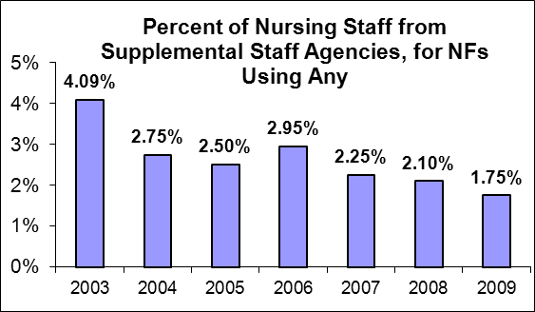
The last staffing related measure presents the proportion of nurse staffing agency hours to permanent staff. The graph on the left shows this proportion for facilities using any temporary staff. In the years 2006 to 2009 between 64% and 68% of facilities have not used any temporary staff. It has steadily declined since 2003, with a small bump in 2006.

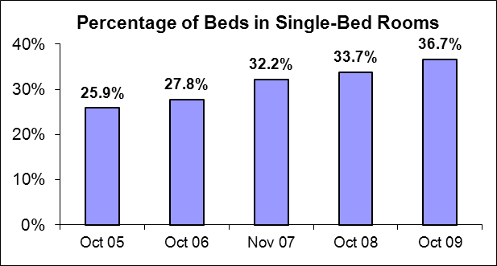
Finally, the Report Card currently includes only one measure explicitly rating the physical environment, the proportion of beds in single-bed (private) rooms. This measure has steadily increased since 2005, possibly in response to DHS single-bed incentives and changing consumer preferences.

In addition to trends, it is useful to track the range of scores on report card measures. The following table includes this information for 2009.

MN Nursing Home Report Card Quality Measure Scores | Minimum | Average | Maximum
Resident Quality of Life Ratings
Overall Score (0 - 100% Positive Possible) | 75% | 83% | 89%
Comfort Domain | 75% | 83% | 89%
Functional Competence Domain | 76% | 89% | 95%
Privacy Domain | 79% | 89% | 94%
Dignity Domain | 88% | 97% | 99%
Meaningful Activity Domain | 51% | 74% | 87%
Food Enjoyment Domain | 74% | 87% | 95%
Autonomy Domain | 73% | 84% | 91%
Individuality Domain | 68% | 84% | 93%
Security Domain | 72% | 87% | 94%
Relationships Domain | 72% | 84% | 91%
Satisfaction Domain | 71% | 84% | 93%
Mood Domain | 61% | 72% | 83%
MN Risk-Adjusted Clinical Quality Indicators
Overall Score (0 - 40 Points Possible) | 11.47 | 24.66 | 36.5
Worsening Resident Behavior Problems | 1% | 12% | 28%
Incidence of Depression or Anxiety | 0% | 16% | 45%
Prevalence of Symptoms of Depression w/o Antidepressants | 0% | 8% | 38%
Prevalence of Physical Restraints | 0% | 2% | 22%
Worsening Bowel Continence | 0% | 19% | 41%
Worsening Bladder Continence | 3% | 18% | 43%
Improved Bowel Continence | 3% | 22% | 57%
Improved Bladder Continence | 1% | 12% | 32%
Prevalence of Bladder/Bowel Incontinence w/o a Toileting Plan | 0% | 47% | 100%
Prevalence of Indwelling Catheters | 0% | 6% | 20%
Prevalence of Urinary Tract Infection | 0% | 7% | 17%
Prevalence of Infections | 0% | 11% | 43%
Prevalence of Residents who Have Fallen | 1% | 12% | 20%
Prevalence of Burns, Skin Tears or Cuts | 0% | 5% | 15%
Prevalence of Residents with Unexplained Weight Loss | 0% | 5% | 17%
Prevalence of Moderate-Severe Pain | 0% | 17% | 66%
Prevalence of New Pressure Sores | 0% | 5% | 17%
Incidence of Cured Pressure Sores | 18% | 62% | 94%
Prevalence of Antipsychotics w/o a Psychosis Dx | 0% | 13% | 66%
Improved Ability to Function | 6% | 27% | 49%
Increased Need for ADL Help | 0% | 15% | 28%
Walking as Well or Better than on Previous Assessment | 66% | 82% | 100%
Worsening Ability to Move Around Room | 0% | 15% | 35%
Decline in Range in Motion | 0% | 7% | 28%
Direct Care Staff Adjusted Hours per Resident Day
Hospital Peer Group | 3.91 | 5.34 | 11.04
NF-II Peer Group | 3.16 | 3.98 | 4.73
Standard Peer Group | 3.71 | 5.06 | 8.01
Direct Care Staff Retention | 34% | 75% | 100%
Use of Temporary/Pool Staff | 0% | 0.5% | 10%
Proportion of Single Bed Rooms | 0% | 38% | 100%
MN Department of Health Survey Findings | 1 Star | 4.5 Stars | 5 Stars

Pay for Performance: In 2005 the Minnesota Legislature enacted a first step in adopting Pay for Performance for nursing facilities. This initiative was in the form of a quality add-on to payment rates. Based on quality scores, facilities received operating payment rate increases up to 2.4% of their operating payment rates effective October 1, 2006. The quality score was developed from five of the eight measures on the Report Card:
- Clinical outcomes, accounting for 40% of the total score
- Direct care staff retention, accounting for 25% of the total score
- Direct care staff turnover, accounting for 15% of the total score
- Use of temporary staff from outside pool agencies, accounting for 10% of the total score
- Inspection findings from certification surveys, accounting for 10% of the total score

A quality add-on of up to 0.3% was then provided for operating payment rates effective October 1, 2007. The method of determining the quality score was revised:
- Clinical outcomes, accounting for 35% of the total score
- Quality of life, accounting for 20% of the total score
- Direct care staffing levels, accounting for 10% of the total score
- Direct care staff retention, accounting for 20% of the total score
- Use of temporary staff from outside pool agencies, accounting for 5% of the total score
- Inspection findings from certification surveys, accounting for 10% of the total score

No quality add-on has been provided since 2007.

In 2007 DHS initiated the Performance Incentive Payment Program (PIPP). PIPP is a voluntary competitive program designed to reward innovative projects that improve quality or efficiency or contribute to rebalancing LTC. Selected projects will receive temporary operating payment rate adjustments of up to 5%, under amendments to the Alternative Payment System contracts. Of the money rewarded, 80% is contingent upon implementing the program described in the amendment. The remaining 20% is contingent upon achieving specified outcomes.

At the time of this writing, 162 nursing facilities have participated in the program, representing over 60 different quality improvement projects. Selected PIPP projects have addressed areas such as:
- Exercise physiology
- Resident transfers
- Culture change
- Technology
- Dementia care
- Bathing
- Community discharge
- Falls
- Incontinence

Evaluation and Dissemination of Quality Improvement Efforts
The Minnesota Department of Human Services, Nursing Facility Rates and Policy Division employs a Quality Improvement Coordinator, an RN, dedicated as a consultant and trainer to help nursing homes succeed by introducing strategies to optimize their performance for the Minnesota Risk Adjusted Quality Indicators and Nursing Home Resident Quality of Life Satisfaction Survey.
The Quality Improvement Coordinator meets with management, QA / QI teams or any group to examine the specific areas that need improvement. Facility specific root causes are identified and the team receives help to begin to develop a plan to improve. In addition to consultation, the coordinator has a comprehensive curriculum available for on-site employee development and occasional statewide training seminars in quality areas that show a need for statewide improvement.

Dr. Greg Arling, Indiana University was recently awarded a 3-year grant from the federal Agency for Healthcare Research and Quality (AHRQ) to evaluate the MN Nursing Facility Performance-Based Incentive Payment program (PIPP) administered by the Nursing Facility Rates and Policy Division. Dr. Arling will serve as the Principal Investigator and has arranged a study team which includes several highly-qualified researchers throughout the country. The study will conduct a comprehensive evaluation of PIPP to discover effective strategies of system-level change that will lead to higher quality and more efficient long-term care. The AHRQ review team stated, “This research will advance public health by identifying organizational structure, process, and cultural factors that lead to successful implementation and sustainability of nursing home quality improvement projects, assessing the case for state investment in quality improvement, and determining the savings to Medicaid and funding sources potentially achieved by improving upon the value of healthcare. Additionally, national dissemination of methods to enhance nursing home quality and value is of importance to nursing home consumers, the long term care industry, and governmental funding agencies.” Planned dissemination activities include the diffusion of successful interventions among nursing home providers by developing a PIPP toolkit containing methods and resources for quality improvement, conference presentations and publications, and a social network site dedicated to PIPP and other nursing home pay for performance strategies.

B. Nursing Home Costs/Expenditures

In State Fiscal Year 2009, $833 million was spent through the Medicaid Program for nursing home care in Minnesota, of which the state share was $348 million. During 2009, due to federal economic stimulus provisions, the federal share of MA was 61.59%, rather than the usual 50%. For the year ending September 30, 2009, nursing facilities reported total revenues of $2.125 billion as shown in the table below with an estimate of revenues for non-MA certified nursing homes, yielding a total estimated revenue of $2.223 billion.

Estimated Total Nursing Home Costs in Minnesota (2009) by Source of Payment
Source | Amount  ($s in millions)
MA payments, including recipient resources and managed care |  | $1058
Private pay |  | 506
Medicare Part A and Part B |  | 316
Other |  | 245
Estimated revenues of non-MA nursing homes |  | 98
Estimated Total Nursing Home Revenues |  | $2,223

The line graph below shows total MA spending on nursing homes in Minnesota from 1995 through 2009. The level of spending has been remarkably stable over this period, fluctuating between a low of $813 million in 2008 to a high of $913 million in 2004.

The next two charts show the very different trends in MA caseload and unit costs. Caseload has declined because an increasing proportion of persons needing LTC services are being supported in non-institutional home- and community-based settings. MA caseload, the number of resident days paid for by MA, has decreased from 11,571,518 in 1995 to 6,257,421 in 2009, a reduction of 46%. At the same time, the average daily payment rate (MA payment not counting recipient resources) has increased from $76.25/day in 1995 to $133.13/day in 2009, an increase of 75%.

C. Industry Size

Rightsizing the nursing home industry has been a dominant policy theme for the state for over 25 years. This section of the report will examine the trends in bed availability and need, and specifically, will address the question: “Will Minnesota soon experience a shortage of nursing home beds?”

Number of Beds and Beds per 1,000 Elderly. As of September 30, 2009, Minnesota had 399 licensed nursing homes and licensed and certified boarding care homes with a total of 33,878 beds in active service, with 381 facilities and 32,342 certified to participate in the Medicaid Program.

The number of nursing homes and licensed beds has been declining since 1987, when Minnesota had 468 facilities with 48,307 beds. By September 2009, 69 facilities had closed altogether and 13,391 beds had been completely delicensed. An additional 1,038 beds were out of active service, in “layaway” status. The supply of active beds has declined by 30% over the 22 years since the 1987 peak. In the last two years, the bed supply has declined by 2,002 beds or 5.6%.

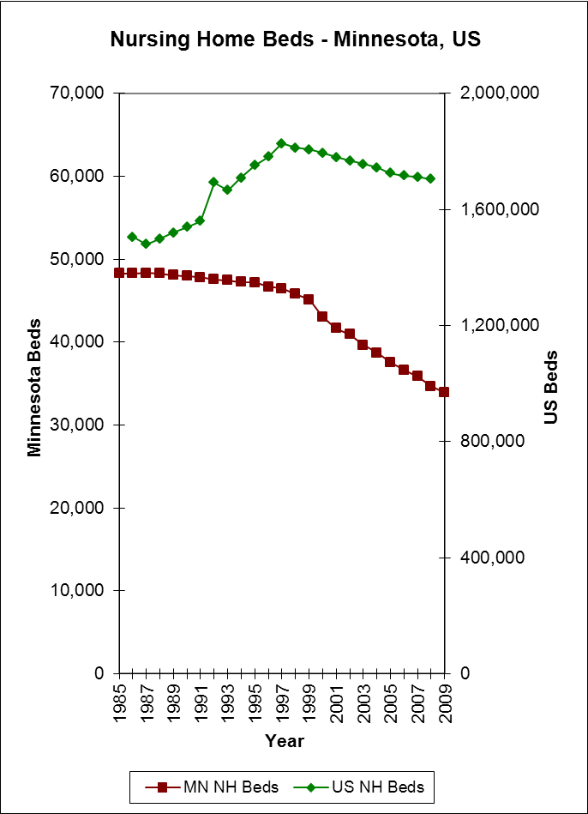
The availability of beds varies substantially across counties. One of the easiest ways to describe this variability is in terms of the ratio of nursing home beds per 1,000 elderly persons, and in this case we will examine this ratio under two definitions of “elderly”: age 65 and older, and age 85 and older. While the former measure is most commonly used nationally, the generally longer life expectancy in Minnesota results in a higher than national rate of very old persons in this state. The table below shows the state averages for these measures as well as the variance across counties and across “groups” of counties. This latter measure takes into account the use of nursing homes by persons in adjacent counties.

Average Nursing Home Beds per Thousand Persons Age 65+ and 85+
(and Range) -- Minnesota 2009
VARIABLE | AGE 65+ | AGE 85+ | Age Intensity Adjusted
Statewide beds per 1000 | 51.1 | 309.4
County beds per 1000 - Low | 17.9 in Anoka | 128.3 in Hubbard | 19.9 in Hubbard
County beds per 1000 - High | 119.7 in Wilkin | 661.2 in Wilkin | 112.7 in Wilkin
Contiguous county groups beds per 1000 - Low | 28.5 in Chisago | 227.4 in Crow Wing
Contiguous county groups beds per 1000 - High | 82.3 in Yellow Medicine | 419.1 in Cook

The Appendix includes information about nursing home bed distribution at the county level in Minnesota in 2009:
- A chart showing the beds/1000 65+ by county
- A table showing the number of facilities and beds by county, each county’s beds/1000 persons age 65+, and that county’s rank from the most beds per 1000 (1) to the fewest (87). This same information is also presented for each county with its contiguous group of counties, and then the same information based on the 85+ population, and the age intensity adjusted beds per 1000 and rank.

In terms of beds/1000, Minnesota continues to have more nursing home bed availability than the national average. However, for both the 65+ and the 85+ measures, Minnesota is approaching the national average, as shown in the table and graphs above and those that follow. In 1995, Minnesota had 58% more beds per 1000 age 65+ and 28% more for the 85+ population than the national average. By 2008 these numbers had decreased to 22% and 9% respectively.

For many years policy makers have considered Minnesota to be over-bedded, based on its comparison with the U.S. as a whole. Nationally (as well as in Minnesota) rates of beds per capita have been declining over the past several years. As recently as 2008, Minnesota still had comparatively more bed capacity that the rest of the nation (22% more for persons aged 65+ and 9% more for persons age 85+). However, the rate of reduction in Minnesota has exceeded the national average (see table below), raising the question of the degree to which Minnesota may continue to have an “over-supply” of nursing home beds in the future. The following table compares Minnesota data on nursing home supply with comparable national data.

Comparison of Minnesota and U.S. Data on Nursing Home Supply
 | Minnesota | U.S. | MN as % of U.S.
Historic number of beds | 1987 – 48,307
Historic number of beds | 1995 – 47,181 | 1995 – 1,751,302 | 2.69%
Current number of beds | 2008 – 34,684 | 2008 – 1,703,846 | 2.04%
Current number of beds | 2009 – 33,878
Average annual % change in number of beds, 1995 to 2008 | -2.3% | -0.2%
Peak beds per 1000 age 65+ | 1987 – 91.2
Peak beds per 1000 age 65+ | 1995 – 82.0 | 1995 – 51.9 | 158%
Current beds per 1000 age 65+ | 2008 – 53.3 | 2008 – 43.8 | 122%
Current beds per 1000 age 65+ | 2009 – 51.1
Average annual % change in beds per 1000 age 65+, 1995 to 2008 | -3.3% | -1.3%
Peak beds per 1000 age 85+ | 1987 – 745.3
Peak beds per 1000 age 85+ | 1995 – 611.4 | 1995 – 475.8 | 128%
Current beds per 1000 age 85+ | 2008 – 324.6 | 2008 – 297.8 | 109%
Current beds per 1000 age 85+ | 2009 – 309.4
Average annual % change in beds per 1000 age 85+, 1995 to 2008 | -4.8% | -3.5%

Occupancy. Occupancy is defined as the percentage of days that nursing home beds are occupied. It is calculated as the actual number of resident days of nursing home care provided during a year divided by the maximum capacity for that year, that is, the number of resident days that would have been provided if all beds in active service were occupied every day.

Occupancy in Minnesota’s nursing homes has ranged between a high of 95.4% in 1993 and a low of 91.1% in 2000. This rather narrow range of occupancy has been maintained in recent years largely by taking beds out of service. The statewide occupancy rate for the fiscal year ending 9/30/09 was 91.5%. Occupancy is an important statistic to monitor for two reasons. First, it is important that nursing home beds be available when needed. People should be able to access this service when needed—sometimes on very short notice. If occupancy is too high, nursing home services may not be available when needed. The Department of Human Services would be concerned about access if occupancy rates exceeded the historic (20-year) range. If occupancy were to exceed about 97%, access problems would likely become common. On the other hand, low occupancy is likely to exacerbate the financial strain on facilities, and perhaps, reduce the overall efficiency of the industry.

Extreme Hardship Counties. The general distribution of nursing home beds is certainly not uniform across the state. As noted earlier, the range in number of beds per thousand persons aged 65+ is over 6-fold (i.e., a low of 17.9 in Anoka County and a high of 119.7 in Wilkin County). Further declines in bed supply may trigger an “extreme hardship” situation in some areas of the state. By definition in statute, two criteria must be met for such an extreme hardship situation to be recognized:
- A county must have fewer beds per 1,000 for people age 65+ (in that county and contiguous counties) than the national average plus 10% (110% of 43.8 beds/1000 [in 2008, the most recent year for which the data is available] is 48.2), and
- An extreme hardship situation can only be found after the county documents the existence of unmet medical needs that cannot be addressed by any other alternatives.
When an extreme hardship situation is determined to exist, the Human Services and Health commissioners may approve the addition of new beds. This has never occurred.

In 2009 there were 28 counties— Aitkin, Beltrami, Benton, Carlton, Cass, Chisago, Crow Wing, Douglas, Goodhue, Hennepin, Hubbard, Isanti, Itasca, Kanabec, Koochiching, Meeker, Morrison, Mower, Pine, Pope, Ramsey, Rice, Sherburne, Sibley, St. Louis, Todd, Washington—where an exception to the moratorium on nursing home beds might be considered due to the potential for the “extreme hardship” criteria defined above. In 2008, fourteen counties met this test, in 2005 eleven counties met the test and in 2003 only five counties met the test.

The statutory definition of “extreme hardship county” produces some peculiar results, best exemplified by Anoka and its contiguous counties. Hennepin, Ramsey, Chisago, Isanti, Washington, and Sherburne Counties all border Anoka County, which has the state’s lowest number of beds per 1000 age 65+ with 17.9. Even though Isanti and Sherburne counties have high beds per 1000 (ranking 25th and 32nd respectively in bed capacity), they are potential extreme hardship counties, while Anoka (ranking 87th—lowest capacity in the state) is not. The status of a county may be driven more by the availability of beds in a more populous neighboring county than by its own bed availability. So low-bedded Anoka, adjacent to larger high-bedded Hennepin and Ramsey Counties will not meet the hardship test, while higher-bedded Chisago, Isanti and Sherburne Counties, adjacent to a larger low-bedded county, Anoka, will meet the test.

The objective of identifying potential hardship counties may be better met by using criteria that consider age-intensity adjusted beds per 1000, high occupancy and out migration. (See Appendix for county out migration data.)

Nursing Facility Utilization. With increasing numbers of elderly and declining numbers of nursing home beds, why is it that occupancy rates have remained relatively stable? The market is shifting away from institutional care, and state policies have been implemented to support and encourage this shift, which can be seen in the declining utilization. Nursing home utilization is a measure of how likely it is that a person will be in a nursing home—namely the percent of people within an age group who are in a nursing home on a given day. The nursing home utilization rate for older people in Minnesota has been declining for at least the past 25 years. In 1984, the utilization rate for persons aged 65+ was 8.4 %, and by 2009, it had declined to 4.0 %—a 52 % reduction. The utilization rate for people age 85+ declined even more dramatically, from 36.4% in 1984 to 15.1% in 2009, a 59% reduction.

Nursing Home Utilization Rates in Selected Years from 1984 – 2009 for Persons 65+ and 85+ in Minnesota
Year | 65+ Utilization | Annual Rate of Change | 85+  Utilization | Annual Rate  of Change
1984 | 8.4% |  | 36.4%
1987 | 8.1% | -1.2% | 35.1% | -1.2%
1989 | 7.8% | -1.9% | 33.4% | -2.5%
1993 | 7.6% | -0.6% | 30.8% | -2.0%
1994 | 7.1% | -6.6% | 28.7% | -6.8%
1996 | 6.9% | -1.4% | 28.2% | -0.9%
1998 | 6.1% | -6.8% | 24.3% | -7.2%
2000 | 5.8% |  | 22.8%
2001 | 5.6% | -4.3% | 21.3% | -6.5%
2002 | 5.5% | -1.3% | 20.6% | -3.2%
2005 | 5.2% | -2.1% | 20.1% | -0.8%
2006 | 4.9% | -5.6% | 18.7% | -7.3%
2007 | 4.7% | -4.3% | 17.6% | -5.7%
2008 | 4.4% | -6.8% | 17.1% | -2.9%
2009 | 4.0 % | -8.0% | 15.1% | -11.9%
Source: Residents – MDH and DHS; Population – US Census Bureau
*Beginning in 2000, the data source use to compute utilization rates changed because the Minnesota case mix system was replaced with the RUGS system.

Why is utilization dropping? Several factors may be contributing to this long term trend:
- Declining rate of dependency,
- Growth in availability of home and community based services and assisted living,
- Changing consumer preferences and expectations, and
- Increased availability of short stay specialty care.

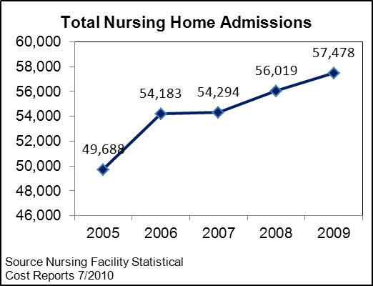
Two other measures of utilization shown here, admissions and length of stay, illustrate this increased availability and use of short stay care. While the annual number of admissions has risen from less than 50,000 in 2005 to nearly 58,000 in 2009, these stays have steadily become shorter, with over half of stays in 2009 lasting 30 days or less. These trends suggest that most individuals using nursing facilities today require more-frequent, shorter stays, likely for short-term health needs before returning to long-term residences in the community.

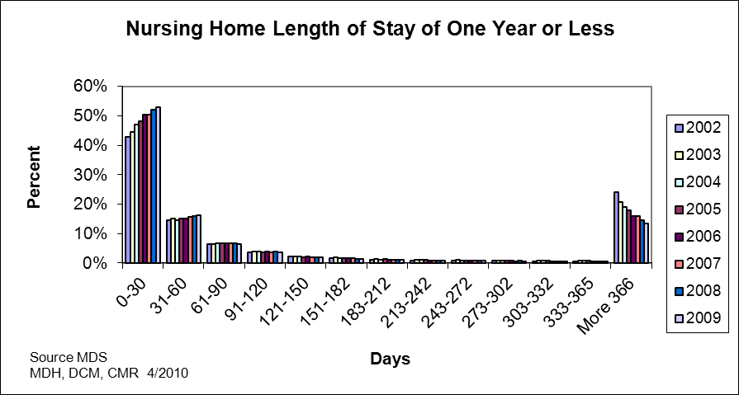

Age Intensity Adjusted Beds per Thousand. The goal of creating this measurement is to be able to report on bed supply using all population groups at once. By adjusting the 65+ age group for age intensity, we can measure beds per 1000 in one number. As is seen above, nursing home bed utilization is greater for those 85 and over than it is for the 65+ age group. The difficulty with reporting beds/1000 by either age group is that it doesn’t tell the whole story. If we were to report the number of beds per 1000 elderly 65 and over for two different counties that had the same number of beds and the same number of residents 65 and over, they would have the same beds/1000 65+ ratio. But by examining the age distribution of the 65+ age cohort, we can better determine the adequacy of the bed supply. The following table shows the average percentage of elderly Minnesotans in nursing facilities in 2009, by age group.

The age intensity adjusted (AIA) beds per 1000 rate is calculated by using the 65+ beds/1000 rate and adjusting it for age distribution. For each county, each 5-year age group is weighted using the utilization rates at left. The weights are combined to create a weighted score for each county. The weighted scores are then each divided by the statewide weighted score to establish a weighting factor for each county. The factor is applied to the county’s 65+ beds/1000 rate to adjust it to arrive at their age intensity adjusted beds/1000 rate.
NH Utilization in MN
By Age Group, 2009
Age Group | Util Rate
65-69 | 0.6 %
70-74 | 1.2 %
75-79 | 2.3 %
80-84 | 4.7 %
85+ | 15.1 %

The map below shows the state distribution of age intensity adjusted beds per 1000 rates. See the Appendix for a comparison of beds per 1000 rates.
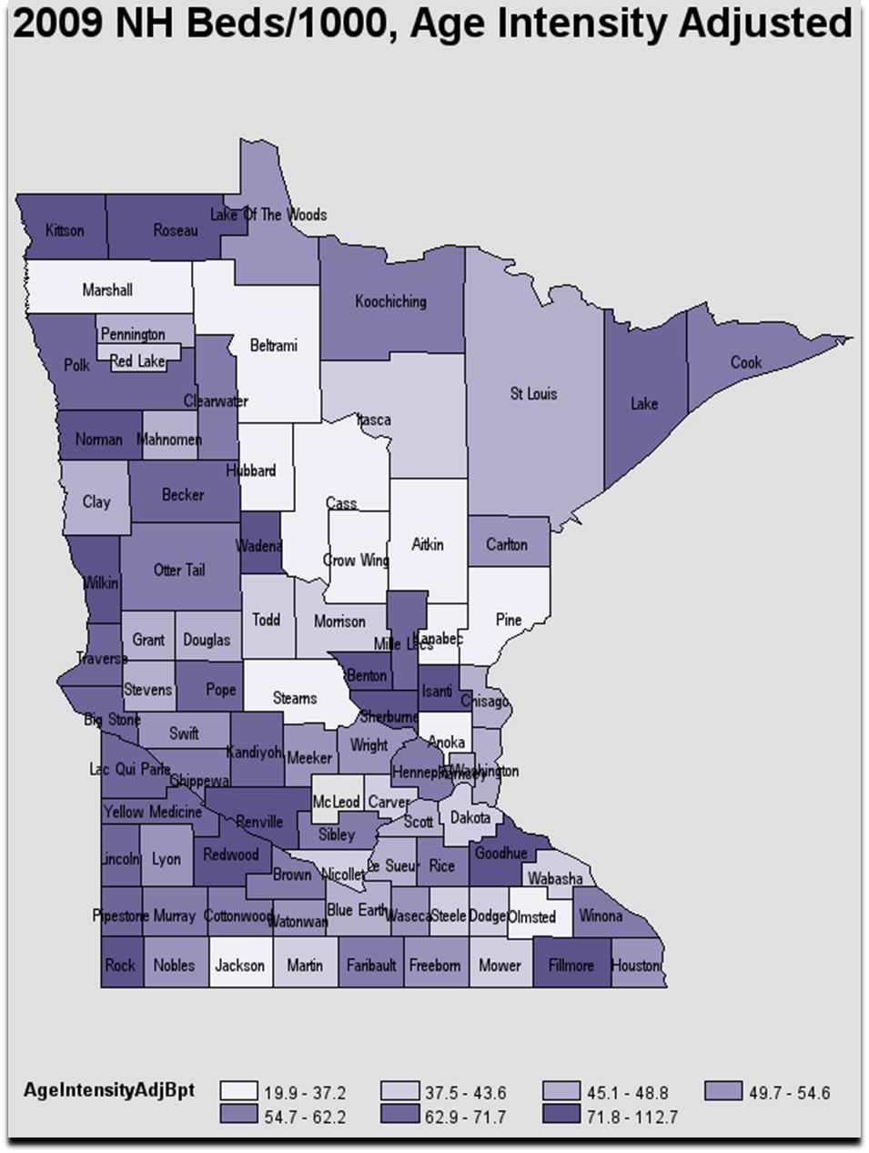

- Future Industry Size--Projections

One of the questions this report is intended to address is whether the state continues to be over-bedded, has an adequate supply of nursing home beds for the foreseeable future or if additional beds will be needed, and specifically, is the moratorium still needed. To answer this question we will first look at projected bed availability based upon changes in the number of beds, then projected bed need based upon changes in the rate of utilization of nursing home services and of population, and then combine these two projections.

Projected availability based on changes in the number of beds. As we have seen, the number of nursing home beds in Minnesota has been decreasing consistently over the last 23 years. The projection for the next 20 years continues the trend.

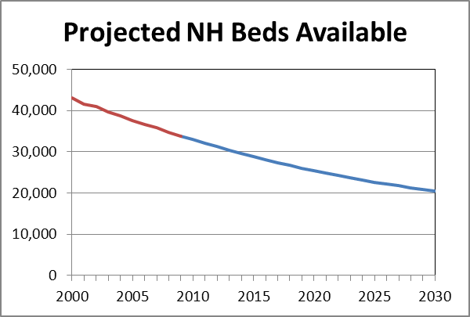
The chart on the left shows the projected nursing home bed availability in Minnesota to 2030, starting with 33,878 beds in 2009 and resulting in 20,552 beds in 2030.
Projecting Number of Nursing Home Beds Available in Minnesota -- 2010-2030
2009* | 33,878
2015 | 28,869
2020 | 25,430
2025 | 22,668
2030 | 20,552
*2009 = actual number of beds

Projected need based on the changing utilization rate of nursing home services and population estimates. Utilization rates have been falling for many years. Nonetheless, if we were to assume that the rate of nursing home bed utilization would level off at the 2009 rate of 4.0% for the 65+ age group, the need for beds would increase steadily due to growth in the elderly population and would surpass current supply as soon as 2011, assuming occupancy does not exceed the record high of 95.4% in 1993.

But because of the decline in disability rates, shorter nursing home stays, and increasing utilization of alternatives to nursing home services, we expect that the nursing home utilization rate will continue to exhibit the trend we have seen for many years.

Assuming that utilization rates will continue to decline, we have projected utilization rates for the 65-84 and 85+ age groups and applied those rates to population estimates to project future bed need.

The final step of this analysis is to lay the bed availability projection on top of the bed need projection. The chart below shows the projected bed need (the blue dashed line) overlaid on the projected number of beds (the green solid line). The red dotted line shows the projected effect of the Return to Community Initiative (RTC).

We start with a projected surplus, in 2010, of 2,958 beds. That surplus falls to about 1,300 beds in 2030, without RTC. However, the expected effect of RTC is to maintain a larger buffer of over 4,000 beds for the next 15 years, declining to 3,400 by 2030.

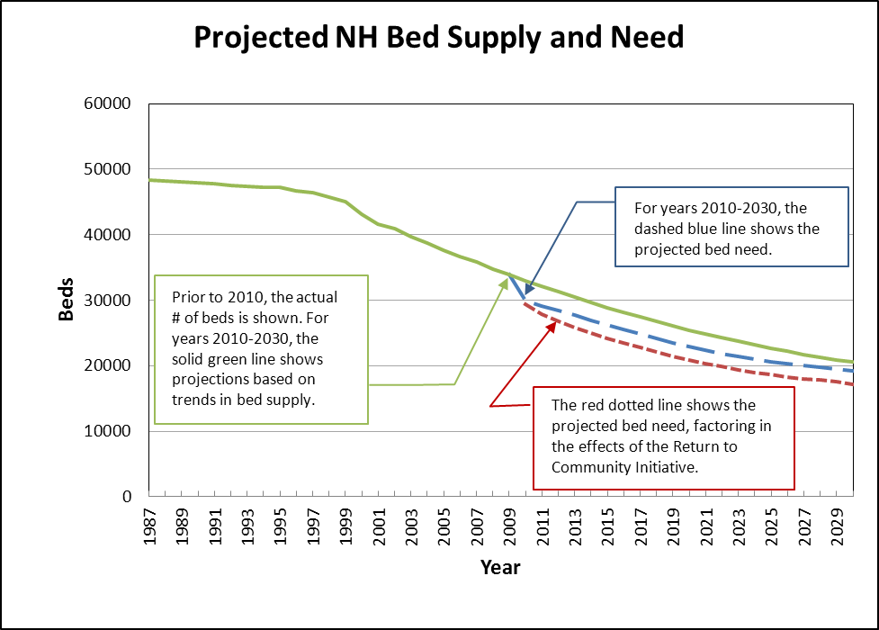

In conclusion, we suggest that we are at a point where the moratorium on new nursing home beds is still useful, but we should be:
- Watching for local and regional access problems,
- Encouraging the use of existing mechanisms that allow beds to be relocated from high bedded areas to low bedded areas, and
- Preparing to allow the addition of new beds in the event access problems arise.

VI. Minnesota Department of Health

The Minnesota Department of Health (MDH), through its Compliance Monitoring Division, is primarily responsible for assuring compliance with state and federal regulations that exist to protect and improve the health, safety, comfort and well being of individuals receiving long-term care services from federally certified and state licensed health care providers.

- Long-Term Care Quality Assurance

MDH continued its efforts to improve and maintain consistency across nursing home survey teams through statewide implementation of the Quality Indicator Survey (QIS) process. QIS is a newly revised federal survey process for nursing homes which will eventually be rolled out nationwide and replace the current survey process. In May of 2007 Minnesota was chosen by CMS to be the first state to implement QIS statewide beyond the six demonstration states. Training of MDH survey staff began in January 2008 and by March 2010 all survey staff had been trained in QIS and all annual nursing home surveys were being conducted using the new survey process. QIS is designed to improve consistency and accuracy of quality of care and quality of life problem identification; comprehensively review the full range of regulatory care areas; enhance documentation of survey findings through automation; and focus survey resources on facilities with the largest number of quality concerns. CMS has been sending states implementing QIS data reports that help states identify outliers and variances by areas and individual surveyors. MDH is currently working with CMS to better understand these reports and use them to their fullest extent.

MDH has also been preparing for the replacement of the current Minimum Data Set 2.0 (MDS 2.0) with MDS 3.0, which is to be effective October 1, 2010. MDS 2.0 is a standardized assessment instrument used by nursing homes and boarding care homes to complete comprehensive assessments of residents’ needs. MDS 2.0 is also used by the federal and state government for payment purposes and for quality indicators. The Department is in the process of providing training and both clinical and technical support to all stakeholders on MDS 3.0 and planning for the integration of MDS 3.0 into the QIS process.

The Department is also promoting regulatory compliance through working jointly with providers to educate and train on revised federal clinical guidelines, root cause analysis, and planning for and responding to emergencies.

MDH has been reviewing and making changes to its home health care licensing program and activities in order to improve consumer protection. In January 2010, MDH reorganized to have dedicated staffing whose sole responsibilities were to conduct home health surveys. This new program activity, Home Care and Assisted Living Program, also evaluated the home health licensing survey process and forms used and streamlined those to make better use of precious staff resources and to have better and clearer documentation about survey results for both providers and consumers.

Additionally, MDH has continued its home care work group activities started in the fall of 2007 to make recommendations to the Commissioner for improving the current licensing regulations (statutes and rules). The workgroup membership includes provider advocates, consumer advocates and other state agencies such as the Department of Human Services, the Minnesota Board on Aging, and the Office of Ombudsman for Long Term Care. Within the last year, MDH has sought additional input from individual providers and consumers. MDH has identified and is using the following set of guiding principles for this work. Regulation will: protect consumer health, safety and well-being; allow consumer to have a role in their home care; focus on ensuring quality of life for the consumer; be clear for home care providers and understandable to consumers; allow flexibility to accommodate new technologies, delivery systems/models while ensuring a balance between regulation and innovation; be operationally feasible and not excessively burdensome or bureaucratic for providers and consumers; and include improved/additional enforcement mechanisms.

Complaint investigations of licensed and certified health care facilities and services are also a responsibility of MDH. The Office of Health Facilities Complaints (OHFC) is responsible for the receipt of all complaints and facility reported incidents from hospitals, nursing and boarding homes, Supervised Living Facilities, home care services. MDH is to gather information necessary to evaluate and triage facility reports/complaints and to initiate an appropriate level of investigative response.

One indicator of quality assurance in long-term care settings is the provider’s record regarding complaints, and substantiated complaints in particular. OHFC continues to experience an upward trend in the number of home care complaints it receives. Based on this increase in home care complaints, MDH is adding an investigator in OHFC to focus on state license only home care provider complaint investigations. Complaints involving nursing homes have been relatively consistent in numbers the past few years. OHFC participates in MDH efforts to work with stakeholder groups to encourage industry sponsored training in areas where training is needed due to increases in correction orders and deficiencies issued for violations of regulations and complaints received.

For more information on MDH quality assurance efforts, please refer to the Annual Quality Improvement Report of the Nursing Home Survey Process available at
http://www.health.state.mn.us/divs/fpc/2009NHQIfinalrpt.pdf
and the Complaint Investigations of Minnesota Health Care Facilities report available at
http://www.health.state.mn.us/divs/fpc/2010ohfcfinalrpt.pdf

- Consumer Information

Minnesota’s Nursing Home Report Card, developed in collaboration with DHS, with input from long term care researcher Dr. Robert Kane and provider and advocacy representatives, became operational on the MDH website on January 20, 2006. The Report Card uses multiple measures of quality, and incorporates sophisticated risk adjustments to compare facilities fairly. Consumers can compare nursing homes on eight quality measures.

Each nursing home can receive one to five stars on each measure. The report card website also contains a number of links to other sources of information consumers may find helpful in choosing a home. The Report Card can be found at: www.health.state.mn.us/nhreportcard.

Additionally, the Centers for Medicare and Medicaid Services (CMS) offer additional information to consumers on nursing homes. They recently added a 5 Star Quality Rating system, similar to information provided on the Minnesota’s Nursing Home Report Card. The Nursing Home Compare information can be found at: www.medicare.gov/NHCompare/Home.asp.

Based on the success of the Nursing Home Report Card, MDH worked with DHS and stakeholders in 2006-2007 to design a Uniform Consumer Information Guide (UCIG). During the 2010 Legislative Session, the law was expanded to require that all Housing with Services settings, not just assisted living centers as previously mandated, complete the UCIG requirements. This guide assists consumers in researching and comparing housing with services and community based long-term care options. Along with the UCIG project, MDH has been collaborating with the Minnesota Board on Aging to make more provider information available to consumers on www.MinnesotaHelp.Info and through the Senior Linkage Line. This will improve consumers’ access to the information they need to make choices about their long term care needs.

VII. Reducing Future Need for Long-Term Care

Health Promotion, Disability Prevention & Disease Self-Management

Research shows that when older adults increase physical activity, improve their eating habits, avoid tobacco, and take steps to minimize the risk of falling they can live longer and healthier lives. Although changing behavior is not easy, there are evidence-based community interventions that have been proven effective in helping adults of all ages make healthier lifestyle choices. Increasing the availability of well-targeted, effective programs can provide both health and financial benefits for individuals as well as the general public.

Minnesota Falls Prevention Initiative
The Minnesota Department of Human Services, Department of Health and the Minnesota Board on Aging launched the statewide Minnesota Falls Prevention Initiative in 2005. Falls are the leading cause of trauma deaths, non-fatal major trauma and other trauma care in Minnesota, and the majority of these cases are among older Minnesotans. Minnesota’s fall death rate is almost twice the national average and it is increasing. Minnesota consistently ranks among the top four states in the country for death rate due to falls.

The Minnesota Falls Prevention Initiative seeks to reduce the risk for falls in older Minnesotans through four objectives:
- Increase awareness of preventing falls among older adults, family members and professionals;
- Increase assessment of fall risk;
- Increase the availability of evidence-based falls prevention interventions statewide; and
- Measure the impact of efforts to prevent falls in older Minnesotans.

Evidence-Based Programs
The Minnesota Department of Human Services, Department of Health and the Minnesota Board on Aging are also partnering to implement a portfolio of evidence-based programs for health promotion, falls prevention and chronic disease self-management. The lead state agencies are coordinating efforts to expand evidence-based programs through: training and support for class leaders; start-up materials; evaluation; and monitoring for fidelity—an essential element of quality assurance. Other critical partners in this effort include managed care organizations, Area Agencies on Aging, local public health agencies, and local aging services providers.

In choosing evidence-based community programs, the lead state agencies are using the definition of evidence-based that includes programs that have gone through at least two levels of implementation research. These include programs that have, in the first phase, been tested in a rigorous, controlled design with experimental and control groups. Selected programs have gone through a second phase of research involving “field testing” in community settings using the type of practitioners, recruitment strategies and participants that will be used in broad implementation. It is important that these programs be implemented with fidelity to ensure the expected outcomes. The state partners on this project are also working with other states to learn from each other, and share the implementation methods that are most effective.

Program Descriptions
The Arthritis Self-Management Program (also The Arthritis Foundation Self-Help Program) was originally developed by Kate Lorig and Jim Fries at Stanford University. The program consists of groups of 8-12 persons who meet with trained peer facilitators for a two-hour session each week for six weeks. Participants gain skills in self-management behaviors including healthy eating, increasing physical activity as well as effective use of medications, navigating the health care system and pain management. The program has been demonstrated to decrease physician visits by 40% and decrease pain by 20%. The program is currently being implemented in English and Spanish.

The Chronic Disease Self-Management Program (in Minnesota, called Living Well with Chronic Conditions) was also developed by Lorig and Fries at Stanford, and is based on the success of the Arthritis Self-Management program. Groups of 8-12 persons with chronic conditions meet with trained peer facilitators for a two and a half-hour session each week for six weeks. This intervention is targeted to a broader audience of individuals who want to learn how to better manage their one or more chronic conditions. Participants learn effective self-management skills to support healthy behavior change in nutrition and physical activity, as well as effective use of medications, navigating the health care system and disease management. The program has been demonstrated to significantly decrease hospitalizations, increase healthy behaviors, increase quality of life, and reduce disability.

A Matter of Balance is a falls prevention program developed at Boston University and modified by MaineHealth’s Partnership for Healthy Aging. The goals of the program include decreasing fear of falling (a risk factor for falls) and increasing physical activity levels particularly related to strength, balance and mobility control. It is built on the Stanford education model, and is led by trained peer leaders. Groups of 8-12 individuals meet for a two-hour session each week for 8 weeks. Starting at week 3, the sessions include 30 minutes of exercise. Program participants have demonstrated increased confidence in managing and controlling falls, and increased engagement in daily activities without falling, and significant reduction in falls at 6 and 12 months after class completion,

The state partners in this initiative are also implementing community exercise programs to increase the opportunities for safe and effective physical activity for adults and older adults in their communities. All of these programs are offered by trained leaders and can accommodate a wide diversity of physical abilities and fitness levels. In addition to contributing to overall health and fitness, regular participation will decrease participants’ risk of falls.

The EnhanceFitness Program was developed by the University of Washington and Seattle Senior Services. This community-based program is led by trained fitness professionals and emphasizes physical activity to improve balance, strength, endurance and flexibility. It has been demonstrated to increase fitness, reduce pain, reduce depression and reduce health care costs.

The Arthritis Foundation Exercise Program and The Arthritis Foundation Warm Water Exercise Program are led by trained community exercise program leaders. The Arthritis Foundation Exercise program was developed at the University of Missouri and includes exercises for flexibility, strengthening, balance, endurance and low-impact aerobics. The exercises can be done while seated or standing. The Arthritis Foundation Warm Water Exercise Program is held in pools heated to a temperature of at least 83°F, and includes exercises for flexibility, strength, balance, endurance and very low impact aerobics. Warm water makes the exercises more comfortable to do. Participants do not need to know how to swim. Both programs have been shown to help participants exercise more, have less pain and be more confident in being able to exercise.

Additional key strategies for supporting the health of adults and older adults include those policy and environmental changes to support healthy behavior choices in communities. We need to support the availability, accessibility and affordability of healthy foods and opportunities to be physically active in safe and enjoyable settings.

VIII. Access to Information and Assistance

The expectations of older persons and their families regarding “aging” and the kinds of help and support that should be available are changing. Increasingly, people are seeking more home and community-based services instead of institutional models of care. Because consumers generally do not seek out information about “long-term care” until a crisis occurs, legislation over the past few years has strived to create a multi-pronged approach to improve consumer information and assistance so that it can respond in real time to the need for information.

The Minnesota Board on Aging has worked with several partners to segment the population in order to inform its outreach efforts, understand the technologies needed to reach people more effectively and optimize the use of state resources in order to help people remain in the community. One significant challenge faced by information providers is that people generally fall into several categories of “readiness” to seek out information and assistance—consumers represent a continuum of interest and likelihood to “manage” personal health care. For example, some people may be very willing to seek out preventive services and make changes for better health. These types of consumers (making up fewer than 30% of the population) are more likely to plan ahead and listen to the advice of medical professionals. On other end of the spectrum, consumers may be “uninvolved fatalists” who are pessimistic about their health, and neither seek nor take health advice from others.

A. Information and Assistance Improvements

The Minnesota Board on Aging has provided information and assistance through the Area Agencies on Aging for over a decade. In response to the 2001 legislation, the MBA developed an easy-to-use website called MinnesotaHelp.info. Legislation passed in 2008 and 2009 designated the Senior LinkAge Line® service as the statewide long-term care options counseling organization including charging the Senior LinkAge Line® with several new initiatives including Transitional Consultation and Return to Community. The MBA then worked to improve the quality of service provided through its Senior LinkAge Line® service by expanding the toll-free telephone information and assistance service, improving the technology used to make the service available, bolstering in-person assistance provided by the service and creating linkages between the Senior LinkAge Line® and the assessment, screening and eligibility determination functions of the counties.

B. Long-Term Care Consultation Services

In Minnesota, the Long-Term Care Consultation (LTCC) program was designed to make available, within every county, an objective needs assessment for any individual with long-term or chronic care needs, as well as information about service and support options for the person and her/his family to consider in making long-term care decisions. In particular, the LTCC program was intended to connect individuals with home and community-based alternatives to facility-based long term care. From its inception, the county responsibility has included the provision of “consultation” services to older persons of all income levels faced with long-term care issues. Each county receives an allocation through payments to the nursing facilities within the county to fund LTCC services. In addition, the county receives a fee for in-person assessments for persons under 65, and for transition or relocation assistance provided to all persons eligible for Medical Assistance.

An initial assessment and support plan is provided a no cost to individuals, whether in the community (to avoid nursing facility admission), or in a facility (to return to the community). Historically, most of the community assessments have been provided to persons over age 65, while most of the facility assessments (to plan for return to the community) have been provided to persons under age 65, in part because of legislation that requires early follow-up visits for people under 65 admitted to nursing facilities. Recent informal assessment of this program found wide variation across the counties in accessibility, especially for persons who are private pay.

LTCC activities include preadmission screening for nursing facility admission, in-person assessments and support plan development, and transition or relocation assistance. Between calendar years 2005 and 2008, LTCC activity provided by counties, tribes and MCOs increased by 25 percent; more than 70% of all LTCC services are provided to individuals age 65 and older.

Many individuals are not educated about options available to remain in one’s home, nor the resources available to evaluate one’s situation and needs, including LTCC services. For this reason, the 2008 legislature required that LTCC services funds be designated to the Senior LinkAge Line® to provide long-term care options counseling to those looking at moving to a housing with services facility. Housing with services providers must provide prospective residents information about the Senior LinkAge Line® service. The Senior LinkAge Line® staff will then screen individuals for risk, such as falls, lack of caregiver or assistance with activities of daily living. If an individual scores at high risk for facility admission as a result of the screen, the individual must be referred for a LTCC regardless of public program eligibility.

C. One-Stop Aging and Disability Resource Centers

The design of the Aging and Disability Resource Center effort in Minnesota, which was made permanent in federal law as a part of the 2006 Older Americans' Act reauthorization, is based on a network model. The Minnesotahelp Network™ will ensure that community-based providers are inter-connected to create a “no wrong door” system of access. The network has four components:
- Online navigator access through www.minnesotahelp.info;
- Phone access to a trained information specialist through the Linkage Lines;
- In-person assistance through local access sites that are located in clinics, workforce centers, Centers for Independent Living and other helping agencies, and
- Printed materials.

This strategy links components of Minnesota’s highly regarded information and assistance system to community providers to improve consumer access to information about long-term care services. This overall system proved its capacity and effectiveness during the roll-out of the Medicare Part D drug benefit in 2005-2006.

In May 2006, a new web-based navigator was launched to help consumers navigate the complex array of long-term care choices. Long-term Care Choices is a step-by-step tool created to help individuals, in particular older adults and their caregivers, figure out what they need to live well and age well. The site also guides older adults and caregivers to resources in their community, and allows users to create a personalized plan for anyone in need of extra help. The Long-Term Care Choices tool is available at: longtermcarechoices.minnesotahelp.info.

In January 2009, the MBA added a live chat function to www.MinnesotaHelp.info. This feature allows individuals who prefer to seek resources independently easy access to assistance when using the Web site. The live chat function is also highlighted when consumers call the Senior LinkAge Line®, but must wait in queue thus offering them another option for receiving needed assistance.

D. Long-term Care Options Counseling

Long-term care options counseling has continued to become an expanded area of expertise for the Senior LinkAge Line®. A year after transitional consultation began, the 2009 legislative session broke ground for a new long-term care options counseling strategy. The Return to Community Initiative targets private pay individuals who have been in a nursing home for less than 90 days, expressed a desire to return home and have support in the community to assist with returning home. The Area Agencies on Aging hired seven new Senior LinkAge Line® specialists titled MinnesotaHelp Network™ Community Living Specialists who began assisting consumers who fit the targeted profile on April 12, 2010.

As of June 28, 2010, eight individuals have return to the community due to the work of the Community Living Specialists, while over 30 individuals have received in-person long-term care options counseling assistance from a Community Living Specialist. Those who return to the community will receive the option to receive a check-in call every 90 days for five years to ensure successful living in the community.

To provide long-term care options counseling and care transitions to a larger population, the Minnesota Board on Aging applied for, and received, another federal Aging and Disability Resource Center grant. This grant will focus on care transitions from hospital to nursing home or hospital to home. Individuals will be informed earlier in the transition process (in the hospital) of the option to return home. This will increase the number of individuals receiving long-term care options counseling, made aware of options available to remain in the community and not in the nursing home long term, and avoid spenddown to Medical Assistance.

IX. Long-Term Care Benchmarks

Four benchmarks were selected to measure the state’s progress toward rebalancing the long-term care system as called for in the state’s long-term care reform. These benchmarks are described below, with the most recent measures included.

Benchmark #1

Percent of public long-term care dollars spent on institutional vs. community care for persons 65+.
What does this benchmark measure? It measures the relative proportion of the public long-term care budget (including federal Medicaid, state and county total long-term care funds) spent for nursing home care and community care for persons 65+. Community care includes expenditures in the Elderly Waiver, Alternative Care and the Medical Assistance home care programs, and institutional care includes MA expenditures for nursing facility care.

Why is this important? Minnesota’s use of nursing home care has historically been higher than the national average. As we reduce our reliance on nursing homes, we reduce the proportion of public long-term care dollars spent on nursing home care and increase the proportion spent on community care. This benchmark allows us to compare each county with statewide averages, and compare Minnesota to other states in the country.

Where do we stand? In 2009, Minnesota was still spending 71% of public long-term care dollars for older Minnesotans on nursing facility-based care. However progress has been steady since benchmark year 2000 at which time roughly 88% of public funding was budgeted for facility-based care. It should be noted that institution-based spending for non-elderly Minnesotans receiving publicly funded long-term care (i.e., children and adults younger than age 65 with disabilities) is significantly below national averages. Because of this, Minnesota ranks third among states in meeting national Medicaid balancing goals across MA populations: Minnesota spends 32% of public long-term care dollars on institution-based care while the United States average is 57%.

Benchmark #2

Percent of nursing home resident days that are low acuity.

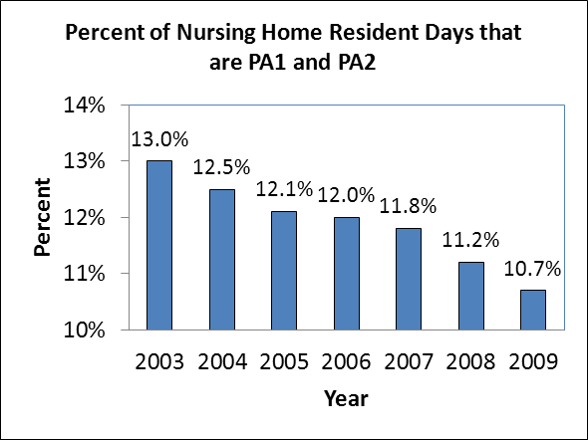
What does this benchmark measure? It measures the percent of nursing home resident days that are provided to residents with low nursing needs. For purposes of this measure, Resource Utilization Group (RUG) categories of “PA-1 & PA-2” are considered low needs. These are categories that include residents with no special conditions, no nursing rehab needs, and a low level of dependency in activities of daily living.

Why is this important? In order to reduce our reliance on nursing homes, we need to examine the way we use nursing homes, especially for people with fewer needs who could be maintained in the community if proper support services were available.

Where do we stand? In 2003, the overall state proportion of nursing home resident days that was low acuity was 13%. By 2009, this percent has gone down to 10.7%, indicating that a smaller proportion of those served in nursing facilities are light care individuals. This indicates that an increasing proportion of the people being served in our nursing facilities are high acuity, and that less disabled individuals are able to receive needed assistance in other settings.

Benchmark #3

Percent of Elderly Waiver and Alternative Care recipients that is high acuity
What does this benchmark measure? It measures the percent of the elderly served in the two largest publicly funded LTC programs (e.g., Elderly Waiver and Alternative Care) who are at higher risk for nursing home care because they are more disabled and need more intensive services. This measures the capacity of home-and community-based services to support frail people in their own homes, and not rely solely on institution-based approaches for persons with higher needs.

Why is this important? In order to reduce our reliance on nursing homes, we need to expand the ability of home and community care options to support more disabled frail elderly in their homes or apartments.

Where do we stand? In 2009 the statewide proportion of “higher risk” elderly served in the major publicly-funded community care programs was 50.0%. This benchmark has shown a steady though gradual increase from baseline year 2000, when about 36% of clients were at higher case mix levels.
Benchmark #4

Ratio of nursing home beds per 1000 persons 65+.

What does this benchmark measure?
It measures the current number of nursing home beds and computes the ratio of nursing home beds to the current population 65+. It allows a consistent comparison of the relative supply of nursing home beds and allows for comparisons across geographical areas within Minnesota and across states.

Why is this important? Minnesota’s ratio of nursing home beds per 1000 has historically been among the highest n the nation, and we are trying to reduce our reliance on nursing home-based long-term care. This measure helps us compare the supply of beds to the population, and monitor how this changes over time, as more community options are put in place.

Where do we stand? In 2008, the most recent date for which there is comparable data across all states, Minnesota had 53 beds/1000 age 65+ while the national average at that time was 44. In the past year Minnesota has moved somewhat closer, with about 51 beds per 1000 persons 65+ in 2009.

X. Conclusions and Future Challenges

A. Progress in Long-Term Care Reform

Since the Legislature first initiated reform of the state’s long-term care system in 2001, there has been steady and significant progress toward the stated goals of reform -- reducing the state’s reliance on facility-based long-term care and increasing our capacity to support elderly in their own homes and communities. The legislative initiatives and tools described in this report have contributed to the state’s overall success in this effort, and each of the four key Benchmarks shows that progress on all fronts continued through 2009.
- The proportion of public long-term care dollars for facility-based care has continued to decline as the state shifts its purchasing power to include more home- and community-based alternatives. Benchmark # 1 shows that in 10 years, Minnesota has moved from spending nearly 88% of all LTC dollars on institution-based care in 2000, to 71% in 2009.
- This is a result of state programs and incentives to down-size the nursing home industry, and at the same time to develop new community-based service and support alternatives. Benchmark # 4 shows that Minnesota has moved from having one of the highest rates of nursing home utilization in the country, 84 beds/1000 65+ in 1993, to 51 beds/1000 65+ in 2009 – a one third smaller ratio driven by a reduction in the number of beds against a background of a growing elderly population.
- Public long-term care dollars are increasingly targeted to persons with the highest needs. Benchmark # 2 shows that nursing home settings provide care to an increasing proportion of residents who are very frail (and a decreasing proportion who are less frail). At the same time, public funding for home-and community-based services is increasingly targeted to those with more disability and higher need (Benchmark # 3).

Minnesota’s measures of success in long-term care reform are currently focused on the balance between facility-based and community-based care options. In 2007 the Centers for Medicare and Medicaid Services (CMS) awarded grants to 10 states (including Minnesota) to use a common tool to describe their state long-term care systems and to explore the development of prototype “balancing indicators” for long-term care. The completed Minnesota State Profile Tool: An Assessment of Minnesota’s Long-Term Support System is available at: http://www.dhs.state.mn.us/main/groups/aging/documents/pub/dhs16_144888.pdf. As we move forward, new measures of “success” in system reform are likely to emerge which include such elements as consumer impact/outcomes, quality (as embedded in the Nursing Home Report Card and new HCBS Performance measures under development) and “value” or the cost-effectiveness of different providers and service models.

A number of initiatives enacted by the 2009 Legislature are currently being implemented. These initiatives will further advance long-term care reform, strengthen program sustainability and improve the consistency of the State’s long-term care programs across Minnesota. These initiatives include:
- Return to Community: enables consumers that have expressed a desire, at the time of admission, to transition back to the community after a stay in a nursing facility by utilizing home and community-based services.
- Comprehensive Assessment: implements a comprehensive assessment process and tool across all long-term care programs and populations.
- Provider Enrollment and Provider Standards: transitions DHS from lead agency contracts to a more consistent statewide approach to address waiver provider standards, qualifications and access to services.
- Rate Setting Methodologies: establishes statewide rate-setting methodologies for home and community-based services for individuals with disabilities.
- Customized Living Rate Setting Tool: accomplishes a consistent statewide approach to the negotiation of rates for customized living; establishes a rate reflective of the individual’s approved customized living service plan; and provides transparency in the component services that result in a specific rate.

B. Increased Community-Based Options and Activity in the Private Market

The current cohort of older persons in Minnesota has more “family resources” than either past or future cohorts. They have more children to help them—the Boomers are their adult children—and they are more likely to be married and live with a spouse. As noted in the report, older Minnesotans today are also more likely to purchase services to help them stay in their own homes, and more likely to seek some kind of housing-with-services arrangement when they decide that staying in their own home is no longer feasible. There has been a continued expansion of “housing-with-services” facilities and, within this, Assisted Living.

The proliferation of private services and options is a natural response to the increasing market demand. With this, however, come new challenges to the public responsibility for protecting the vulnerable from fraud or abuse. The state has made significant progress in targeting public dollars to those “at highest risk.” However, this has shifted—and will continue to shift—a significant amount of responsibility onto community resources and supports, especially family caregivers, neighbors and volunteers. Faith-based and other community-based initiatives already play a significant role in Minnesota’s long-term care system.

C. State Health Care Reform

Persons with multiple chronic illnesses are significantly more likely to experience preventable hospitalizations and to consult multiple physicians. As a result, fully 79% of all Medicare spending is for persons with four or more chronic conditions. Any efforts to contain America’s future health care costs must necessarily address these cost drivers. Minnesota, as a state, is beginning to move forward in this area. As of today, the majority of persons on the Elderly Waiver program are served under the auspices of managed care organizations. While this strategy holds great promise for integrating the social supportive and health care services, improving care while holding down costs, its implementation is yet too recent to be able to evaluate the outcomes

Legislation in 2007 requires that by January 1, 2015, all hospitals and health care providers (including physician offices, clinics, nursing homes, transitional care and home health care) must have in place an interoperable electronic health records (EHR) system. Assessments made by the 2007 e-Health Advisory Committee have identified two settings of special interest for implementation: public health and long-term care. However, a 2007 survey of nursing homes in Minnesota conducted by Stratis Health found that very few facilities are using electronic tools to support care delivery, and for those that are, they must use three or four different information systems to meet their needs. At this time there are few (if any) management information products available for long-term care applicability, and in order to move forward , long-term care providers, in concert with state e-Health authorities, must take a leadership role in defining the basic business requirements for a system that could meet their unique needs.

The use of new E-health products to improve long-term care extends across the entire healthcare spectrum. State health reform legislation in 2008 included the development of the health care home as an adjunct to the EHR system. The health care home model has been demonstrated to be more effective in managing serious and disabling chronic conditions than current mainstream health care delivery models. Two of these conditions – Alzheimer’s Disease and falls – are predictive of high levels of health care utilization and also nursing home placement. The multi-factorial nature of these conditions illustrate the need to coordinate the provision of both health care and community-based long-term care services to effectively address and stabilize health status and community living. In order to maximize the cost-effectiveness and impact of the health care home model the state must work towards (1) a seamless connection between health care and community-based long-term care and (2) consistent targeting of this coordinated service delivery to individuals determined to be at highest risk for unnecessary health care utilization or nursing home placement.

D. Federal Health Care Reform

The Patient Protection and Affordable Care Act, which was signed into law in March 2010, includes several important policy changes that seek to improve the delivery of health care and community supports for older people. DHS and MDH are exploring opportunities for Minnesota, to participate in the multiple reform components. The long-term care focused reforms include a Medicare medical home demonstration program, the CLASS Act long-term care insurance program, several nursing home reform measures and opportunities to expand home and community-based service options. The provisions that seek to expand access to health insurance coverage will likely result in increased demands on the health care workforce, which is already strained to meet current needs.

E. Other Major Trends

There are many significant trends that will influence and shape the kind of long-term care system that will evolve in Minnesota over the next 10-15 years. Within the larger context of significant challenges identified through Transform 2010, three will be significant for the future of Minnesota’s long-term care system.
- Changes in Minnesota’s Workforce: Both the general aging of Minnesota’s workforce, and the projected decrease in younger workers in the next few decades will put particular strain on the long-term care industry. Relatively low wages in a service industry, combined with the heavy, physical labor and emotional demands of direct care, make jobs in this industry less competitive. Among professionals in long-term care (i.e., nurses, physicians, therapists) there are presently unfilled positions and the forecasts are for fewer qualified persons seeking employment in these areas in the future. New service models will increasingly leverage non-paid assistance: extending and improving the care provided by family and unpaid sources, and expanding opportunities for and application of volunteer-based services. Maximizing the service capacity of paid workers requires service models where less time is spent on paperwork and travel; and more time is spent in direct service provision.

- Application of Technology: Minnesota is successfully moving toward a more decentralized system—where more frail persons are supported in their own homes and apartments. The growing challenge of this success is increasing need for (and costs of) transportation: either frail person must be brought to the service provider or the services must be brought to the person. Through the state’s CS/SD grants and other initiatives, service providers in Minnesota are increasingly using new telehealth technologies to improve monitoring and reduce the costs. We must continue to explore and implement technological solutions to the challenges of decentralization, as well as to the workforce issues described above.

- The State’s Economy: Project Transform 2010 has helped us to quantify the degree to which Minnesota will need to reduce its reliance on public sector funding for long-term care, and several strategies for increasing private funding. The population and economic forecasts for the state make this inevitable, regardless of the current state of the State’s economy. Minnesota is now challenged to invest in strategic changes—specifically, changes in service delivery models as described in this paper—in order to create the next, sustainable iteration of Minnesota’s Long-Term Care System.

APPENDIX

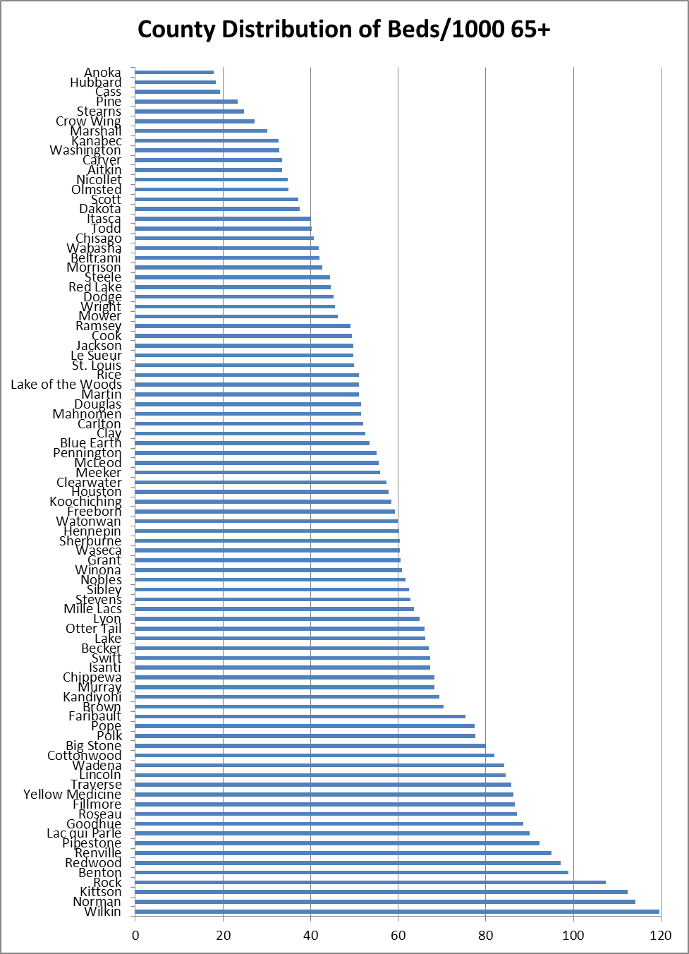
Out Migration By County, 2009
County | Admissions | Stay | Out migrated | Pct Out
Aitkin | 58 | 50 | 8 | 13.8%
Anoka | 255 | 206 | 49 | 19.2%
Becker | 146 | 141 | 5 | 3.4%
Beltrami | 96 | 92 | 4 | 4.2%
Benton | 243 | 236 | 7 | 2.9%
Big Stone | 35 | 33 | 2 | 5.7%
Blue Earth | 127 | 125 | 2 | 1.6%
Brown | 99 | 97 | 2 | 2.0%
Carlton | 105 | 94 | 11 | 10.5%
Carver | 78 | 73 | 5 | 6.4%
Cass | 48 | 43 | 5 | 10.4%
Chippewa | 57 | 57 | 0 | 0.0%
Chisago | 81 | 67 | 14 | 17.3%
Clay | 125 | 124 | 1 | 0.8%
Clearwater | 37 | 35 | 2 | 5.4%
Cook | 5 | 4 | 1 | 20.0%
Cottonwood | 59 | 58 | 1 | 1.7%
Crow Wing | 126 | 124 | 2 | 1.6%
Dakota | 387 | 358 | 29 | 7.5%
Dodge | 42 | 41 | 1 | 2.4%
Douglas | 143 | 138 | 5 | 3.5%
Faribault | 65 | 61 | 4 | 6.2%
Fillmore | 88 | 83 | 5 | 5.7%
Freeborn | 115 | 114 | 1 | 0.9%
Goodhue | 215 | 211 | 4 | 1.9%
Grant | 17 | 15 | 2 | 11.8%
Hennepin | 2,476 | 2,422 | 54 | 2.2%
Houston | 62 | 60 | 2 | 3.2%
Hubbard | 41 | 36 | 5 | 12.2%
Isanti | 95 | 88 | 7 | 7.4%
Itasca | 122 | 118 | 4 | 3.3%
Jackson | 31 | 28 | 3 | 9.7%
Kanabec | 115 | 113 | 2 | 1.7%
Kandiyohi | 167 | 163 | 4 | 2.4%
Kittson | 63 | 60 | 3 | 4.8%
Koochiching | 51 | 49 | 2 | 3.9%
Lac qui Parle | 52 | 52 | 0 | 0.0%
Lake | 28 | 27 | 1 | 3.6%
Lake of the Woods | 16 | 14 | 2 | 12.5%
Le Sueur | 53 | 48 | 5 | 9.4%
Lincoln | 36 | 36 | 0 | 0.0%
Lyon | 67 | 62 | 5 | 7.5%
McLeod | 114 | 113 | 1 | 0.9%
Mahnomen | 22 | 15 | 7 | 31.8%
Marshall | 20 | 16 | 4 | 20.0%
Martin | 79 | 77 | 2 | 2.5%
Meeker | 89 | 82 | 7 | 7.9%
Mille Lacs | 126 | 124 | 2 | 1.6%
Morrison | 109 | 106 | 3 | 2.8%
Mower | 95 | 85 | 10 | 10.5%

County | Admissions | Stay | Out migrated | Pct Out
Murray | 31 | 28 | 3 | 9.7%
Nicollet | 52 | 43 | 9 | 17.3%
Nobles | 81 | 81 | 0 | 0.0%
Norman | 39 | 38 | 1 | 2.6%
Olmsted | 221 | 208 | 13 | 5.9%
Otter Tail | 257 | 244 | 13 | 5.1%
Pennington | 44 | 41 | 3 | 6.8%
Pine | 85 | 71 | 14 | 16.5%
Pipestone | 46 | 46 | 0 | 0.0%
Polk | 221 | 219 | 2 | 0.9%
Pope | 54 | 53 | 1 | 1.9%
Ramsey | 1,254 | 1,218 | 36 | 2.9%
Red Lake | 11 | 9 | 2 | 18.2%
Redwood | 74 | 72 | 2 | 2.7%
Renville | 96 | 96 | 0 | 0.0%
Rice | 159 | 157 | 2 | 1.3%
Rock | 33 | 32 | 1 | 3.0%
Roseau | 58 | 57 | 1 | 1.7%
St. Louis | 686 | 681 | 5 | 0.7%
Scott | 111 | 107 | 4 | 3.6%
Sherburne | 125 | 123 | 2 | 1.6%
Sibley | 49 | 43 | 6 | 12.2%
Stearns | 209 | 178 | 31 | 14.8%
Steele | 117 | 116 | 1 | 0.9%
Stevens | 23 | 18 | 5 | 21.7%
Swift | 59 | 51 | 8 | 13.6%
Todd | 70 | 63 | 7 | 10.0%
Traverse | 26 | 26 | 0 | 0.0%
Wabasha | 55 | 54 | 1 | 1.8%
Wadena | 100 | 97 | 3 | 3.0%
Waseca | 58 | 54 | 4 | 6.9%
Washington | 244 | 228 | 16 | 6.6%
Watonwan | 39 | 35 | 4 | 10.3%
Wilkin | 31 | 31 | 0 | 0.0%
Winona | 152 | 146 | 6 | 3.9%
Wright | 194 | 177 | 17 | 8.8%
Yellow Medicine | 12,243 | 11,711 | 532 | 4.3%
State Total | 24,388 | 23,326 | 1,062 | 4.4%

Number of admissions for NH residents in calendar year 2009, if length of stay was greater than 30 days and the admission was no earlier than 7/1/2009.
Availability of Essential* Home and Community-Based Services/Supports, 2009

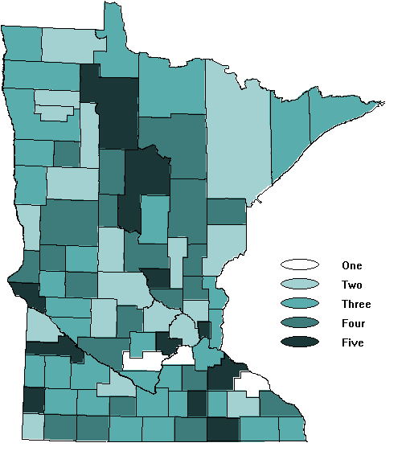
County has adequate supply one or more Essential Services*
*Essential Home and Community Based Supports defined as (1) Non-County Case Management,
(2) Chore Service, (3) Homemaker Service, (4) Home Delivered Meals and (5) Caregiver Training and Support

DHS Gaps Analysis, 2009
6/27/2010

Non-County Case Management, 2009

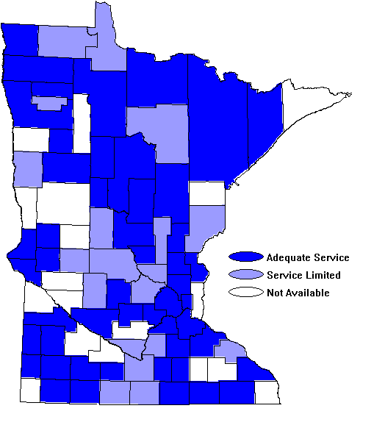

DHS Gaps Analysis 2009
6/24/2010

Chore Service, 2009

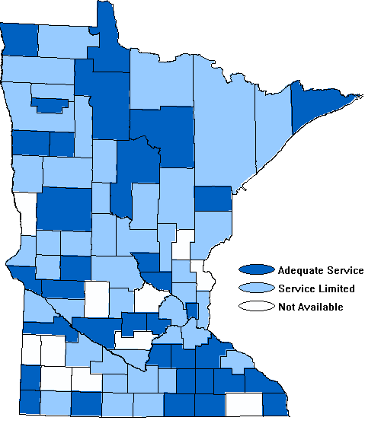

DHS Gaps Analysis 2009
6/24/2010

Homemaker Service, 2009

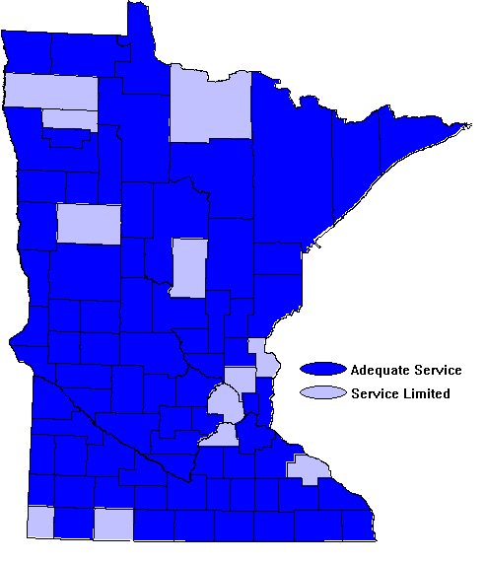

DHS Gaps Analysis 2009
6/24/2010

Home Delivered Meals, 2009

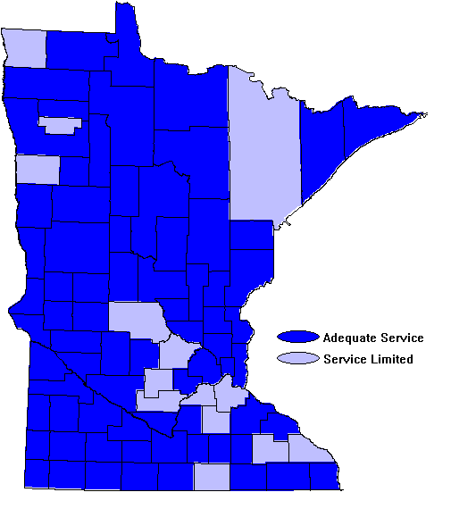

DHS Gaps Analysis 2009
6/24/2010

Caregiver Training and Support, 2009

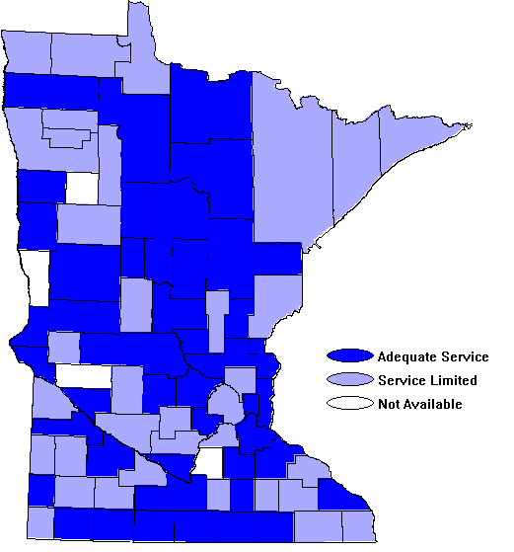

DHS Gaps Analysis 2009
6/24/2010

“Long-term care” and “long-term support” – these phrases are used interchangeably and defined as “a variety of services and supports to meet health or personal care needs over an extended period of time” intended to help a person maximize independence and functioning. U.S. Department of Health and Human Services, National Clearinghouse for Long-Term Care Information “Understanding LTC” Web site at http://www.longtermcare.gov, last updated October 22, 2008
Harvard University Initiative for Global Health and the Harvard School of Public Health, Business Week, September 15, 2006.
National Long-Term Care Survey, 2006.
He et al (2005) 65+ in the United States: Current Population Reports, National Institute on Aging.
2009, Thomson Reuters, Minnesota State Profile Tool: An Assessment of Minnesota’s Long-Term Support System, Table 1.2 (p. 8).
Houser, Ari (2007) Long Term Care Research Report, AARP Public Policy Institute.
Minnesota Board on Aging, 2005 Survey of Older Minnesotans.
The proportion of boomers who are projected to live alone is nearly twice the rate of current elderly (86.7 % higher). Census Bureau: Projections of the Number of Households and Families in the United States 1995-2010.
MN Board on Aging (2005) Survey of Older Minnesotans http://www.mnaging.org/advisor/survey.htm.
Activities of Daily Living include a standard set of 7 self-care tasks: Bathing; Dressing/undressing; Eating; Transferring from bed to chair/back; Continence; Using the toilet; and Ambulation.
Brennen Center for Justice (2007) Unregulated Work in the Home Health Care Industry; New York Times, New Options (and Risks) in Home Care for Elderly, March 1, 2007.
A more comprehensive description of the statewide LTC Gaps Survey is available on the DHS website at: www.dhs.state.mn.us/GapsAnalysis. This site provides an overview of service capacity by county and by region of the state. County-level information on key services is located in the Appendix.
Lincoln/Lyon/Murray counties and Faribault/Martin counties each submitted a single survey; their responses are represented as a single county agency.
This amount is the approximate equivalent of the cost of serving an estimated 1,000 persons in a nursing home setting for one year.
Data provided through 6/30/10. Total number of people served and volunteers used is duplicated across fiscal years.
In a parallel development, the Minnesota Board on Aging and Area Agencies on Aging are implementing CDCS service models under Title III (at least one in each planning and service area in the state) for caregiver respite and for nutrition interventions targeted to individuals at high nutritional risk.
The 2005 Survey of Older Minnesotans found that about 9% of persons age 65+ lived in market-rate rental apartments and slightly more that 4% lived in rent-subsidized housing; nearly 87 % owned their housing.
The Minnesota housing with service establishment definition: . . .an establishment providing sleeping accommodations to one or more adult residents, at least 80 % of which are 55 years of age or older, and offering or providing, for a fee, one or more regularly scheduled health-related services or two or more regularly scheduled supportive services, whether offered or provided directly by the establishment or by another entity arranged for by the establishment (MN Statutes Chap. 144D.01, subd.4).
MN Statute 144 G.03.
Programs and strategies that have been enacted (and modified) during this period to assist in right-sizing the nursing home industry include: (a) Moratorium on new licensure and MA certification of nursing home beds; (b) Pre-admission screening, now LTC Consultation; (c) Funding for HCBS, through Elderly Waiver and Alternative Care; (d) Local and regional long-term care planning and service “gaps” analysis, (e) Community Services and Service Development grants; (f) Nursing home bed layaway program; (g) Planned closure incentive payments; and (h) the Single bed incentive.
More information on the methodology behind this instrument is available in Section V of this report.
A New Vision of Aging: Helping Older Adults Make Healthier Choices. Issue Briefing No. 2, Center for the Advancement of Health, Washington, DC, March 2006.
More information on the Minnesota Falls Prevention Initiative is available at www.mnfallsprevention.org.
These same consultation services are also being provided to their respective members by tribes and managed care organizations under contract with DHS to support long-term care decision making, and connect individuals to home and community-based alternatives, including publically-funded alternatives.
Some of this increase is attributable to MCO use of the LTCC assessment process to perform health risk assessments of all enrolled members living in the community.
Fee-for-service data and some EW managed care data from Burwell, Brian; Sredl, Katherine; and Eiken, Steve Medicaid Long-Term Care Expenditures in FFY 2008 Thomson Reuters: December 1, 2009. Expenditures are based on Federal Fiscal Year. Additional data provided by MN Department of Human Services, Aug-Sept. 2009.
For technical reasons this measure has been converted to a count of resident days rather than residents, and includes all nursing home residents regardless of age. For the Benchmark measures reported here, prior year measures have been re-computed to reflect this change, allowing the use of one standard methodology for comparisons across time.
MDH (2008) A Prescription for Meeting Minnesota’s 2015 Interoperable Electronic Health Record Mandate.
Information and recommendations from this project are available on the web at www.dhs.mn.us/2010.

