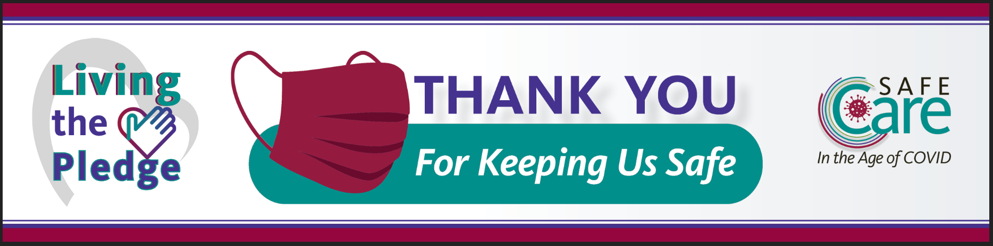
Introducing the
Living the Pledge Campaign
We are so proud of how hard everyone is working to follow safe practices and honor our pledge and commitment to do our best to keep residents, staff, and visitors safe during the COVID-19 pandemic.
As time goes by during this pandemic, we might find ourselves relaxing our safe practices. It takes all of us working together and reminding each other of those basic, but critically important, safety actions.
That’s where the Living the Pledge Campaign comes in. Each month, we will focus on a different prevention practice to support each other in following the proper practice for every person, every time. And, we hope to have some fun and celebrations along the way.
What Will You See?
- Posters highlighting a key practice for the month’s focus topic.
- You can earn vouchers from staff who “catch you” doing the safe practices highlighted in the posters.
- Vouchers can be redeemed for a chance to receive prizes in our monthly “Living the Pledge” drawing.
Please share with us your ideas on how we can support each other in Living the Pledge to Safe Care for everyone, every day.
We are better together!

