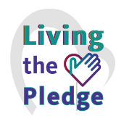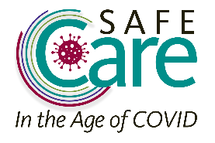­­­­­­

**I am a Safe Care Hero: I Got Vaccinated!**

*Together we can Honor the Safe Care Pledge to keep*

*those we serve, and our co-workers, along with*

*our families and community, Safe from Harm.*

INSERT PICTURE HERE