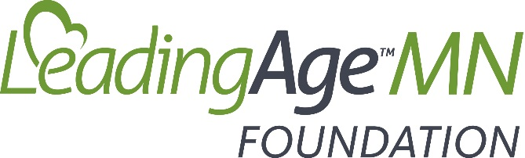

SCHOLARSHIPS AVAILABLE NOW!
Investing in the professional development of the aging services workforce is one of the signature areas of focus for the LeadingAge Minnesota Foundation. To that end, the Foundation is excited to offer educational scholarships for 2021.
To qualify, applicants must:
- Be 17 years of age or older;
- Be employed by a provider member of LeadingAge Minnesota (care center, senior housing, assisted living, adult day, etc.);
- Be currently enrolled (or enroll no later than Fall of 2021) in an accredited post-secondary institution of higher education;
- Complete the scholarship application; and
- Provide two letters of recommendation.
Scholarship awards range from $500 to $1,500.
Applications are available at:
www.leadingagemn.org/about/aging-services-foundation/foundation-scholarships/

The deadline to apply is 5:00 P.M., Monday, June 7, 2021.

