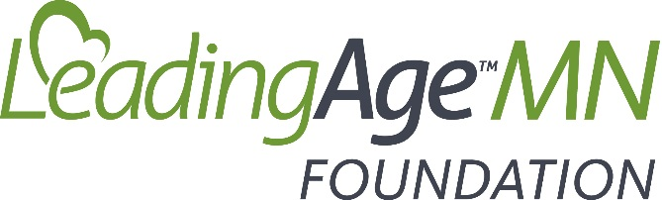
2021 Silent Auction Donation Form
~ Please complete one form per donated item ~
Date: __________________________________
Please indicate the type of donation:
- Personal Donation
- Corporate Donation
Name: _____________________________________________________________________________________
Company: _____________________________________________________________
Address: ______________________________________________________________

City: ___________________________________ State: _______ Zip: __________

Phone: _______________________________________________________________

E-mail: ________________________________________________________________

Description of Donation: __________________________________________________
______________________________________________________________________
Monetary Value of Donation: $____________________________________________
- LIVE AUCTION DONATION: I will send/drop off at: LeadingAge Minnesota, ATTN: Lori Meyer, 2550 University Avenue West, Suite 350 South, St. Paul, MN 55114

Please email completed form ASAP to Lori Meyer at lmeyer@leadingagemn.org. All donations—items or cash/check—must be received by Wednesday, July 28, 2021.For questions regarding the 2021 LeadingAge Minnesota Foundation Silent Auction, or to make alternative donation arrangements, please contact Lori Meyer, Senior Vice President & Chief Operating Officer, at lmeyer@leadingagemn.org or 612.308.6504.
Thank you for your donation & support of the LeadingAge Minnesota Foundation!

The LeadingAge Minnesota Foundation is a 501(c)(3) tax-exempt organization. Although the Foundation does not determine the value of non-cash contributions, you may be able to deduct the value of your gift as a donation for Federal income tax purposes. Consult your tax advisor. The Foundation does not provide goods or services to donors in exchange for their gifts.
Item # _______________
Date Received_________
For LeadingAge MN Use Only

