Mentorship Application
Employee Name: _______________________________________ Date: ________________
Department: __________________________________ Supervisor: ____________________

Job Function
The main responsibility of the Mentor is to foster genuine relationships between new hires and to offer support and resources to ensure a successful work environment. The mentor will provide hands on support for those who have been newly hired by The Good Shepherd Community. Such tasks will include; explaining how the organization is structured, supporting and encourage Good Shepherds mission and values, be a positive role model, and remain accessible, committed, and engaged throughout the mentees first year of employment.

How Would Others Describe Your Personality? (Circle all that apply)

Compassionate
Outgoing

Friendly
Encouraging

Sympathetic
Motivational

People Person
Approachable

Open Ended Questions
Why would you like to become a mentor?
____________________________________________________________________________________________________________________________________________________________________________________________________________________________________________________________________________________________________________
What do you hope to gain from becoming a Mentor? What would you like your Mentee to gain from you?
____________________________________________________________________________________________________________________________________________________________________________________________________________________________________________________________________________________________________________
What is your favorite thing about working at Good Shepherd?
____________________________________________________________________________________________________________________________________________________________________________________________________________________________________________________________________________________________________________

Why is having a positive and caring team important to you?
____________________________________________________________________________________________________________________________________________________________________________________________________________________________________________________________________________________________________________
Applicant Signature: _______________________________________ Date: _____________

Supervisor Review/Verification
______________________________ has indicated she/he would like to become a Mentor and help train our future team members. We highly value your input and ask that you complete the following rate scale and answer a couple questions.

 | (5) = Exceptional | (4) = Exceeds Requirements | (3) = Meets Requirements | (2) = Gets By | (1) = Needs Work
Is a team player throughout the shift | ☐ | ☐ | ☐ | ☐ | ☐
Finds ways to help keep residents and the shift relaxed | ☐ | ☐ | ☐ | ☐ | ☐
Is a positive role model | ☐ | ☐ | ☐ | ☐ | ☐
Is polite to residents, staff and visitors | ☐ | ☐ | ☐ | ☐ | ☐
Shares job knowledge professionally and respectfully | ☐ | ☐ | ☐ | ☐ | ☐
Uses job knowledge to benefit the residents/team | ☐ | ☐ | ☐ | ☐ | ☐
Listens well to others and follows what is being asked | ☐ | ☐ | ☐ | ☐ | ☐
Communicates well with others | ☐ | ☐ | ☐ | ☐ | ☐
Is approachable and responds well to any questions | ☐ | ☐ | ☐ | ☐ | ☐

Represents the values of Service with Compassion, Trust and Respect | ☐ | ☐ | ☐ | ☐ | ☐

Open Ended Questions

Explain a situation where the applicant demonstrated good team work?
______________________________________________________________________________________________________________________________________________________________________________________________________________________________________________________________________________

How does the applicant try to engage all staff in working as a team?
______________________________________________________________________________________________________________________________________________________________________________________________________________________________________________________________________________

Is the applicant seen as someone who is approachable and easy to talk to or ask questions?
______________________________________________________________________________________________________________________________________________________________________________________________________________________________________________________________________________

Supervisor Signature: ________________________________________ Date: ____________

Leadership Pin Earned by Mentors

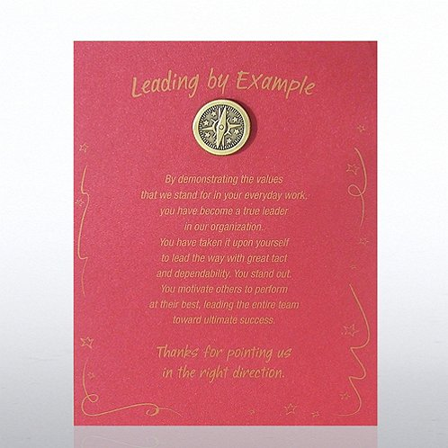

Source: https://www.baudville.com/awards/lapel-pins/premium-pins/character-pin-compass-leading-by-example/details/8/1/71098

