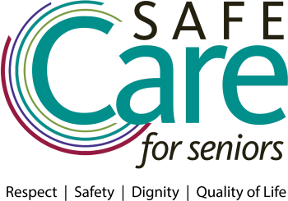

SAMPLE SOCIAL MEDIA POSTS

FACEBOOK
We encourage you to share photos of your event, quotes from people who spoke at your event or feature individual or group photos of staff members, residents and/or family members who took the pledge.

- Celebrating and renewing our commitment to respect and dignity – always, and providing safe, quality care. X people took the Safe Care for Seniors pledge! @leadingagemn #safecare
- Creating safe, trusted environments for all who live and work at @InsertOrgName through Safe Care for Seniors. @leadingagemn #safecare
- We took the Safe Care for Seniors pledge and are ready to better our best in pursuit of our united mission – quality of life for those we serve! @leadingagemn #safecare
- Safe Care for Seniors is a partnership at @InsertOrgName between our staff, residents and families. Thank you all for making the pledge, and committing to respect, safety and dignity. Together we will prevent harm in the course of caregiving. @leadingagemn #safecare

TWITTER
We encourage you to use share photos of your event, or individuals who made the pledge as part of your social media promotion.

United in a shared mission: Safe Care for Seniors @leadingagemn #safecare
- We Took the Pledge: Safe Care for Seniors @leadingagemn #safecare
- X caregivers took the Safe Care for Seniors pledge at Insert Org Name. @leadingagemn #safecare
- Respect. Safety. Dignity. Quality of Life. Our Pledge. Our Mission. @leadingagemn #safecare
- Bettering our Best w/ Safe Care for Seniors. @leadingagemn #safecare

