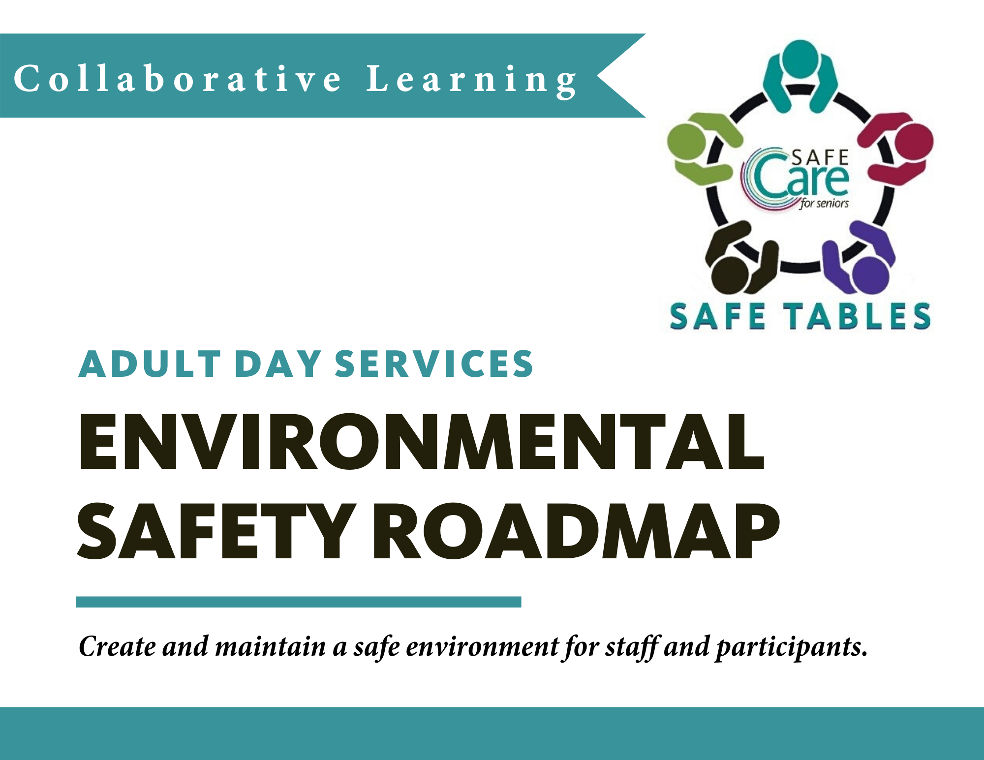

BACKGROUND – SAFE TABLES
As part of Safe Care for Seniors, LeadingAge Minnesota started a process for collaborative learning and sharing we call Safe Tables.

A Safe Table is a safe space to come together and explore a targeted safety issue by conducting a deep dive into the key factors contributing to the safety events and developing and sharing prevention strategies and tools.

IDENTIFYING THE NEED
The Adult Day Services Quality Work Group of the LeadingAge Minnesota Adult Day Committee identified the need for a structured tool and resources to support providers in ensuring their participants were receiving services in a safe environment.

Through review of best practices and shared learning, the Adult Day Services Quality Work Group developed a set of base recommendations along with tools and resources for improving environmental safety.
USING THE ROADMAP AND TOOLS
Adult Day Services providers can use the Environmental Safety Roadmap to assess the practices currently present in your organization by clicking on the checkbox next to each practice.

Based on the findings of your assessment, you can use the Action Planning Document (or another action planning tool) to create a plan to address one or more of the practices identified as an area of initial focus.

Toolkit items and implementation tips are included in each section to provide examples that you can use as reference or customize for your program. Included in the tools are a series of daily, weekly and monthly safety checklists that you can use and modify for your program.

Disclaimer: Information and tools shared in the Environmental Safety Roadmap are intended for purposes of sharing, learning and improvement only. The practices outlined in this document should not be interpreted as setting a standard of care.

Environmental Safety Recommendations
A structured process is in place to create and maintain a safe environment for staff and participants by implementing the following practices, at minimum:

Environmental Safety Practice  (check box if practice is in place in your organization) | Toolkit Items & Implementation Tips
☐ Appoint a Safety Champion to oversee safety checklist, track safety concerns and lead safety improvement efforts  ☐ Develop a Safety/Quality Committee that meets quarterly to review safety/quality issues and develop and track improvement projects  ☐ Conduct regular (weekly/monthly) leadership rounds to build a culture of safety and trust so that staff feel comfortable speaking up and reporting concerns  ☐ Implement a process for staff to report incidents/safety concerns and for leaders to respond to, and address, concerns  ☐ Implement a process to conduct Root Cause Analysis (such as the “5 Whys”) when safety events occur and develop an action plan, with strong actions, to address findings  ☐ Implement a process to report and resolve concerns identified in safety rounds  ☐ Create a structured process to conduct mock drills for emergency codes  ☐ Track and implement state regulations related to creating a safe environment  ☐ Conduct Daily Safety Checks  ☐ Conduct Weekly Safety Rounds  ☐ Conduct Monthly Safety Sweeps | TOOLS:  DHS Safety Requirements  DHS Physical Plan and Space Requirements  Leadership Rounding Toolkit  The “5 Whys” Tool  Hierarchy of Safety Actions  Daily Safety Checklist  Weekly Safety Rounding Template  Monthly Safety Sweeps Rounding Template  IMPLEMENTATION TIP:  Customize the types of drills and frequency of drills you conduct in your organization to address state/local requirements and internal priority areas – i.e., Fire Drills; Tornado Drills; Active Shooter; Disaster Plan; Code Blue; and/or Rapid Evaluation Teams, a new LeadingAge MN initiative.
NOTES:

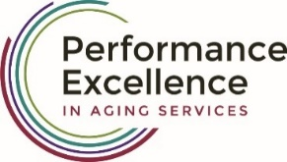
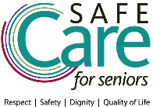

adult day services environmental safety action plan:
action (s) | target date | person responsible | notes

