[AGENCY NAME]
POLICIES AND PROCEDURE

SUBJECT: DEVICES AND DEVICE ASSESSMENT

Accountability: Clinical Nurse Supervisor Document No.:

POLICY:

- Due to the risk of injury related to the use of physical devices, such devices will only be used after an assessment has been completed to determine the risks and benefits of this use.
- The resident/responsible party will be educated regarding the risks and benefits of physical devices. Physical devices will be reviewed for safety and used according to manufacturer’s recommendations.
- Continued use of physical devices will be assessed at least every 90 days or with significant change to determine if the device is still needed to enhance the resident’s safety and/or bed mobility.
- If the physical device restricts a resident’s freedom of movement, it constitutes a restraint, and our facilities are restraint free. Physical devices that do not restrict the resident’s freedom of movement and are used to assist the resident/client in bed mobility are not restraints.
- Physical devices include, but are not limited to, side rails (half or full); grab bars, halo bars, positioning poles.
- Grab bars that are either placed/attached or strapped between the mattress and box spring or bed frame are not allowed in our building. If the facility staff learn of a device like this on a bed it will be removed and alternatives will be discussed with the resident/responsible party.
- If a resident needs a device to assist with bed mobility the preferred device is a Halo. This device can be safely placed on a residential bed.
PROCEDURE:
- If the resident expresses the desire to use a device or a device is in use / recommended, a nurse will complete a device assessment at the time of move in, upon hospital return, change in condition, and / or upon discovery of a rail.
- The licensed nurse or designee will review the risks and benefits of device use and potential device alternatives with the resident and/or responsible party.
- Devices will be installed as appropriate for the type of bed:
  - For hospital beds: Device will be installed per FDA guidelines
  - For non-hospital beds: Devices will be installed according to the device manufacturer’s instructions.
- Documentation will be entered in the resident’s record to include:
  - Results of the assessment
  - Discussion with resident/responsible party regarding risks and benefits and alternatives considered / recommended
  - Decision made/outcome of discussion.
- Staff will be educated to report to a licensed nurse immediately if the device is found to be loose or malfunctioning.
- Physical devices will be assessed for safety during each re-assessment. If there are any safety issues identified, the Director of Health Services, or Housing Director will be notified immediately.
- Maintenance staff will inspect bed and mattress for zone safety on a monthly basis.
- Maintenance staff will inspect bed devices monthly. If the device has become loose / unstable in any way it will be removed and the responsible party will be notified. Or you may choose to have maintenance attempt to secure the device and if unable remove it and notify the responsible party.
- Two times per year the Clinical Nurse Supervisor, or designee, will check the FDA website for recalls on bed assistive devices. Customize how you’ll monitor for this – you can either Search the FDA Data Base or sign up for the FDA Email Subscription where you can choose your alerts and device/safety is one option.
- If a licensed nurse, or other designee believes that the assistive device places the resident at risk for harm (EX: Unable to use safely etc) it will be removed and the family will be notified.
Information from FDA Regarding Side Rails:
In 2006, the Food and Drug Administration (FDA) released its recommendations for reducing entrapments. The FDA identified seven “zones of entrapment” and recommended maximum dimensions for four of the zones.
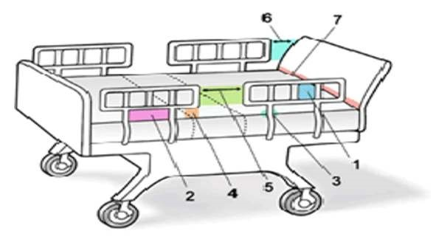
In the diagram above, zones 1, 2, and 3 are areas where a person’s head can be caught within the side rail or between the side rail and the mattress. Zone 4 is an area where a person’s neck can be caught between the side rail and the mattress.
The FDA recommends that the dimensions in Zones 1-4 be less than:
- Zone 1: Within the Rail (4.75”)
- Zone 2: Under the Rail, Between the Rail Supports or Next to a Single Rail Support (4.75”)
- Zone 3: Between the Rail and the Mattress (4.75”)
- Zone 4: Under the Rail, at the Ends of the Rail (2 and 3/8” and greater than 60° angle)
The FDA has not established recommended maximum dimensions for Zones 5-7:
- Zone 5: Between Split Bed Rails
- Zone 6: Between the End of the Rail and the Side Edge of the Head or Foot Board
- Zone 7: Between the Head or Foot Board and the Mattress End

Effective Date:
Reviewed By: Date:
Revised By: Date:

