LTC Payment Reform Legislation

Overview
This year, another 60,000 Minnesotans will turn 65. Minnesota's senior population is growing so quickly that it will double during the time that baby boomers will retire -- eventually becoming one-quarter of Minnesota's population. This group of seniors is expected to live longer, and likely will require more care, than any group of seniors in the state's history.

The Age Wave has arrived, and it will change how we think about senior care. The current funding system for long term care in Minnesota will not be able to serve the needs of seniors, caregivers or the state. However, actions we take this legislative session can create a permanent solution that ensures that the full cost of quality care is covered for every senior in Minnesota, while providing incentives for innovation and efficiency that will preserve the quality of life for our seniors -- today and in the future.

2015 Legislative Goals
- Preserve Access to the Continuum of Care
- Invest in Recruitment and Retention of Caregivers
- Reward Quality Care
- Preserve Dignity and Quality of Life, Regardless of How and Where Services Are Delivered
- Institute a Payment System That Fully Funds the True Cost of Care - Today and Tomorrow

Payment Reform
Senator Tony Lourey (DFL-Kerrick) and Representative Joe Schomacker (R-Luverne) have introduced SF273/HF316 which will change the way the state pays for services for older adults. This bill is designed to address all of the goals listed above and to put into place effective payment systems that will serve the state, providers and consumers well as the state faces the age wave.

Nursing Facility Rates
One key aspect of the bill is an update of the state's nursing facility reimbursement system, the methodology that governs most public and private payments for facility-based care for seniors.
Below is a summary of the proposed calculation for each component of the rate in the new payment system proposal and information on the modeling results. The bill calls for full implementation of the new rate system on October 1, 2015, with the exception of property rates which would change on October 1, 2016. To determine rates under the new system, DHS will use the most recent statistical cost report and quality measures available. The year ending 9/30/2014 cost report will be used for establishing the October 1, 2015 rates.

Care-Related Rate: This component pays for nursing, social services, raw food and activities. It is calculated using the actual costs reported on the cost report by each facility.
- The nursing portion of this per diem is adjusted for case mix to address variation in the needs of residents. The non-nursing care portion is not adjusted for case mix.
- A facility’s care related rate is the lower of the actual facility cost per diem or a limit.
- The limit is determined by two components, percentage of peer group median costs and quality score. Current proposal is to use quality scores from 10 (95% of median limit) to 90 (140% of median limit) with limit percentage being adjusted on a straight line basis for quality scores between 10 and 90 (i.e., score of 50 equals limit of 117.5% of median).

Other Operating Rate: This component pays for dietary staff, housekeeping, laundry, utilities and administrative costs such as property and liability insurance.
- Each nursing facility will receive a price that is calculated as 105% of the peer group median costs.
- This component is not adjusted for case mix, and provides a strong incentive for efficiency because higher individual facility costs does not increase rate.

External Fixed Rate: This component pays for a number of items that are out of the control of the facility or do not change annually, including bed closure incentives, surcharge, property taxes, license fees and the surcharge. Biggest change in this bill is to add health insurance costs, which is defined as costs of employer plans, contributions to HSAs and the cost of employer shared responsibility payments.

Property Rate: This component pays for the cost of building and maintaining the physical property. A new property payment system will begin implementation on October 1, 2016 to provide a system for funding necessary investments in facility improvements. The details of this proposal will be developed early this year and introduced as an amendment to the proposal in March.

Peer Groups: The legislation groups nursing facilities into two new geographic peer groups based on existing labor market differences identified from current wage data (see map below). Within each group, the care-related rate is based on individual costs compared to a limit that is influenced by both quality score and the costs of other peer group facilities, so these groups DO NOT represent a specific rate level for each sets of counties.

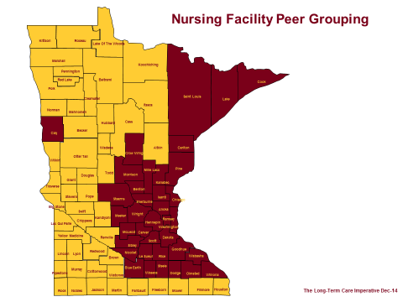

Other States: Before developing this proposal, we reviewed the Medicaid rate systems in place in other states, to see what approaches were being used most often. The current payment system in Minnesota, where rates are essentially frozen unless the Legislature acts to provide an increase, has not functioned well over the last twenty years and has resulted in a significant level of underfunding. As the graphic below shows, we are also an outlier in that we do not currently use the cost and price features that are part of this proposal.

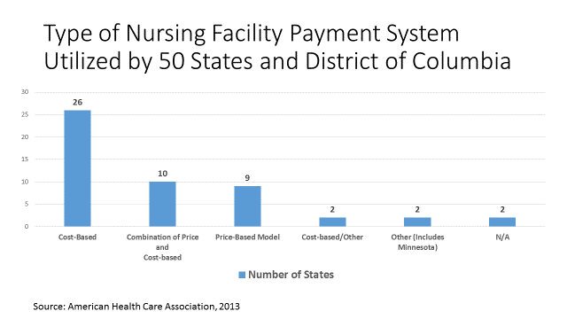

Modeling Results: Working with DHS, we have modeled the changes to the operating and external fixed components described above using the 2013 cost reports and have compared the new rates against current facility rates. The rate increase distribution is:

Percent increase in Revenue | Number of Nursing Facilities
0% to 5% | 12
5% to 10% | 14
10% to 15% | 19
15% to 20% | 55
20% to 25% | 70
25% to 30% | 83
30% to 35% | 59
35% to 40% | 26
40% or Greater | 29

Additional facts of full implementation:
- Average rate increase of 25%
- Rate increases are slightly higher in gold (rural) group (27% in gold group, 24% in maroon)
- Annual costs of new operating payment system to state is around $105 million

Stable, Predictable Funding for the Continuum of Care
Another key part of payment reform is linking the Elderly Waiver budget caps to changes in nursing facility rates. The Elderly Waiver (EW) program funds home- and community-based services (HCBS), including services provided in assisted living settings for people age 65 and older who are eligible for long-term care under Medicaid (MA).

EW has successfully created opportunities for Medicaid recipients to access services in settings other than nursing facilities. Since the program began, it has saved the State of Minnesota billions of dollars by allowing for client choice and access to HCBS services. This legislation will re-institute the link between EW budget caps and nursing facility rate increases, allowing seniors to choose the most cost effective and appropriate setting for the care they need.

Cost of Bill
Initial cost estimates indicate that this legislation will cost about $200 million in state funds for the biennium with nursing facility operating payment system changes making up the bulk of the proposal’s cost.

