The Covid-19 emergency funding response by the state and federal governments has raised many questions for Minnesota’s nursing facilities.

* What funding program is responsible for covering which costs?
* What “order” should the funding be used?
* Which instructions or guidelines supersede other instructions?
* How is an expense determined allowable under each relief program—which of the following rules/policies take precedence??
  + The rules in effect on the day the expense occurred.
  + The rules created during the pandemic.
  + Pre-existing state and/or federal policies.
  + Or some set of laws or rules that were unknown at the time the expense occurred.
* Funding received, expenses incurred, and revenue lost, do not align with:
  + The use of October 1 for the beginning and September 30 for the ending of the 12-month Medicaid cost report period.
  + The pandemic’s uncontrollable arbitrary start and end dates—note the end date has not yet happened.
  + Federal reporting requirements that are still not settled and partially understood; this point is further exacerbated due to the change in administration and agency staff.

|  |  |  |  |
| --- | --- | --- | --- |
| **Decreased Census** | **Increased Expense** | **Decreased Revenue** | **Increased Funding** |
| Arrow Down with solid fill | Arrow Up with solid fill | Arrow Down with solid fill | Arrow Up with solid fill |

The overlap of cost reporting and funding from emergency relief programs will confound rate setting for two years or more.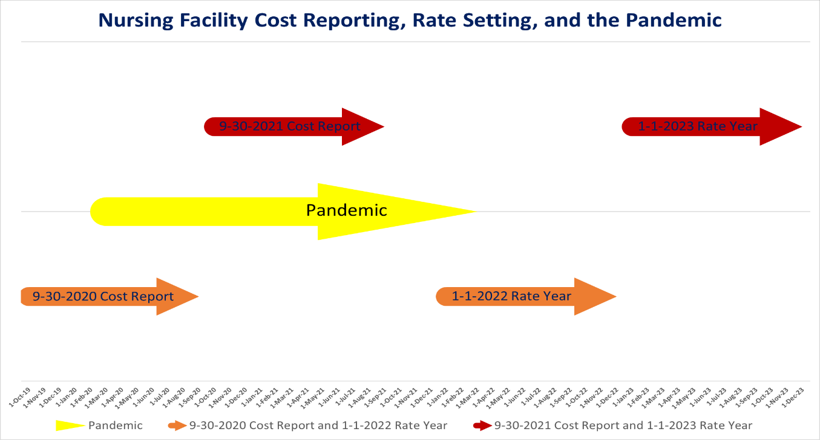

Nursing facilities have balanced the immediate needs of their residents and staff with the possibility that no more federal aid will arrive and lack of clarity about whether or when they can access state emergency funds. The federal funds require reporting, an audit, and the return of any unused funds. While there are numerous pages of guidance, neither the reporting form nor the instructions are yet available and with the administration change this information may not be immediately forthcoming.

While there is potential relief from **Minnesota Medicaid via 12A.10 statutes**, the emergency powers granted to the Minnesota Department of Human Services were designed with a discreet type of emergency in mind that impacted a small number of providers at a time. Previously, qualifying emergencies included damage from tornados and evacuations due to flood or fire. The pandemic, however, is not isolated to a specific day or week, but instead the pandemic will continue through 2021 and cross multiple cost reporting periods.

DHS has developed a process for nursing facilities to receive payment for Covid-19 related costs via the 12A.10 statutes. These payments will be adjusted off the cost report when setting rates in the future. The routine cost reporting and rate setting, the impacts of the pandemic on expense and revenue, the always changing guidance, and Minnesota Statutes 12A.10 have created several issues.

DHS has provided some guidance about the interaction between state and federal emergency funds:

* Healthcare related expenses attributable to coronavirus that another source has not reimbursed and is not obligated to reimburse are eligible for 12A.10 funding. DHS believes that federal relief funds must be used prior to 12A.10.
* Provider relief fund payment amounts not fully expended on healthcare related expenses attributable to coronavirus are then applied to patient care lost revenues.

DHS has stated that 12A.10 is the payer of last resort. However, the federal government has guidance indicating that state Medicaid programs should be accessed before using federal relief funds. Compounding the issue is that DHS needs information reported by a certain date for expenses from the 9-30-2020 cost report year to be eligible for 12A.10 payment. Since the federal government has not yet issued their reporting instructions, nursing facilities are concerned that they might expend resources that the federal government rejects, leaving them with no way to access state funding because of the deadline for 12A.10 requests for the 9-30-2020 year.

|  |  |
| --- | --- |
| **Nursing facilities will exit the pandemic with many challenges including:** | * Workforce * Decreased census * Altered payer mix |
|  |

Minnesota nursing facility payment system needs to focus on the goal of maintaining access to services via reimbursement rates that are adequate to achieve that goal.

**BACKGROUND ON STATE EMERGENCY FUND FOR NURSING FACILITIES:**

**MINNESOTA STATUTES 12A.10 HUMAN SERVICES.**

Subdivision 1. Costs eligible for payment. As used in this section, "commissioner" means the commissioner of human services. Notwithstanding the limitations of section 12A.01 and the requirement in section 12A.03 that all appropriations must be used to assist with recovery, the commissioner may pay parties under contract, provider agreement, or other arrangement with the commissioner as of the date of a natural disaster, or the date when action was taken in anticipation of a possible natural disaster or other event that threatens the health and safety of individuals served by a program that receives funding from medical assistance for the costs of evacuation, transportation, medical, remedial, or personal care services provided to vulnerable residents. Costs eligible for payment under this section are those necessary to ensure the health and safety of medical assistance recipients during and up to 60 days following the disaster. Only costs that are not already paid for by another source are eligible. The commissioner may make payments for documented incremental costs incurred by a party, may determine an estimate of the costs at the sole discretion of the commissioner, or may use a combination of these two methods. If after receiving payment from the commissioner for a documented cost, the provider is able to acquire payment from another source for that cost, the provider shall reimburse the commissioner in the amount paid.

Subd. 2. Payment in residential program. In a residential program, the commissioner shall make payment under this section based on an allocation of costs as determined under subdivision 1 between medical assistance recipients and all other residents. The allocation must not be done in a nursing facility. In a nursing facility the commissioner shall pay all of the costs determined under subdivision 1.

Subd. 3. Source of payment. The commissioner shall pay costs under this section using money appropriated for medical assistance and shall seek federal cost sharing to the extent permitted under the Medicaid state plan or under waivers granted by the federal Centers for Medicare and Medicaid Services.

Subd. 4.Nursing home bed layaway. In consultation with the commissioner of human services, the commissioner of health may waive timelines specified in section 144A.071, subdivision 4b, at any time when a partial or complete evacuation occurs in response to a natural disaster, a possible natural disaster, or another event that threatens the health and safety of residents of a nursing home. For a nursing home placing beds in or removing them from layaway under this subdivision, property payment rates must not be adjusted.

**Current DHS assumptions on 12A.10:**

* 12A.10 is an authorized reimbursement program under the general Medicaid State Plan Amendment (SPA) authority.
* Establishment of future rates is under SPA authority.
* 12A.10 is not a COVID provider relief fund.
* Only incremental COVID costs that are not already paid for by another source are eligible.
* HHS guidance on allowable uses of PRFs is not directing how the use of the funds will affect cost findings for future rates established under the SPA.

**US Department of Health and Human Services guidance on federal funding and Medicaid:**

My state or territorial Medicaid or Children’s Health Insurance Program (CHIP) agency has directed providers to use Provider Relief Fund dollars before applying Medicaid or CHIP reimbursement, as well as Medicaid COVID-19 supplemental payments, to cover health care-related expenses or lost revenues attributable to coronavirus. Is this permissible? (Added 12/28/2020)

**No.** As it relates to expenses, providers identify their health care-related expenses, and then apply any amounts received through other sources (e.g., direct patient billing, commercial insurance, Medicare/Medicaid/CHIP, reimbursement from the Provider Relief Fund COVID-19 Claims Reimbursement to Health Care Providers and Facilities for Testing, Treatment, and Vaccine Administration for the Uninsured, or funds received from FEMA or SBA/Department of Treasury’s Paycheck Protection Program) that offset the health care-related expenses. Provider Relief Fund payments may be applied to the remaining expenses or cost, after netting the other funds received or obligated to be received which offset those expenses.