MDH Recommendations for Long-term Care Visitation and Activities:
How and When to Safely Transition to the Next Level Throughout the COVID-19 Pandemic
TIP SHEET: Case Activity Level in Community
Appendix A of the MDH Recommendations identifies a number of risk factors that facilities should considering when determining when and how to transition from Level 1 to Level 2 (or back again). One of those factors is the COVID-19 case rate in your community. MDH advises that providers should be informed of the level of community transmission by monitoring the 14-day case rate in their county.
STEP 1: Navigate to the MDH COVID-19 Weekly Report (LINK). This report is updated every Thursday and includes detailed information on testing, confirmed positive cases, demographics, likely exposure, and syndromic surveillance.
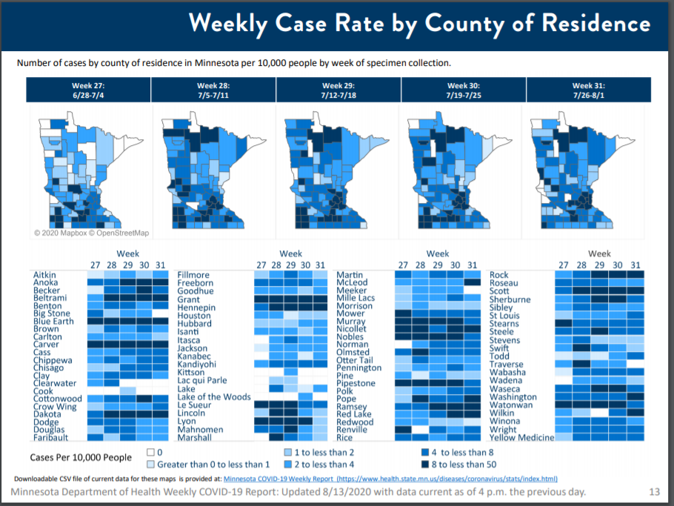

STEP 2: Select the Weekly Case Rate by the County of Residence link and download the Weekly Case Rate by County of Residence (CSV) file.
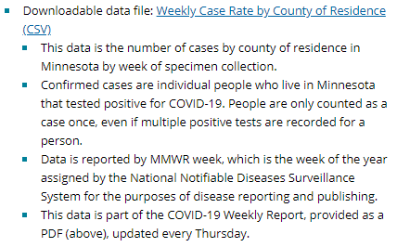
STEP 3: Add the numbers of the two most recent weeks in your county to determine the 14-day case rate. If that number is greater than 10, you may consider the county at elevated risk of disease transmission.
STEP 4: If a facility is close to a county border, also assess the adjacent county’s case incidence. Make the same calculation as in Step 3.
EXAMPLES
Here is a screen shot of the first few rows of the downloadable file:
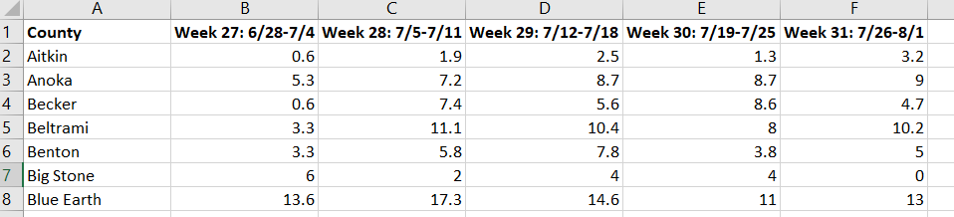

If using this tool on August 14, you would add the numbers for the two most recent weeks of available data (July 19 – August 1) and add the numbers for those weeks together. E.g.
- Aitkin County: 1.3 + 3.2 = 4.5
- Blue Earth County: 11 + 13 = 24
If that number is greater than 10, you may consider the county at elevated risk of disease transmission. This is one important risk factor for a provider to consider, but it is not determinative. It should be considered along with the other considerations identified in the MDH Recommendations.

* * * * * * * * * * * * *
Revised: 08.13.2020

