CMS COVID-19 Testing Requirements for Nursing Homes
TIP SHEET: DETERMINING COVID-19 POSITIVITY RATE IN YOUR COUNTY
CMS has issued a new rule requiring nursing homes to test staff and residents for COVID-19, effective September 2, 2020. CMS has released a memorandum that gives detailed guidance about implementation of these requirements: QSO-20-38-NH. That memo explains that the frequency of routine testing of staff should be based on the county COVID-19 positivity rate, as shown in the table below.

Table 2: Routine Testing Intervals Vary by Community COVID-19 Activity Level
Community COVID-19 Activity | County Positivity Rate in the past week | Minimum Testing Frequency
Low | <5% | Once a month
Medium | 5% - 10% | Once a week*
High | >10% | Twice a week*
*This frequency presumes availability of Point of Care testing on-site at the nursing home or where off-site testing turnaround time is <48 hours. If the 48-hour turn-around time cannot be met due to community testing supply shortages, limited access or inability of laboratories to process tests within 48 hours, the facility should have documentation of its efforts to obtain quick turnaround test results with the identified laboratory or laboratories and contact with the local and state health departments.
As the county positivity rate changes, the testing frequency should be changed based upon the table:
- If the county positivity rate goes up causing a need to increase the testing frequency, facilities should begin at the higher frequency right away.
- If the county positivity rate goes down the facility should not decrease the frequency of testing right away. Continue to test at the higher frequency until the county positivity rate remains at the reduced activity level for at least two weeks.

Case Rate vs. Positivity Rate: It is important not to confuse the county positivity rate with the county case rate.
- The positivity rate is the percent of COVID-19 tests with positive results. This is the measure CMS defines as driving staff testing frequency, and providers must use CMS data for this calculation. Minnesota does have this data published on their website, please do not use the number published by Minnesota, it is important to use the county positivity rate published by CMS.
- The case rate is the number of COVID-19 cases per 10,000 people. This is the measure MDH defines as a risk factor for determining whether to move to Level 2 Visitation. We use MDH data for this calculation, and MDH advises that providers should be informed of the level of community transmission by monitoring the 14-day case rate in their county. See our separate Tip Sheet Calculating Case Rate in Your Community.

How to Determine Positivity Rate
Facilities should use their county positivity rate in the prior week as the trigger for staff testing frequency. The minimum requirement for monitoring the county positivity rate is once every other week.
STEP 1: The CMS published county positivity rates are located HERE (https://data.cms.gov/stories/s/COVID-19-Nursing-Home-Data/bkwz-xpvg). This information will be updated on a weekly basis.
When you reach that webpage, scroll down until you see this paragraph and click on the circled link:
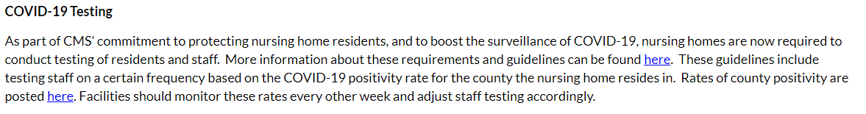
STEP 2: When you click on that link, a .zip file will automatically download:
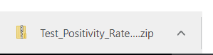
Open the file and you’ll find a spreadsheet you can save to your computer:
STEP 3: The spreadsheet provides data for all counties in all fifty states, so you can either scroll down until you reach Minnesota, or search for your county by name, or filter the file to show only Minnesota counties, and then scroll. Counties will appear in alphabetical order.
We don’t yet know if CMS will provide rolling-data – meaning data from multiple weeks – or just a single week of data. If CMS displays multiple weeks, be sure to note the date in the upper left-hand corner:
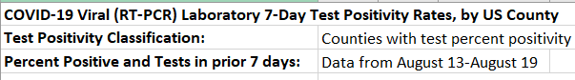
STEP 4: As noted above, CMS is grouping positivity rates into low, medium and high, and they are color-coding the data in the spreadsheet. Low (<5%) is green. Medium (5%-10%) is yellow. High (>10%) is red. For example, here is a screenshot of the line between low and medium:
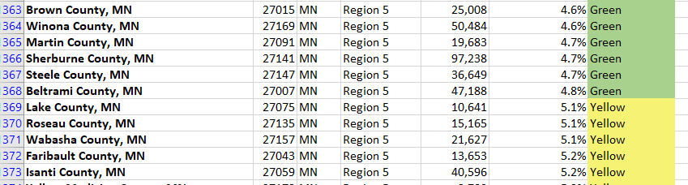
STEP 5: Identify your county, note the positivity rate and color-coded categorization, and implement your routine staff testing accordingly. It will be important to carefully document your monitoring of the county positivity rate in order to evidence compliance with the new requirements.

