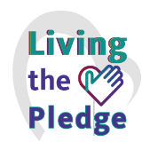­­­­­­

**Be a Safe Care Hero: Get Vaccinated**

*Together we can Honor the Safe Care Pledge to keep*

*those we serve, and our co-workers, along with*

*our families and community, Safe from Harm.*

INSERT PICTURE HERE