SUBJECT: WORKFORCE SOLUTIONS GRANT REPORT

BACKGROUND: An Independent Review Panel of seven members scored and discussed 36 proposals. They made 17 awards totaling $385,024.

Here are Round Two statistics with comparisons to Round One:
- 44 Letters of Intent (Round One =86)
- 36 Proposals received (Round One =68)
- $836,755 requested (Round One = $1.6 million)
- 17 Awards for $385,024 (Round One = 26 for $614,976*)

GRANT AWARD DETAILS:
Examples of Round Two
Grant Projects:
- Diversity:
  - Intercultural workforce coaches, specific to Native Americans
  - On-line literacy improvement tools for candidates with English as a Second Language
- Onboarding/Mentoring:
- Competency-based hiring tool for 60 employees in a new housing community
- Recruiting:
  - A summer Career Academy day camp to recruit high school students into geriatrics
  - Use of social media strategy to attract high school and college students as workers
- Technology:
  - Mobile technology and electronic health record as recruitment and retention strategies
- Training:
  - Special dementia training (Namaste Care) to reduce safety risk

Geographic Distribution of Awards: 43 total awards (17 in Round Two + 26 in Round One)

 | Round One | Round Two | Total Awards | % of Total
District A | $35,000 | $25,000 | $60,000 | 6%
District B | $99,976 | $48,450 | $148,426 | 15%
District C | $175,000 | $69,740 | $244,740 | 24%
District D | $105,000 | $80,549 | $185,549 | 19%
District E | $100,000 | $50,000 | $150,000 | 15%
District F | $50,000 | $111,285 | $161,285 | 16%
District G | $25,000 | $0 | $25,000 | 3%
Multiple Sites | $25,000 | $0 | $25,000 | 3%
 | $614,976 | $385,024 | $1,000,000 | 100%

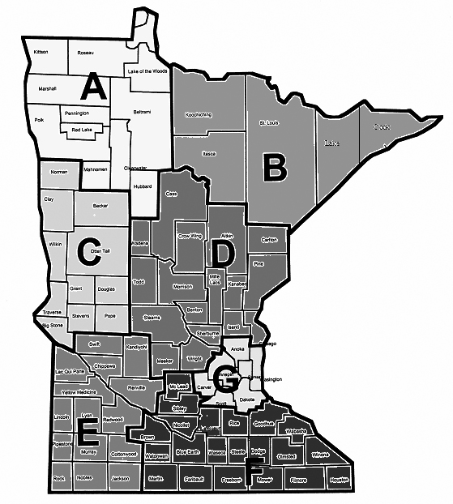

District B:
Round Two Awards = 2
Round One Awards = 4
Total Awards = 6

District A:
Round Two Awards = 1
Round One Awards = 2
Total Awards = 3

District D:
Round Two Awards = 4
Round One Awards = 5
Total Awards = 9

District F:
Round Two Awards = 5
Round One Awards = 2
Total Awards = 7
Multi-District Proposals:
Round One awards = 1
Total Awards = 1

District C:
Round Two Awards =3
Round One Awards = 7
Total Awards = 10

District G:
Round Two Proposals = 0
Round One awards = 1
Total Awards = 1

District E:
Round Two Awards =2
Round One Awards = 4
Total Awards = 6

Type of Service/Setting of Grant Awards:
Most grantees provide more than one type of service. In Round Two awards, Care Centers and Assisted Living were the most frequent settings.

Across Round One and Two awards, Care Centers account for 31%, followed closely by Assisted Living, Memory Care, Independent Living, and Transitional Care.

Round One Grant Awards

Organization | City | Project Description
Benedictine Living Community | Ada | $25,000 to recruit two registered nurses from the United Arab Emirates and work with their colleagues in Crookston to help the new immigrants settle into these rural communities.
Mother of Mercy | Albany | $25,000 to host an onsite Licensed Practical Nurse training course and work with a social media consultant to recruit young people into the profession.
Ecumen Bethany Community | Alexandria | $25,000 to use peer mentors to improve retention and to provide a career ladder for direct care staff.
Knute Nelson | Alexandria | $25,000 to introduce a new intranet to employees who work in 29 counties throughout west central Minnesota to help them stay connected, informed, and retained over time.
Ebenezer Northern Lakes Senior Living | Baxter | $25,000 to provide orientation for employees from northern communities at a new centralized training site that will also host other training programs.
Lutheran Home Association | Belle Plaine | $25,000 to strengthen supervisory skills of managers through a multi-session training program.
Bigfork Valley Communities | Bigfork | $25,000 to train senior managers in a leadership "boot camp" based on the Thrive Leadership model.
Breath of Life Adult Day Service | Brainerd | $5,000 to provide online training for staff from EducCare on adult day services, medication, and memory care.
Villa St. Vincent | Crookston | $25,000 to recruit two registered nurses from the Philippines and to work with their colleagues in Ada to help the new immigrants settle into these small rural communities.
Benedictine Living Communities | Duluth | $25,000 to receive customized leadership training through a partnership with Winona State University and Dimensions International (DDI).
Grand Village | Grand Rapids | $25,000 to launch a new Peer Mentoring Program to support New Hires during the first 90-days of employment and beyond.
Kittson Memorial Healthcare Center | Hallock | $10,000 to provide and improve access to online nursing assistant training onsite; and work with local high school to create a promotional video exposing students to long-term care career opportunities.
Sunnyside Care Center | Lake Park | $25,000 to support STAY conversations and to help staff with concerns outside of work using a shared Retention Specialist with Pelican Rapids
Eventide Lutheran Homes | Moorhead | $25,000 to support iPad kiosks to improve employee engagement and use an Employee Engagement Coordinator to help with New Hire mentoring.
Augustana Care Moose Lake | Moose Lake | $24,976 to pilot a part-time concierge to negotiate discounted goods and services from local businesses to improve convenience for employees.
Oak Hills Living Center | New Ulm | $25,000 to develop Health Support Specialists to serve as team leads to provide mentoring to new employees.
Northfield ParkView Retirement Community | Northfield | $25,000 to introduce middle school, high school and college students to long-term care careers through community partnerships. Selected students will also be trained as Nursing Assistants to work in the organization.
Pelican Valley Senior Living | Pelican Rapids | $25,000 to support a Retention Specialist that is shared with a Lake Rapids partner to help employees learn basic life skills such as budgeting and navigating challenging situations.
Perham Living | Perham | $25,000 to support an onboarding process and new mentor program at Perham Living Home Care.
Renville Health Services | Renville | $25,000 to provide affordable daycare on-site.
Accessible Space Kenosha Apartments | Rochester | $25,000 to support a new Staff Integration Mentor to help retain employees at its Kenosha Drive Apartments senior housing.
Good Shepherd | Sauk Rapids | $25,000 to develop mentors to deliver an onboarding and orientation program for new colleagues.
Ecumen | St. Peter, Duluth, North Branch | $25,000 to help implement best practices in retention determined by a cultural behavioral researcher who will study strategies of sites with high and low retention rates.
Sleepy Eye Home Health and Adult Day Service | Sleepy Eye | $25,000 to improve communication with off-site employees via video conferencing, and web-based training software will be used to support onboarding of new employees.
Rice Care Center | Willmar | $25,000 to recruit Somali workers through a partnership with a local employment agency and Ridgewater College.
Ebenezer Meadow View Apartments | Wyoming | $25,000 to provide orientation for employees from northern communities at a new centralized training site that will also host other training programs.

LeadingAge Minnesota Foundation
Round Two Workforce Solutions Grants

Organization | City | Project Description
St. Mark's Living | Austin | $24,840 to create a career laddering and a retention program called the Peer Mentors that will work with new staff during first 90 days to reduce turnover.
Breath of Life Adult Day Services | Brainerd | $7,500 is to fund training opportunities for building skills and reinforcing culture of a well-trained and dedicated staff.
Browns Valley | Browns Valley | $25,000 to support a collaboration with Sisseton Wahpeton Oyate Tribe of the Lake Traverse Reservation (SWO) using intercultural workforce coaches in retaining current staff and recruiting new employees.
Walker Methodist Levande Housing Community | Cambridge | $25,000 to implement a new competency-based hiring, development, and performance-based process for 60 new employees at a new housing community in Cambridge.
Benedictine Living Community of Duluth | Duluth | $25,000 to extend customized leadership training, provided by Winona State University and Development Dimensions International (DDI), from the first round of grants
Guardian Angels | Elk River | $25,000 to offer nursing assistant programs at four local high schools and to provide career opportunities for students who complete the course.
Field Crest | Hayfield | $25,000 to recruit and train nursing assistants in local high schools using On the Job Training programs.
Villages of Lonsdale | Lonsdale | $16,220 to improve employee satisfaction by applying technology to daily workflow including mobile devices and electronic health record software.
Avera Morningside Heights Care Center | Marshall | $25,000 to develop literacy skills of potential CNA candidates with English as a second language by creating two lower levels of an online curriculum called "Reading Skills for Healthcare Workers."
West Wind Village | Morris | $25,000 to strengthen skills of team building, committee work, mentoring/coaching, conflict resolution and leadership throughout the organization to reduce turnover.
Lifecare Medical Center | Roseau | $25,000 to add a health career exploration class ,including long-term care and CNA training, for Juniors and Seniors in three local schools.
Good Shepherd Lutheran | Sauk Rapids and Becker | $23,049 to create a promotional toolkit to build awareness of caring for the aging while dispelling misconceptions with long-term care employment and to use better demographic targeting in recruitment.
Minnewashka | Starbuck | $19, 980 to apply a social marketing strategy in recruit ng young workers in senior living services.
Ecumen - Scenic Shores | Two Harbors | $23,450 for Experience Camps to introduce high school students to the rewards of working in geriatric care and on developing work readiness skills.
Bethesda | Willmar | $25,000 for an Employee Training and Ambassador Program working with Ridgewater Community and Technical College to improve employee satisfaction.
Lake Winona Manor | Winona | $25,000 to integrate Namaste Care™ into daily programming to reduce turnover through increased employee safety. The program reduces combative behaviors related to care of cognitively impaired residents.
Zumbrota Health Services | Zumbrota | $19,985 to create a Wellness Suite to address employee stress and burnout while improving turnover and retention. The project will include fitness equipment, relaxation studio, and health counseling, including a smoking cessation.

