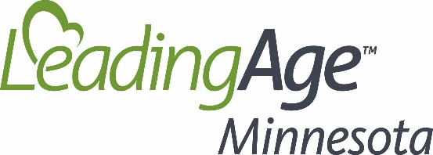

FOR IMMEDIATE RELEASE Contact: Jodi Boyne
June 4, 2019 jboyne@leadingagemn.org
651.659.1430

ALLISON FLOBERG, FAIR OAKS LODGE, RECEIVES MAKE ZERO HARM POSSIBLE AWARD

Saint Paul, MN (June 4, 2019) – Allison Floberg, Social Services Director at Fair Oaks Lodge in Wadena, has received the Make Zero Harm Possible Award from LeadingAge Minnesota. The award recognizes staff in aging services settings who demonstrate their commitment to treat the people they serve with respect and dignity – always, and to keep them safe by speaking up to prevent harm.

“It is because of the actions taken every day by dedicated caregivers like Allison Floberg that elders who reside in aging services settings across Minnesota receive safe, quality care an integral part of a life well lived,” said Gayle Kvenvold, President and CEO, LeadingAge Minnesota. “It is a true honor to recognize Allison for going above and beyond in her daily work to enhance the lives of elders.”

Sam Quam, Administrator at Fair Oaks Lodge, said Floberg has added tremendous value to the Fair Oaks team and its mission to provide quality care with compassion and respect and to enhance human dignity.

“Allison is one of the many people who are working tirelessly to end the stigma of mental health issues, especially with our elderly population,” said Sam Quam.

Fair Oaks serves a high ratio of residents with mental health needs. In her role as Social Services Director, Floberg has built relationships with local mental health outlets to offer more services to residents at Fair Oaks Lodge and improved the care coordination between residents, doctors affiliated with a geriatric psychiatry clinic who serves the organization’s residents and the Fair Oaks team. She also collaborates with the nursing department at Fair Oaks to properly document behaviors for residents with mental health needs to improve care.
The Make Zero Harm Possible award is one component of LeadingAge Minnesota’s Safe Care for Seniors initiative, a comprehensive safety and quality improvement program. The program is designed to strengthen the culture of safety, prevent the risk of harm before it occurs and uncover new opportunities for learning and improvement in the delivery of care and services.

###
About LeadingAge Minnesota
Driven to transform and enhance the experience of aging, LeadingAge Minnesota is the state’s largest association of organizations serving older adults. Together with more than 50,000 caregivers, our members provide quality, compassionate services and support to nearly 70,000 older adults every day in independent living, assisted living, adult day and skilled nursing.

